UNITED STATES

SECURITIES AND EXCHANGE COMMISSION

Washington, D.C. 20549

SCHEDULE 14A

Proxy Statement Pursuant to Section 14(a) of the Securities Exchange Act of 1934

- Filed by the Registrant ☐ Filed by a Party other than the Registrant

Check the appropriate box:
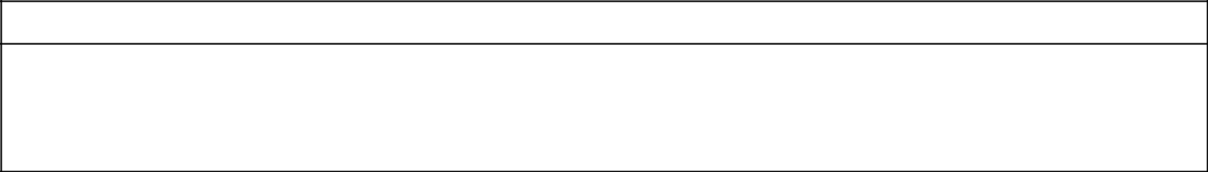

- Preliminary Proxy Statement

- Confidential, for Use of the Commission Only (as permitted by Rule 14a-6(e)(2))

- Definitive Proxy Statement

- Definitive Additional Materials

- Soliciting Material under §240.14a-12

CENTURY THERAPEUTICS, INC.

(Name of Registrant as Specified In Its Charter)
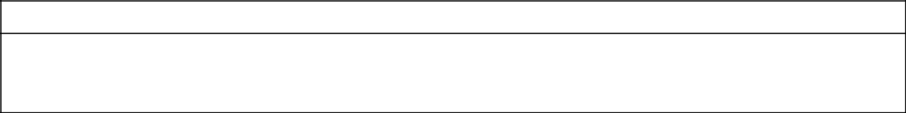

Payment of Filing Fee (Check all boxes that apply):

- No fee required

- Fee paid previously with preliminary materials

- Fee computed on table in exhibit required by Item 25(b) per Exchange Act Rules 14a-6(i)(1) and 0-11



