UNITED STATES
SECURITIES AND EXCHANGE COMMISSION
Washington, D.C. 20549

SCHEDULE 14A

Proxy Statement Pursuant to Section 14(a) of
the Securities Exchange Act of 1934 (Amendment No. )

Filed by the Registrant ☒
Filed by a Party other than the Registrant ☐
Check the appropriate box:
☐ | Preliminary Proxy Statement
☐ | Confidential, for Use of the Commission Only (as permitted by Rule 14a-6(e)(2))
☐ | Definitive Proxy Statement
☒ | Definitive Additional Materials
☐ | Soliciting Material under §240.14a-12

CENTURY THERAPEUTICS, INC.
(Name of Registrant as Specified in Its Charter)
(Name of Person(s) Filing Proxy Statement, if Other Than the Registrant)

Payment of Filing Fee (Check all boxes that apply):
☒ | No fee required
☐ | Fee paid previously with preliminary materials
☐ | Fee computed on table in exhibit required by Item 25(b) per Exchange Act Rules 14a-6(i)(1) and 0-11

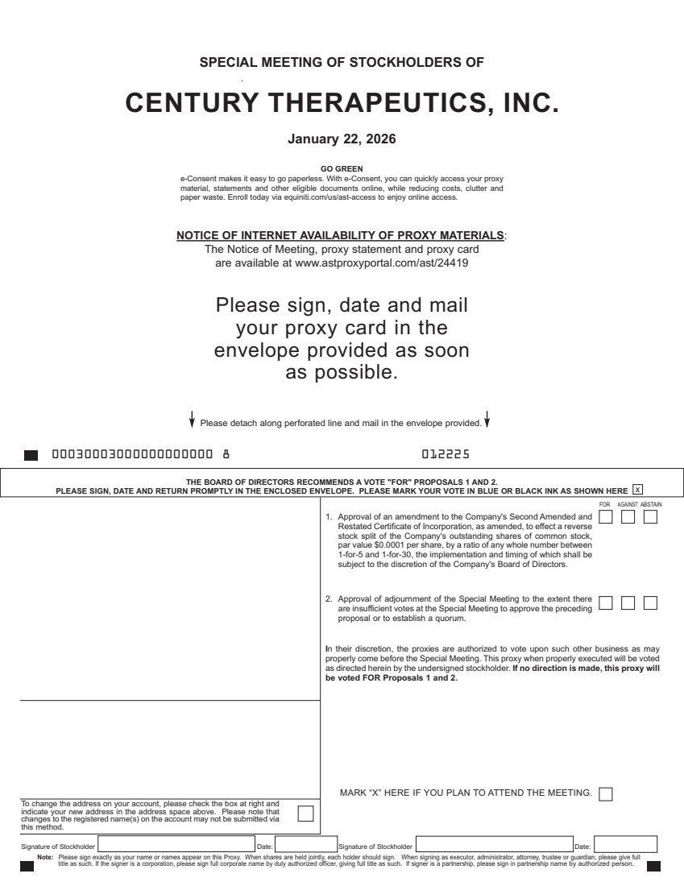 | SPECIAL MEETING OF STOCKHOLDERS OF CENTURY THERAPEUTICS, INC. January 22, 2026 NOTICE OF INTERNET AVAILABILITY OF PROXY MATERIALS: The Notice of Meeting, proxy statement and proxy card are available at www.astproxyportal.com/ast/24419 Please sign, date and mail your proxy card in the envelope provided as soon as possible. Signature of Stockholder Date: Signature of Stockholder Date: Note: Please sign exactly as your name or names appear on this Proxy. When shares are held jointly, each holder should sign. When signing as executor, administrator, attorney, trustee or guardian, please give full title as such. If the signer is a corporation, please sign full corporate name by duly authorized officer, giving full title as such. If signer is a partnership, please sign in partnership name by authorized person. To change the address on your account, please check the box at right and indicate your new address in the address space above. Please note that changes to the registered name(s) on the account may not be submitted via this method. THE BOARD OF DIRECTORS RECOMMENDS A VOTE "FOR" PROPOSALS 1 AND 2. PLEASE SIGN, DATE AND RETURN PROMPTLY IN THE ENCLOSED ENVELOPE. PLEASE MARK YOUR VOTE IN BLUE OR BLACK INK AS SHOWN HERE x Please detach along perforated line and mail in the envelope provided. 00030003000000000000 8 012225 GO GREEN e-Consent makes it easy to go paperless. With e-Consent, you can quickly access your proxy material, statements and other eligible documents online, while reducing costs, clutter and paper waste. Enroll today via equiniti.com/us/ast-access to enjoy online access. 1. Approval of an amendment to the Company's Second Amended and Restated Certificate of Incorporation, as amended, to effect a reverse stock split of the Company's outstanding shares of common stock, par value $0.0001 per share, by a ratio of any whole number between 1-for-5 and 1-for-30, the implementation and timing of which shall be subject to the discretion of the Company's Board of Directors. 2. Approval of adjournment of the Special Meeting to the extent there are insufficient votes at the Special Meeting to approve the preceding proposal or to establish a quorum. In their discretion, the proxies are authorized to vote upon such other business as may properly come before the Special Meeting. This proxy when properly executed will be voted as directed herein by the undersigned stockholder. If no direction is made, this proxy will be voted FOR Proposals 1 and 2. FOR AGAINST ABSTAIN MARK “X” HERE IF YOU PLAN TO ATTEND THE MEETING.
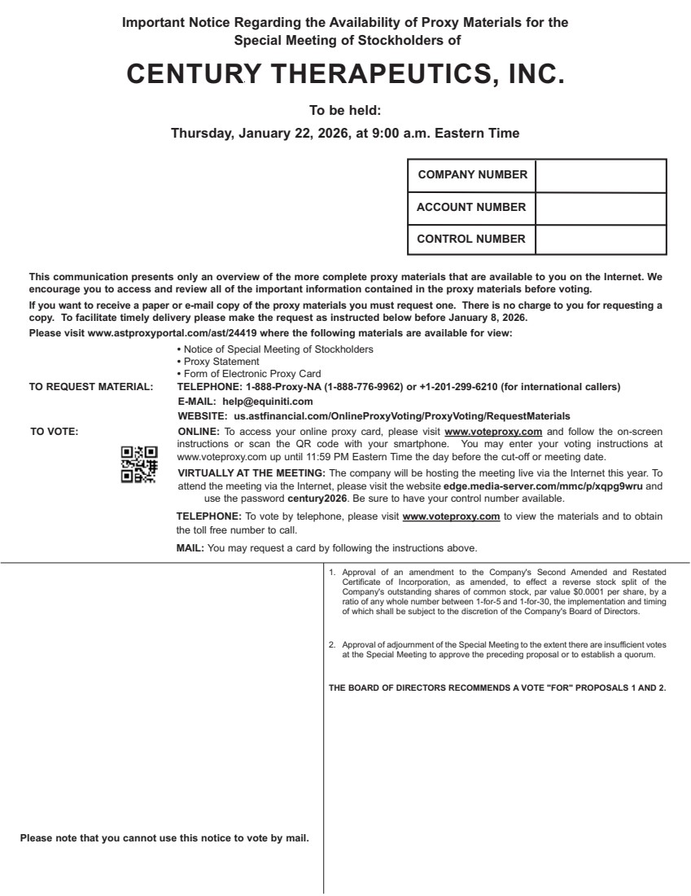 | 1. Approval of an amendment to the Company's Second Amended and Restated Certificate of Incorporation, as amended, to effect a reverse stock split of the Company's outstanding shares of common stock, par value $0.0001 per share, by a ratio of any whole number between 1-for-5 and 1-for-30, the implementation and timing of which shall be subject to the discretion of the Company's Board of Directors. 2. Approval of adjournment of the Special Meeting to the extent there are insufficient votes at the Special Meeting to approve the preceding proposal or to establish a quorum. THE BOARD OF DIRECTORS RECOMMENDS A VOTE "FOR" PROPOSALS 1 AND 2. This communication presents only an overview of the more complete proxy materials that are available to you on the Internet. We encourage you to access and review all of the important information contained in the proxy materials before voting. If you want to receive a paper or e-mail copy of the proxy materials you must request one. There is no charge to you for requesting a copy. To facilitate timely delivery please make the request as instructed below before January 8, 2026. Please visit www.astproxyportal.com/ast/24419 where the following materials are available for view: • Notice of Special Meeting of Stockholders • Proxy Statement • Form of Electronic Proxy Card TO REQUEST MATERIAL: TELEPHONE: 1-888-Proxy-NA (1-888-776-9962) or +1-201-299-6210 (for international callers) E-MAIL: help@equiniti.com WEBSITE: us.astfinancial.com/OnlineProxyVoting/ProxyVoting/RequestMaterials TO VOTE: ONLINE: To access your online proxy card, please visit www.voteproxy.com and follow the on-screen instructions or scan the QR code with your smartphone. You may enter your voting instructions at www.voteproxy.com up until 11:59 PM Eastern Time the day before the cut-off or meeting date. VIRTUALLY AT THE MEETING: The company will be hosting the meeting live via the Internet this year. To attend the meeting via the Internet, please visit the website edge.media-server.com/mmc/p/xqpg9wru and use the password century2026. Be sure to have your control number available. TELEPHONE: To vote by telephone, please visit www.voteproxy.com to view the materials and to obtain the toll free number to call. MAIL: You may request a card by following the instructions above. COMPANY NUMBER ACCOUNT NUMBER CONTROL NUMBER JOHN SMITH 1234 MAIN STREET APT. 203 NEW YORK, NY 10038 Please note that you cannot use this notice to vote by mail. Important Notice Regarding the Availability of Proxy Materials for the Special Meeting of Stockholders of CENTURY THERAPEUTICS, INC. To be held: Thursday, January 22, 2026, at 9:00 a.m. Eastern Time

