UNITED STATES
SECURITIES AND EXCHANGE COMMISSION
Washington, DC 20549

FORM 8-K

CURRENT REPORT
Pursuant to Section 13 or 15(d)
of the Securities Exchange Act of 1934

Date of Report (Date of earliest event reported): October 2, 2026

Century Therapeutics, Inc.
(Exact name of registrant as specified in its charter)

Delaware |  | 001-40498 |  | 84-2040295
(State or other jurisdiction of  incorporation or organization) |  | (Commission File Number) |  | (I.R.S. Employer  Identification No.)

25 North 38th Street, 12th Floor  Philadelphia, Pennsylvania |  | 19104
(Address of principal executive offices) |  | (Zip Code)

Registrant’s telephone number, including area code: (267) 817-5790

Not Applicable
(Former name or former address, if changed since last report)

Check the appropriate box below if the Form 8-K filing is intended to simultaneously satisfy the filing obligation of the registrant under any of the following provisions (see General Instruction A.2. below):

☐ | Written communications pursuant to Rule 425 under the Securities Act (17 CFR 230.425)
☐ | Soliciting material pursuant to Rule 14a-12 under the Exchange Act (17 CFR 240.14a-12)
☐ | Pre-commencement communications pursuant to Rule 14d-2(b) under the Exchange Act (17 CFR 240.14d-2(b))
☐ | Pre-commencement communications pursuant to Rule 13e-4(c) under the Exchange Act (17 CFR 240.13e-4(c))

Securities registered pursuant to Section 12(b) of the Act:

Title of Each Class |  | Trading Symbol |  | Name of Exchange on Which Registered
Common Stock, par value $0.0001 per share |  | IPSC |  | Nasdaq Capital Market

Indicate by check mark whether the registrant is an emerging growth company as defined in Rule 405 of the Securities Act of 1933 (§230.405 of this chapter) or Rule 12b-2 of the Securities Exchange Act of 1934 (§240.12b-2 of this chapter).

Emerging growth company x

If an emerging growth company, indicate by check mark if the registrant has elected not to use the extended transition period for complying with any new or revised financial accounting standards provided pursuant to Section 13(a) of the Exchange Act. ☐

Item 7.01 | Regulation FD Disclosure

On October 2, 2026, Century Therapeutics, Inc. (the “Company”) issued a press release announcing that nonclinical data from the Company’s iPSC-derived cell therapy platform was presented at the European Association for the Study of Diabetes (“EASD”) held on October 2, 2026 in Milan, Italy. The full text of the press release is furnished as Exhibit 99.1 to this Current Report on Form 8-K and is incorporated herein by reference.

The information contained in this Item 7.01 (including Exhibit 99.1) is being furnished and shall not be deemed “filed” for purposes of Section 18 of the Securities Exchange Act of 1934, as amended (the “Exchange Act”), or otherwise subject to the liabilities of that section and shall not be deemed incorporated by reference in any filing under the Securities Act of 1933, as amended, or the Exchange Act, except as shall be expressly set forth by specific reference in such filing.

Item 8.01 | Other Events

A copy of the slides presented by the Company at EASD is filed as Exhibit 99.2 to this Current Report on Form 8-K and is incorporated herein by reference. The Company undertakes no obligation to update, supplement or amend the materials attached hereto as Exhibit 99.2.

Item 9.01 | Financial Statements and Exhibits

(d) Exhibits

Exhibit  No. |  | Document
99.1 |  | Press Release of Century Therapeutics, Inc., dated October 2, 2026
99.2 |  | European Association for the Study of Diabetes Presentation Slides of Century Therapeutics, Inc., dated October 2, 2026
104 |  | Cover Page Interactive Data File (embedded within the Inline XBRL document)

SIGNATURES

Pursuant to the requirements of the Securities Exchange Act of 1934, the registrant has duly caused this report to be signed on its behalf by the undersigned hereunto duly authorized.

CENTURY THERAPEUTICS, INC.
By: | /s/ Brent Pfeiffenberger, Pharm.D., M.B.A.
Name: | Brent Pfeiffenberger, Pharm.D., M.B.A.
Title: | President, Chief Executive Officer and Chairman of the Board of Directors

Date: October 2, 2026

Exhibit 99.1

Century Therapeutics' CNTY-813 Demonstrates Continued Advancement Toward the Clinic Via Nonclinical Data Presented at EASD 2026

Data demonstrated scalable production, in vivo function and immune evasion, and updated progress toward clinical dosing of CNTY-813, Century's iPSC-derived islet replacement therapy for type 1 diabetes

CNTY-813 IND submission remains on track for Q4 2026; initial clinical data anticipated in the second half of 2027

PHILADELPHIA, October 2nd, 2026 (GLOBE NEWSWIRE) -- Century Therapeutics, Inc. (“Century”, NASDAQ: IPSC), a biotechnology company developing induced pluripotent stem cell (iPSC)-derived cell therapies for type 1 diabetes (T1D) and other autoimmune diseases, today announced the presentation of nonclinical data for CNTY-813, Century's iPSC-derived islet replacement therapy engineered with Allo-Evasion™ 5.0. Data were presented in an oral presentation at the 62nd Annual Meeting of the European Association for the Study of Diabetes (EASD) in Milan, Italy.

In a study lasting over eleven months, updated data demonstrated CNTY-813 maintained glycemic control in a diabetic mouse model until CNTY-813’s graft removal. New data further highlighted CNTY-813’s anticipated readiness for clinical testing via demonstration of drug product consistency across five clinical-scale runs, glycemic control in a diabetic mouse model after extended drug product cold storage, and successful engraftment of CNTY-813 via the intended clinical route of administration.

“The data presented at EASD build on the nonclinical package we presented at ADA in June and highlight our continued execution on bringing CNTY-813 into the clinic,” said Brent Pfeiffenberger, Pharm.D., Chief Executive Officer of Century Therapeutics. “Following our pre-IND meeting, in which we reached general alignment with FDA on our nonclinical package, Phase 1 manufacturing process and proposed Phase 1/2 trial design, we remain on track to submit the CNTY-813 IND in the fourth quarter of this year with initial clinical data anticipated in the second half of 2027.”

New Nonclinical Data Highlights

Glycemic control sustained until graft removal in diabetic mice

 | • | Allo-Evasion™ 5.0-edited CNTY-813 islets rapidly restored normoglycemia in streptozotocin-induced diabetic mice and maintained glycemic control until graft removal, demonstrating clear pharmacological activity. The study lasted over eleven months.

 | • | All streptozotocin-induced diabetic mice administered with CNTY-813 achieved normoglycemia.

 | • | CNTY-813 islets showed glucose-stimulated insulin secretion potency similar to primary islets.

Phase 1 clinical manufacturing process produced consistent product across five clinical-scale batches

 | • | Five clinical-scale batches from Century's Good Manufacturing Practice Master Cell Bank produced consistent final product profiles.

 | • | The 29-day process exceeded purity criteria at every stage.

Liver portal vein delivery in rats resulted in successful engraftment supporting the planned clinical route of administration

 | • | In rats, CNTY-813 islets were identified engrafted in the liver at one month post-transplant.

 | • | Engrafted islets stained positive for chromogranin A, an endocrine cell marker, and for insulin, confirming they retained islet endocrine and beta cell identity after delivery.

Clinical-scale product remained functional after 96 hours of cold storage, supporting future clinical supply chain

 | • | Mice transplanted with clinical-scale islets after 96 hours of cold storage normalized blood glucose within 30 days and maintained normoglycemia through three months of follow-up.

 | • | By one month post-transplant, glucose tolerance was indistinguishable from normoglycemic controls.

Grant Welstead, Ph.D., Senior Vice President, Head of Research at Century, delivered the presentation, titled “CNTY-813: Scalable Production of Allo-Evasion™ 5.0-Engineered iPSC-Derived Islets for Off-the-Shelf Cell Therapies” (Presentation 225), on Friday, October 2, 2026, in Session OP 39, “Beta cells on demand: stem cells to beta cell therapy,” held from 10:00 to 11:00 a.m. Central European Summer Time in Paris Hall. The presentation is available in the Scientific Resources section of the Science page on Century's website at Events and Presentations | Century Therapeutics.

Upcoming CNTY-813 Milestones

 | • | Investigational New Drug (IND) submission (4Q 2026): Century expects to submit an Investigational New Drug application for CNTY-813 in the fourth quarter of 2026, subject to completion of remaining IND-enabling studies.

 | • | Initial clinical data (2H 2027): Initial safety and early efficacy data from the first-in-human CNTY-813 study are anticipated in the second half of 2027.

About Century Therapeutics

Century Therapeutics (NASDAQ: IPSC) is a biotechnology company advancing a pipeline of iPSC-derived cell therapies with the potential to meaningfully address autoimmune diseases, including T1D, and cancer. Century's therapies are derived from its iPSC cell foundry and leverage its novel immune evasion engineering technology, Allo-Evasion™. Century believes its approach to developing off-the-shelf cell therapies will expand patient access and provide advantages over existing cell therapies which will ultimately advance the course of care. For more information on Century Therapeutics, please visit www.centurytx.com and connect with us on LinkedIn.

Forward-Looking Statements

This press release contains forward-looking statements within the meaning of, and made pursuant to the safe harbor provisions of, The Private Securities Litigation Reform Act of 1995. All statements contained in this press release, other than statements of historical facts or statements that relate to present facts or current conditions, including but not limited to, statements regarding our timing and expectations for regulatory submissions, nonclinical and clinical development, including CNTY-813's IND submission and expected data readout in the second half of 2027, and our financial resources and expected cash runway, are forward-looking statements. These statements involve known and unknown risks, uncertainties and other important factors that may cause our actual results, performance, or achievements to be materially different from any future results, performance or achievements expressed or implied by the forward-looking statements. In some cases, you can identify forward-looking statements by terms such as “may,” “might,” “will,” “should,” “expect,” “plan,” “aim,” “seek,” “anticipate,” “could,” “intend,” “target,” “project,” “contemplate,” “believe,” “estimate,” “predict,” “forecast,” “potential” or “continue” or the negative of these terms or other similar expressions. The forward-looking statements in this press release are only predictions. We have based these forward-looking statements largely on our current expectations and projections about future events and financial trends that we believe may affect our business, financial condition, and results of operations. These forward-looking statements speak only as of the date of this press release and are subject to a number of risks, uncertainties and assumptions, some of which cannot be predicted or quantified and some of which are beyond our control. These and other risks and uncertainties are described more fully in the “Risk Factors” section of our most recent filings with the Securities and Exchange Commission and available at www.sec.gov. You should not rely on these forward-looking statements as predictions of future events. Except as required by applicable law, we do not plan to publicly update or revise any forward-looking statements contained herein, whether as a result of any new information, future events, changed circumstances or otherwise.

For More Information:

Century Therapeutics

Douglas Carr

Senior Vice President, Finance

investor.relations@centurytx.com

Corey Davis, Ph.D.

LifeSci Advisors, LLC

212-915-2577

Exhibit 99.2
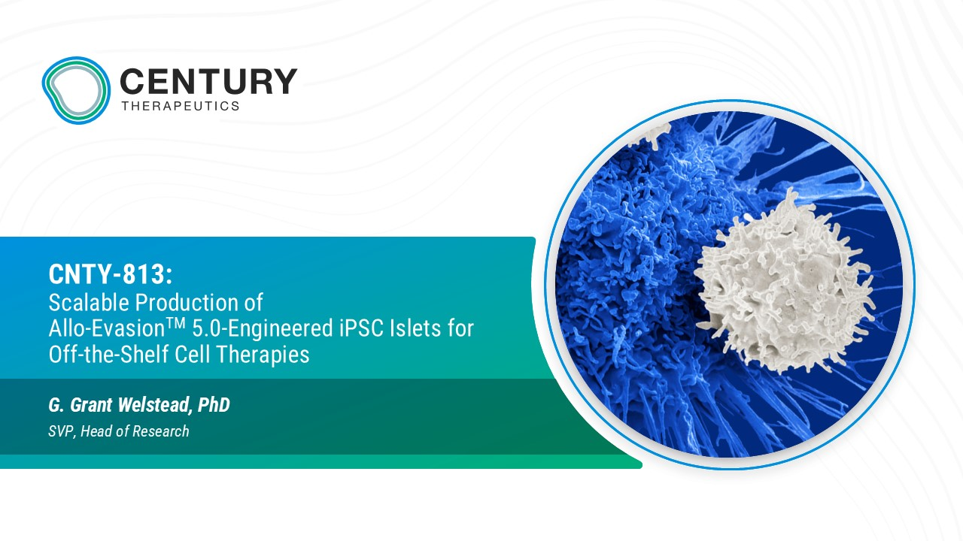
CNTY - 813: Scalable Production of Allo - Evasion TM 5.0 - Engineered iPSC Islets for Off - the - Shelf Cell Therapies G. Grant Welstead, PhD SVP, Head of Research
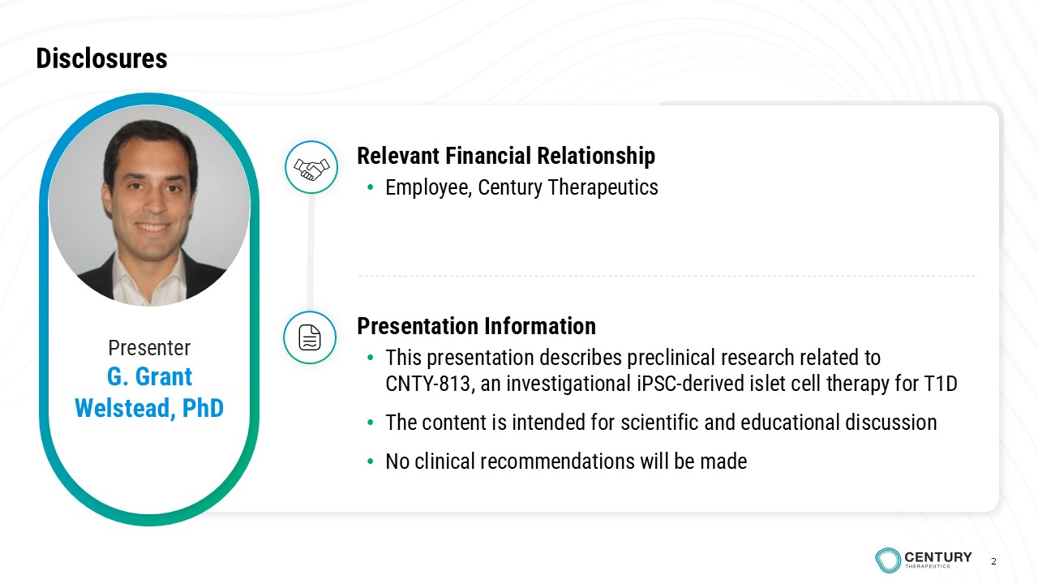
2 Disclosures Presenter G. Grant Welstead, PhD Relevant Financial Relationship • Employee, Century Therapeutics Presentation Information • This presentation describes preclinical research related to CNTY - 813, an investigational iPSC - derived islet cell therapy for T1D • The content is intended for scientific and educational discussion • No clinical recommendations will be made 2
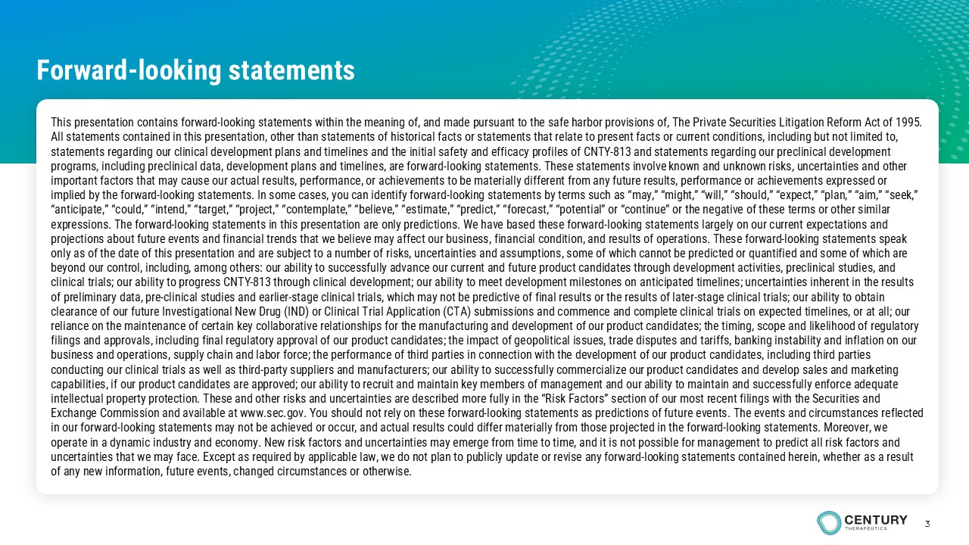
3 This presentation contains forward - looking statements within the meaning of, and made pursuant to the safe harbor provisions of, The Private Securities Litigation Reform Act of 1995. All statements contained in this presentation, other than statements of historical facts or statements that relate to present fa cts or current conditions, including but not limited to, statements regarding our clinical development plans and timelines and the initial safety and efficacy profiles of CNTY - 813 and s tatements regarding our preclinical development programs, including preclinical data, development plans and timelines, are forward - looking statements. These statements involve known and unknown risks, uncertainties and other important factors that may cause our actual results, performance, or achievements to be materially different from any future res ults, performance or achievements expressed or implied by the forward - looking statements. In some cases, you can identify forward - looking statements by terms such as “may,” “m ight,” “will,” “should,” “expect,” “plan,” “aim,” “seek,” “anticipate,” “could,” “intend,” “target,” “project,” “contemplate,” “believe,” “estimate,” “predict,” “forecast,” “potential ” o r “continue” or the negative of these terms or other similar expressions. The forward - looking statements in this presentation are only predictions. We have based these forward - looking state ments largely on our current expectations and projections about future events and financial trends that we believe may affect our business, financial condition, and result s o f operations. These forward - looking statements speak only as of the date of this presentation and are subject to a number of risks, uncertainties and assumptions, some of which c ann ot be predicted or quantified and some of which are beyond our control, including, among others: our ability to successfully advance our current and future product candidates th rou gh development activities, preclinical studies, and clinical trials; our ability to progress CNTY - 813 through clinical development; our ability to meet development milestones on an ticipated timelines; uncertainties inherent in the results of preliminary data, pre - clinical studies and earlier - stage clinical trials, which may not be predictive of final results or the results of later - stage clinical trials; our ability to obtain clearance of our future Investigational New Drug (IND) or Clinical Trial Application (CTA) submissions and commence and compl ete clinical trials on expected timelines, or at all; our reliance on the maintenance of certain key collaborative relationships for the manufacturing and development of our product c and idates; the timing, scope and likelihood of regulatory filings and approvals, including final regulatory approval of our product candidates; the impact of geopolitical issues, trad e d isputes and tariffs, banking instability and inflation on our business and operations, supply chain and labor force; the performance of third parties in connection with the development of ou r product candidates, including third parties conducting our clinical trials as well as third - party suppliers and manufacturers; our ability to successfully commercialize our product candidates and develop sales and marketing capabilities, if our product candidates are approved; our ability to recruit and maintain key members of management and our a bil ity to maintain and successfully enforce adequate intellectual property protection. These and other risks and uncertainties are described more fully in the “Risk Factors” sect ion of our most recent filings with the Securities and Exchange Commission and available at www.sec.gov. You should not rely on these forward - looking statements as predictions of futu re events. The events and circumstances reflected in our forward - looking statements may not be achieved or occur, and actual results could differ materially from those projected in the forward - looking statements. Moreover, we operate in a dynamic industry and economy. New risk factors and uncertainties may emerge from time to time, and it is not pos sib le for management to predict all risk factors and uncertainties that we may face. Except as required by applicable law, we do not plan to publicly update or revise any forward - lo oking statements contained herein, whether as a result of any new information, future events, changed circumstances or otherwise. Forward - looking statements
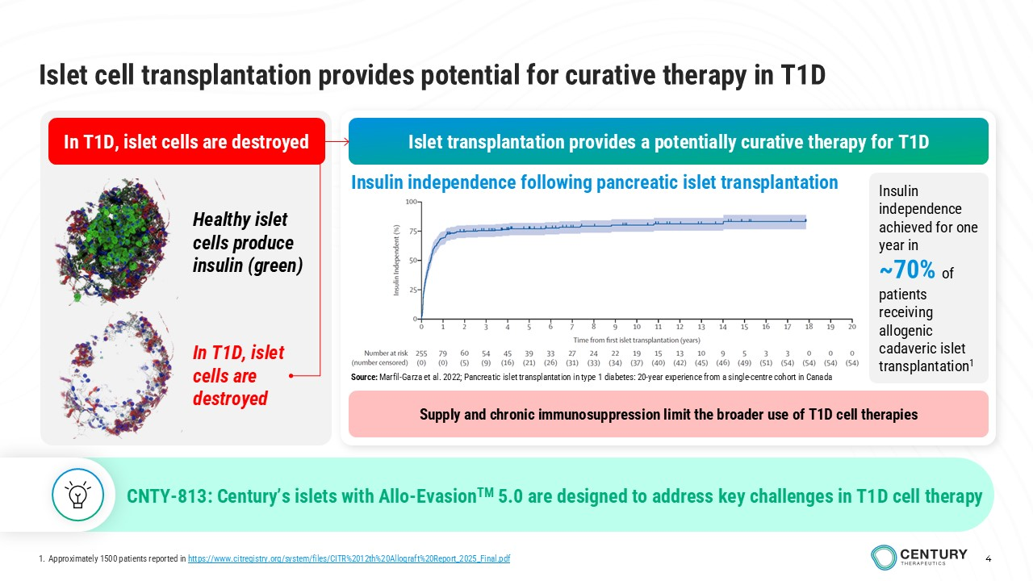
4 Islet transplantation provides a potentially curative therapy for T1D Supply and chronic immunosuppression limit the broader use of T1D cell therapies Islet cell transplantation provides potential for curative therapy in T1D In T1D, islet cells are destroyed Healthy islet cells produce insulin (green) In T1D, islet cells are destroyed Insulin independence following pancreatic islet transplantation Insulin independence achieved for one year in ~70% of patients receiving allogenic cadaveric islet transplantation 1 CNTY - 813: Century’s islets with Allo - Evasion TM 5.0 are designed to address key challenges in T1D cell therapy 4 Source: Marfil - Garza et al. 2022; Pancreatic islet transplantation in type 1 diabetes: 20 - year experience from a single - centre cohort in Canada 1. Approximately 1500 patients reported in https://www.citregistry.org/system/files/CITR%2012th%20Allograft%20Report_2025_Final.pdf
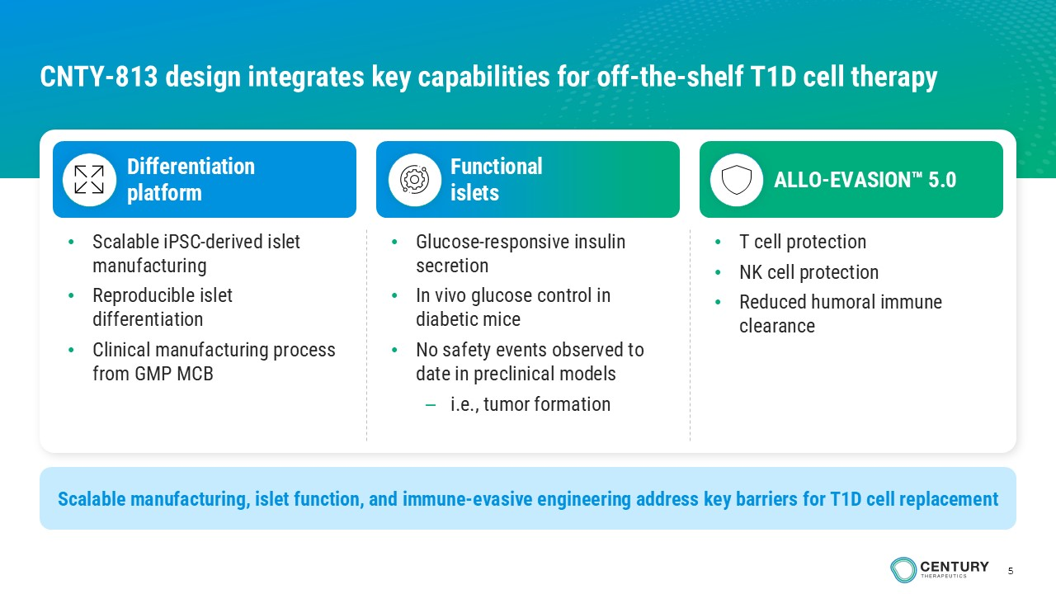
5 • Scalable iPSC - derived islet manufacturing • Reproducible islet differentiation • Clinical manufacturing process from GMP MCB Differentiation platform Functional islets ALLO - EVASION 5.0 Scalable manufacturing, islet function, and immune - evasive engineering address key barriers for T1D cell replacement • Glucose - responsive insulin secretion • In vivo glucose control in diabetic mice • No safety events observed to date in preclinical models – i.e., tumor formation • T cell protection • NK cell protection • Reduced humoral immune clearance CNTY - 813 design integrates key capabilities for off - the - shelf T1D cell therapy
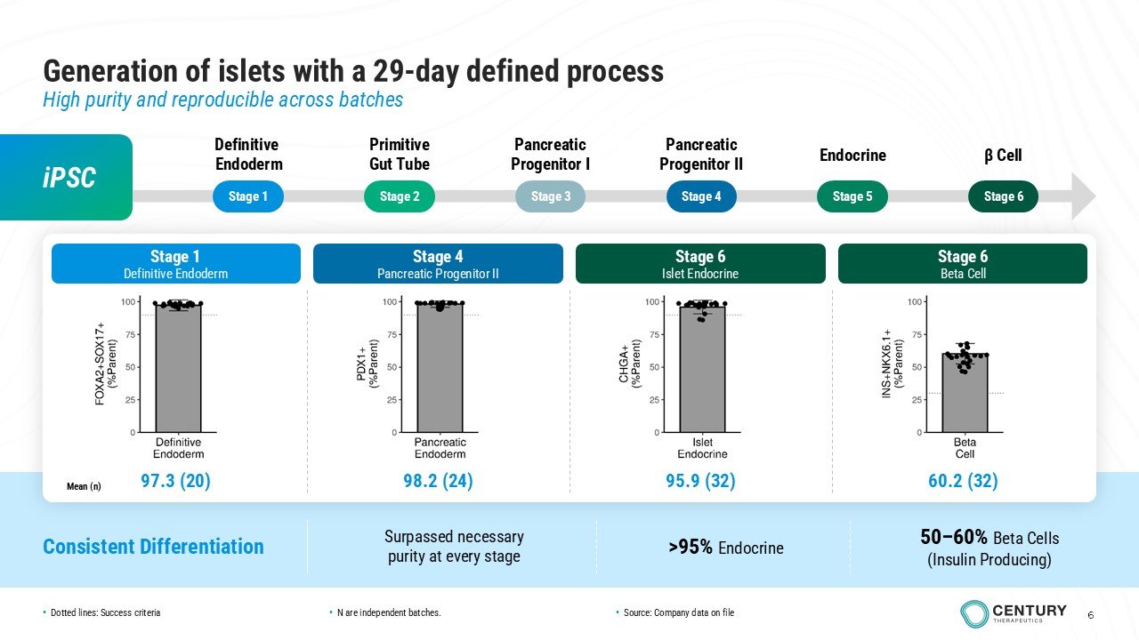
6 6 Stage 1 Stage 2 Stage 4 Stage 5 Stage 6 Stage 3 Generation of islets with a 29 - day defined process High purity and reproducible across batches iPSC Definitive Endoderm Primitive Gut Tube Pancreatic Progenitor II Endocrine β Cell Pancreatic Progenitor I Stage 1 Definitive Endoderm Stage 4 Pancreatic Progenitor II Stage 6 Islet Endocrine Stage 6 Beta Cell 97.3 (20) 98.2 (24) 95.9 (32) 60.2 (32) Mean (n) Consistent Differentiation Surpassed necessary purity at every stage >95% Endocrine 50 – 60% Beta Cells (Insulin Producing) • Dotted lines: Success criteria • N are independent batches. • Source: Company data on file
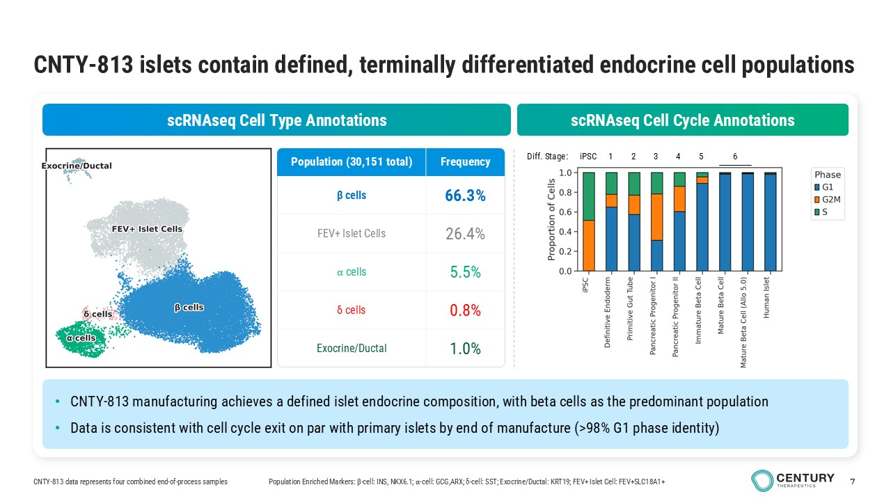
7 CNTY - 813 islets contain defined, terminally differentiated endocrine cell populations Population Enriched Markers: β - cell: INS, NKX6.1; ⍺ - cell: GCG,ARX; δ - cell: SST; Exocrine/Ductal: KRT19; FEV+ Islet Cell: FEV+SLC18A1+ Diff. Stage: scRNAseq Cell Cycle Annotations scRNAseq Cell Type Annotations • CNTY - 813 manufacturing achieves a defined islet endocrine composition, with beta cells as the predominant population • Data is consistent with cell cycle exit on par with primary islets by end of manufacture (>98% G1 phase identity) iPSC 1 2 3 4 5 6 Frequency Population (30,151 total) 66.3% β cells 26.4% FEV+ Islet Cells 5.5% ⍺ cells 0.8% δ cells 1.0% Exocrine/Ductal CNTY - 813 data represents four combined end - of - process samples
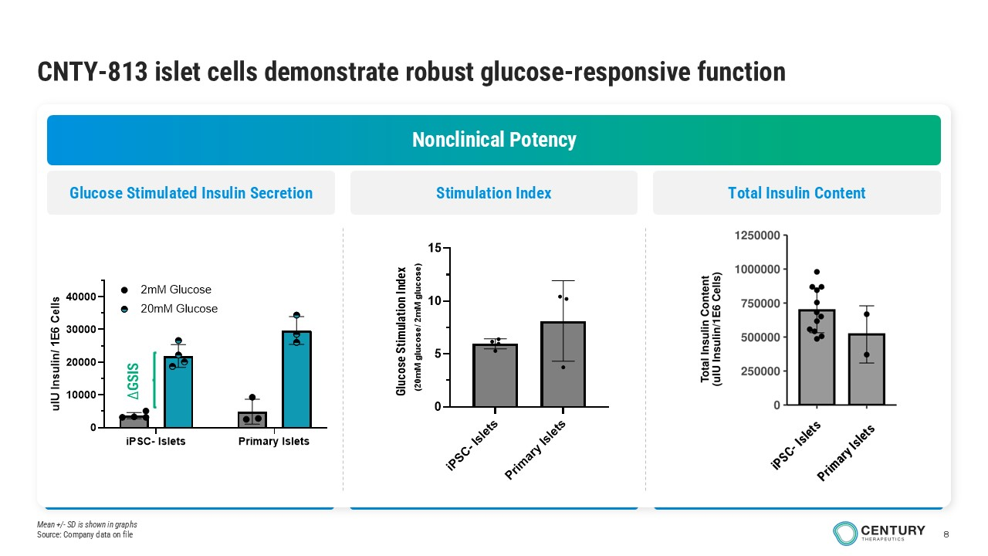
8 CNTY - 813 islet cells demonstrate robust glucose - responsive function Nonclinical Potency Stimulation Index Total Insulin Content Glucose Stimulated Insulin Secretion iPSC- Islets Primary Islets 0 10000 20000 30000 40000 u I U I n s u l i n / 1 E 6 C e l l s 2mM Glucose 20mM Glucose ∆ GSIS i P S C - I s l e t s P r i m a r y I s l e t s 0 5 10 15 G l u c o s e S t i m u a l t i o n I n d e x ( 2 0 m M g l u c o s e / 2 m M g l u c o s e ) Glucose Stimulation Index Mean +/ - SD is shown in graphs Source: Company data on file
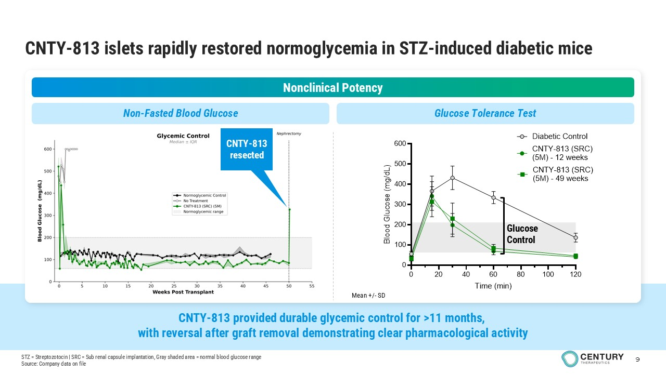
9 CNTY - 813 provided durable glycemic control for >11 months, with reversal after graft removal demonstrating clear pharmacological activity CNTY - 813 islets rapidly restored normoglycemia in STZ - induced diabetic mice Nonclinical Potency 0 20 40 60 80 100 120 0 100 200 300 400 500 600 Time (min) B l o o d G l u c o s e ( m g / d L ) Diabetic Control CNTY-813 (SRC) (5M) - 12 weeks CNTY-813 (SRC) (5M) - 49 weeks Glucose Control Non - Fasted Blood Glucose Glucose Tolerance Test Mean +/ - SD CNTY - 813 resected STZ = Streptozotocin | SRC = Sub renal capsule implantation, Gray shaded area = normal blood glucose range Source: Company data on file
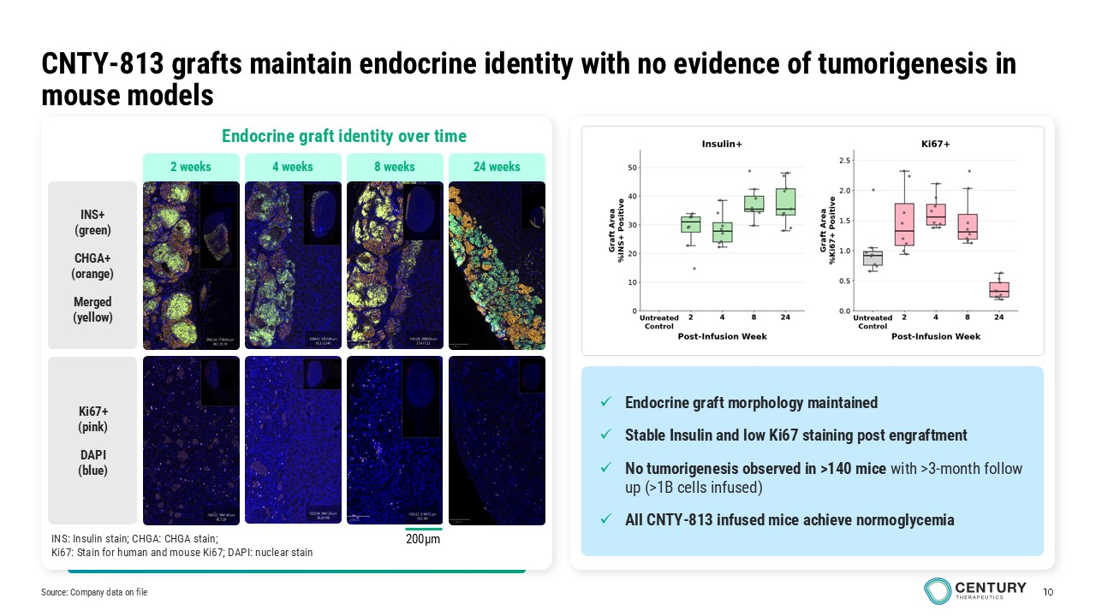
10 CNTY - 813 grafts maintain endocrine identity with no evidence of tumorigenesis in mouse models Endocrine graft identity over time INS+ (green) CHGA+ (orange) Merged (yellow) Ki67+ (pink) DAPI (blue) INS: Insulin stain; CHGA: CHGA stain; Ki67: Stain for human and mouse Ki67; DAPI: nuclear stain 4 weeks 8 weeks 2 weeks 24 weeks 200µm x Endocrine graft morphology maintained x Stable Insulin and low Ki67 staining post engraftment x No tumorigenesis observed in >140 mice with >3 - month follow up (>1B cells infused) x All CNTY - 813 infused mice achieve normoglycemia Source: Company data on file
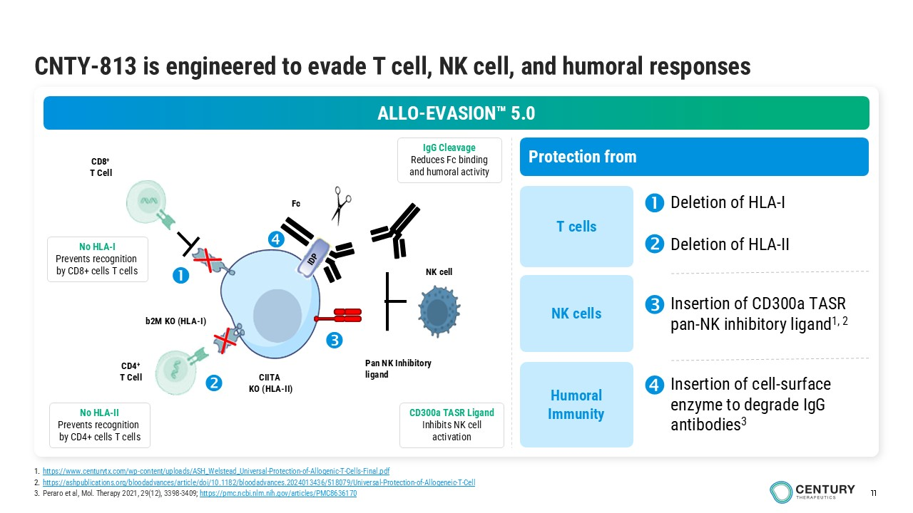
11 CNTY - 813 is engineered to evade T cell, NK cell, and humoral responses b2M KO (HLA - I) CIITA KO (HLA - II) CD8 + T Cell CD4 + T Cell Pan NK Inhibitory ligand Fc NK cell No HLA - I Prevents recognition by CD8+ cells T cells No HLA - II Prevents recognition by CD4+ cells T cells IgG Cleavage Reduces Fc binding and humoral activity CD300a TASR Ligand Inhibits NK cell activation Protection from T cells NK cells Humoral Immunity ALLO - EVASION 5.0 Insertion of CD300a TASR pan - NK inhibitory ligand 1, 2 Insertion of cell - surface enzyme to degrade IgG antibodies 3 Deletion of HLA - I Deletion of HLA - II 1. https://www.centurytx.com/wp - content/uploads/ASH_Welstead_Universal - Protection - of - Allogenic - T - Cells - Final.pdf 2. https://ashpublications.org/bloodadvances/article/doi/10.1182/bloodadvances.2024013436/518079/Universal - Protection - of - Allogeneic - T - Cell 3. Peraro et al, Mol. Therapy 2021, 29(12), 3398 - 3409; https://pmc.ncbi.nlm.nih.gov/articles/PMC8636170
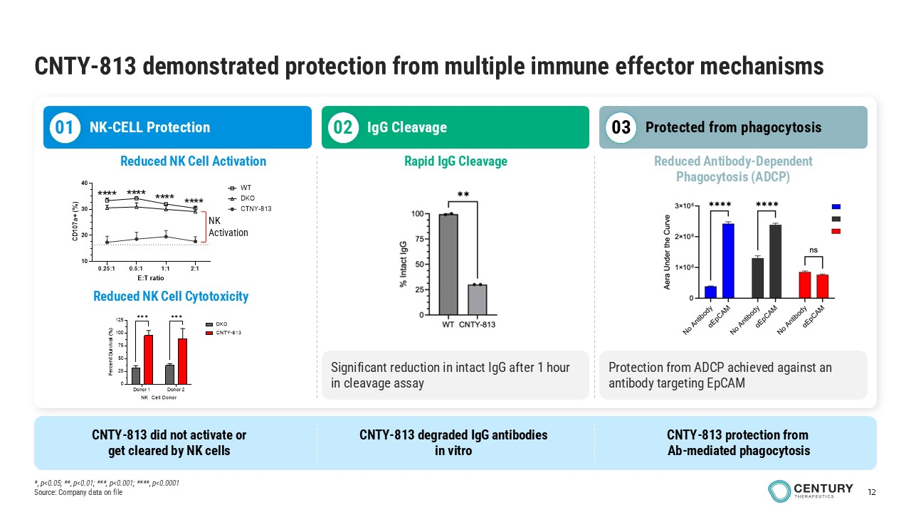
12 CNTY - 813 demonstrated protection from multiple immune effector mechanisms Reduced NK Cell Activation NK - CELL Protection IgG Cleavage Protected from phagocytosis Rapid IgG Cleavage Reduced Antibody - Dependent Phagocytosis (ADCP) 01 02 03 Reduced NK Cell Cytotoxicity 0.25:1 0.5:1 1:1 2:1 10 20 30 40 E:T ratio C D 1 0 7 a + ( % ) WT DKO CTNY-813 NK Activation **** **** **** **** Donor 1 Donor 2 0 25 50 75 100 125 NK Cell Donor P e r c e n t S u r v i v a l ( % ) DKO CNTY-813 ✱✱✱ ✱✱✱ Significant reduction in intact IgG after 1 hour in cleavage assay Protection from ADCP achieved against an antibody targeting EpCAM CNTY - 813 did not activate or get cleared by NK cells CNTY - 813 degraded IgG antibodies in vitro CNTY - 813 protection from Ab - mediated phagocytosis *, p<0.05; **, p<0.01; ***, p<0.001; ****, p<0.0001 Source: Company data on file
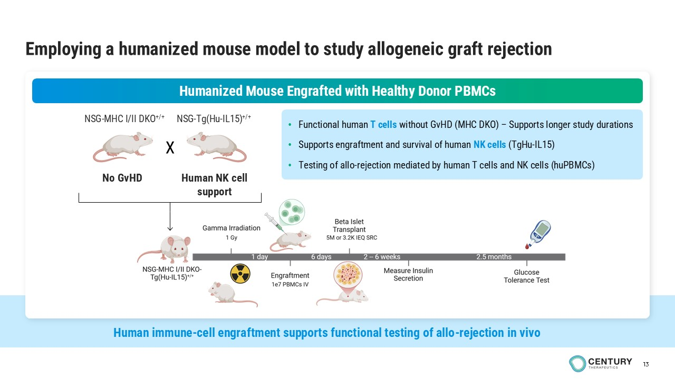
13 Humanized Mouse Engrafted with Healthy Donor PBMCs Employing a humanized mouse model to study allogeneic graft rejection • Functional human T cells without GvHD (MHC DKO) – Supports longer study durations • Supports engraftment and survival of human NK cells (TgHu - IL15) • Testing of allo - rejection mediated by human T cells and NK cells ( huPBMCs ) NSG - MHC I/II DKO +/+ NSG - Tg (Hu - IL15) +/+ X No GvHD Human NK cell support Human immune - cell engraftment supports functional testing of allo - rejection in vivo
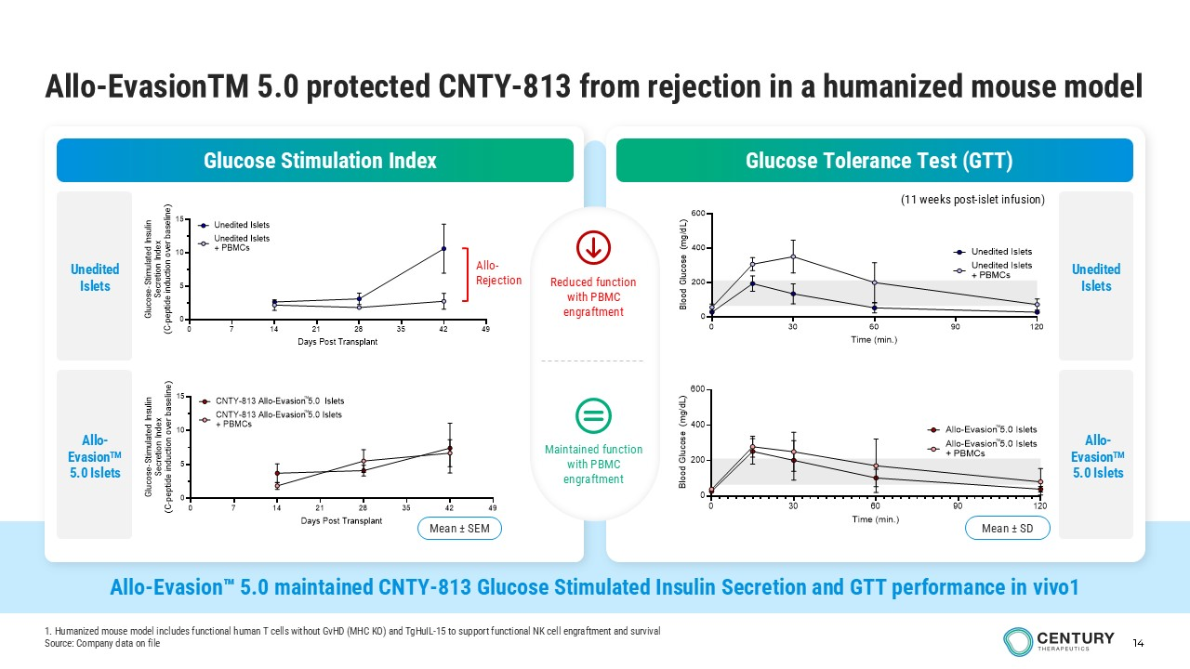
14 Allo - Evasion 5.0 maintained CNTY - 813 Glucose Stimulated Insulin Secretion and GTT performance in vivo1 Allo - EvasionTM 5.0 protected CNTY - 813 from rejection in a humanized mouse model Glucose Stimulation Index Glucose Tolerance Test (GTT) (11 weeks post - islet infusion) Reduced function with PBMC engraftment Maintained function with PBMC engraftment 0 7 14 21 28 35 42 49 0 5 10 15 Days Post Transplant G l u c o s e - S t i m u l a t e d I n s u l i n S e c r e t i o n I n d e x ( C - p e p t i d e i n d u c t i o n o v e r b a s e l i n e ) Unedited Islets + PBMCs Unedited Islets Allo - Rejection 0 7 14 21 28 35 42 49 0 5 10 15 Days Post Transplant G l u c o s e - S t i m u l a t e d I n s u l i n S e c r e t i o n I n d e x ( C - p e p t i d e i n d u c t i o n o v e r b a s e l i n e ) CNTY-813 Allo-Evasion 5.0 Islets + PBMCs CNTY-813 Allo-Evasion 5.0 Islets Mean ± SEM TM TM 0 30 60 90 120 0 200 400 600 Time (min.) B l o o d G l u c o s e ( m g / d L ) Unedited Islets + PBMCs Unedited Islets 0 30 60 90 120 0 200 400 600 Time (min.) B l o o d G l u c o s e ( m g / d L ) Allo-Evasion 5.0 Islets + PBMCs Allo-Evasion 5.0 Islets Mean ± SD TM TM Unedited Islets Allo - Evasion TM 5.0 Islets Unedited Islets Allo - Evasion TM 5.0 Islets 1. Humanized mouse model includes functional human T cells without GvHD (MHC KO) and TgHuIL - 15 to support functional NK cell eng raftment and survival Source: Company data on file
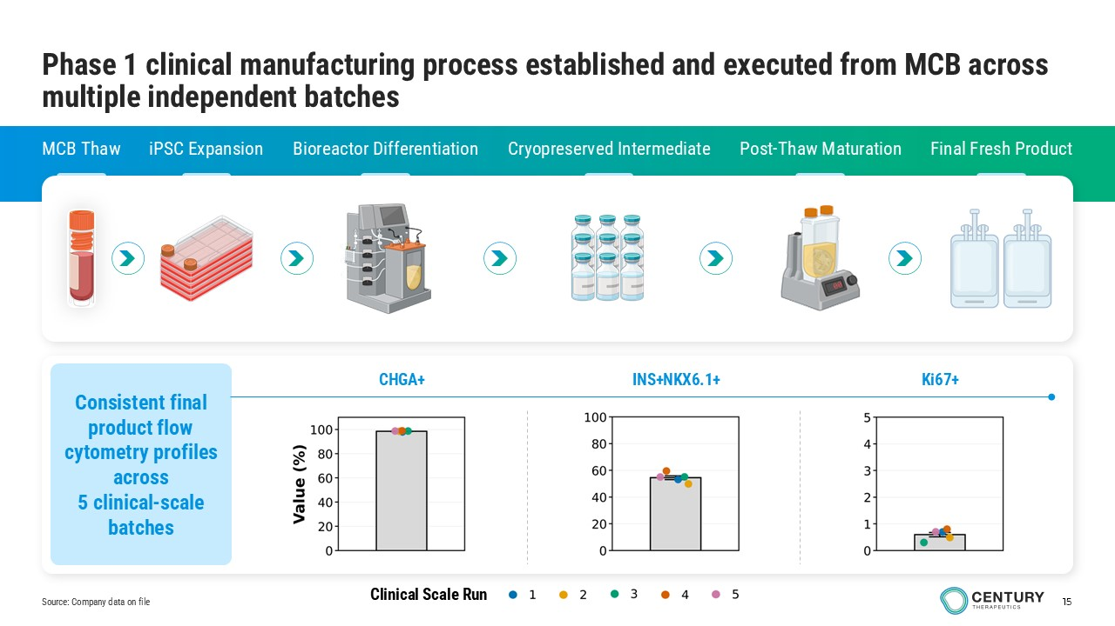
15 Phase 1 clinical manufacturing process established and executed from MCB across multiple independent batches MCB Thaw iPSC Expansion Bioreactor Differentiation Cryopreserved Intermediate Post - Thaw Maturation Final Fresh Product Consistent final product flow cytometry profiles across 5 clinical - scale batches Source: Company data on file Clinical Scale Run CHGA+ INS+NKX6.1+ Ki67+
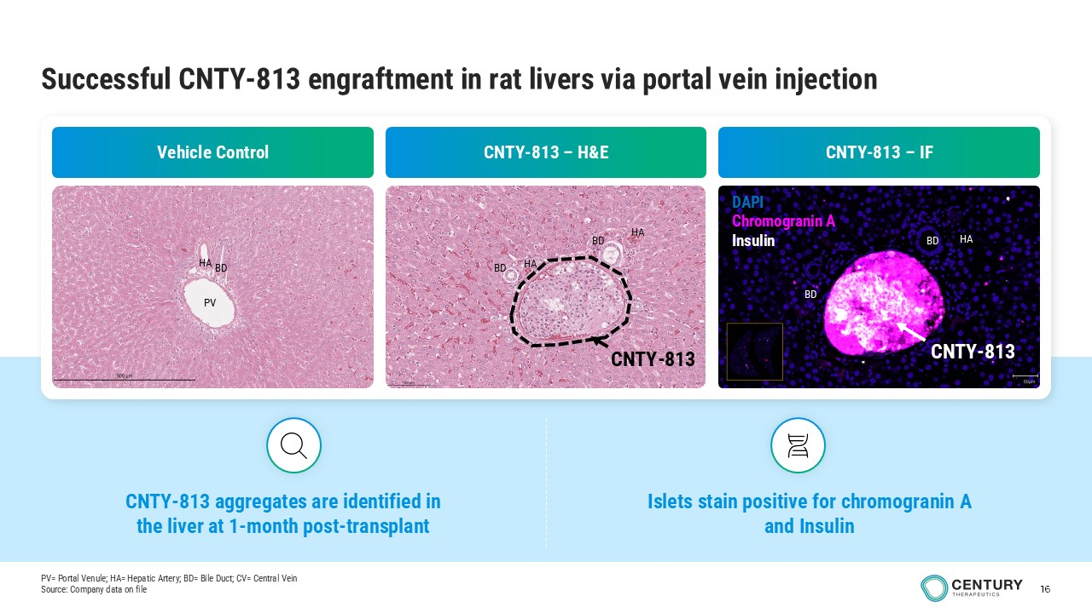
16 Successful CNTY - 813 engraftment in rat livers via portal vein injection Vehicle Control CNTY - 813 – H&E CNTY - 813 – IF PV HA BD HA HA BD BD CNTY - 813 BD HA BD CNTY - 813 BD HA BD DAPI Chromogranin A Insulin CNTY - 813 CNTY - 813 aggregates are identified in the liver at 1 - month post - transplant Islets stain positive for chromogranin A and Insulin PV= Portal Venule; HA= Hepatic Artery; BD= Bile Duct; CV= Central Vein Source: Company data on file
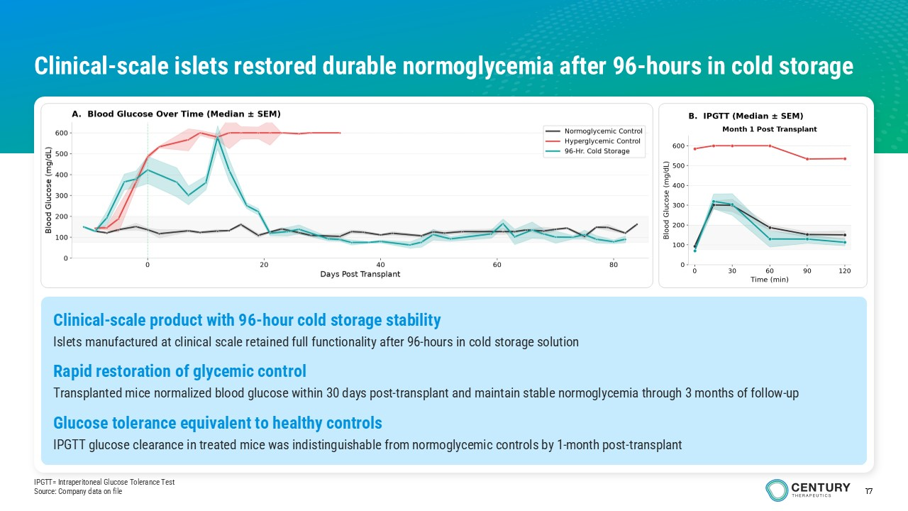
17 IPGTT= Intraperitoneal Glucose Tolerance Test Source: Company data on file Clinical - scale islets restored durable normoglycemia after 96 - hours in cold storage Clinical - scale product with 96 - hour cold storage stability Islets manufactured at clinical scale retained full functionality after 96 - hours in cold storage solution Rapid restoration of glycemic control Transplanted mice normalized blood glucose within 30 days post - transplant and maintain stable normoglycemia through 3 months of follow - up Glucose tolerance equivalent to healthy controls IPGTT glucose clearance in treated mice was indistinguishable from normoglycemic controls by 1 - month post - transplant
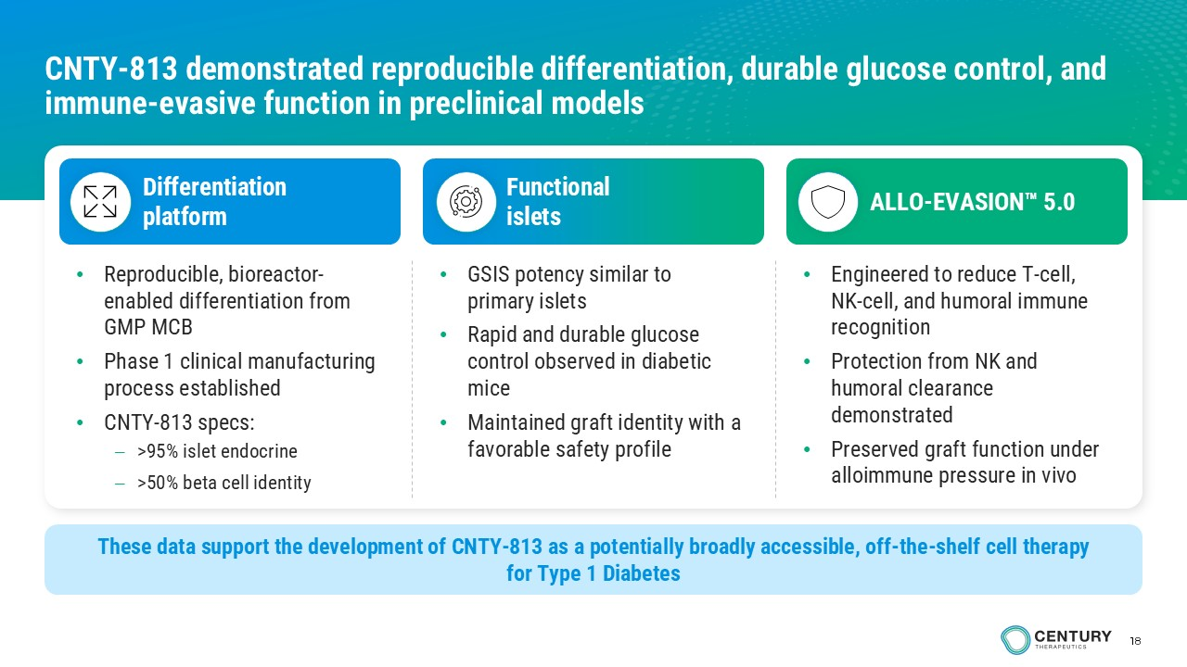
18 CNTY - 813 demonstrated reproducible differentiation, durable glucose control, and immune - evasive function in preclinical models • Reproducible, bioreactor - enabled differentiation from GMP MCB • Phase 1 clinical manufacturing process established • CNTY - 813 specs: – >95% islet endocrine – >50% beta cell identity Differentiation platform Functional islets ALLO - EVASION 5.0 • GSIS potency similar to primary islets • Rapid and durable glucose control observed in diabetic mice • Maintained graft identity with a favorable safety profile • Engineered to reduce T - cell, NK - cell, and humoral immune recognition • Protection from NK and humoral clearance demonstrated • Preserved graft function under alloimmune pressure in vivo These data support the development of CNTY - 813 as a potentially broadly accessible, off - the - shelf cell therapy for Type 1 Diabetes
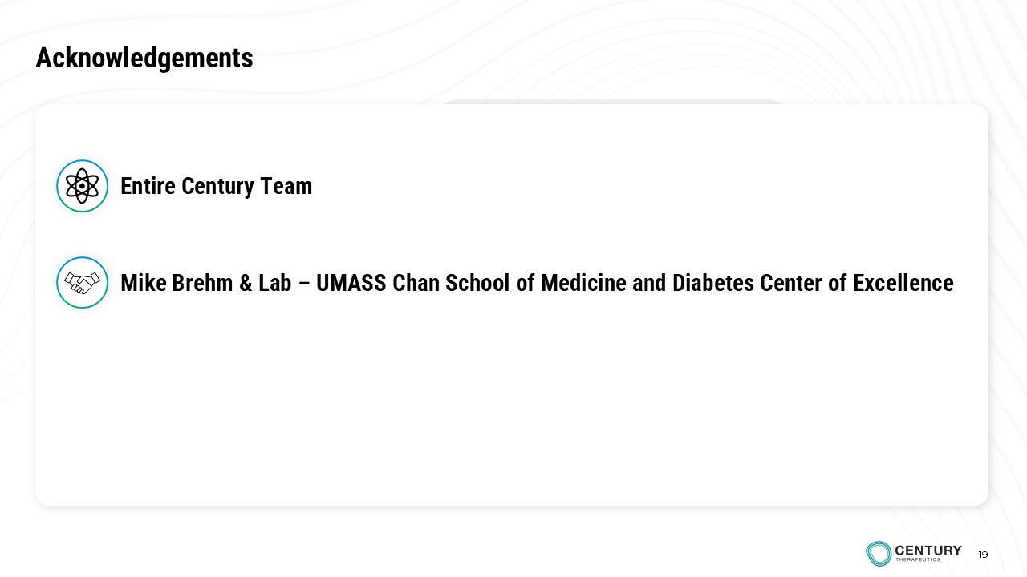
19 Acknowledgements Mike Brehm & Lab – UMASS Chan School of Medicine and Diabetes Center of Excellence 19 Entire Century Team

