UNITED STATES
SECURITIES AND EXCHANGE COMMISSION
Washington, D.C. 20549

SCHEDULE 14A

Proxy Statement Pursuant to Section 14(a) of the Securities Exchange Act of 1934

☒ Filed by the Registrant ☐ Filed by a Party other than the Registrant

Check the appropriate box:

☐ Preliminary Proxy Statement
☐ Confidential, for Use of the Commission Only (as permitted by Rule 14a-6(e)(2))
☐ Definitive Proxy Statement
☒ Definitive Additional Materials
☐ Soliciting Material under §240.14a-12

Century therapeutics, INC.
(Name of Registrant as Specified In Its Charter)

Payment of Filing Fee (Check all boxes that apply):
☒ | No fee required
☐ | Fee paid previously with preliminary materials
☐ | Fee computed on table in exhibit required by Item 25(b) per Exchange Act Rules 14a-6(i)(1) and 0-11

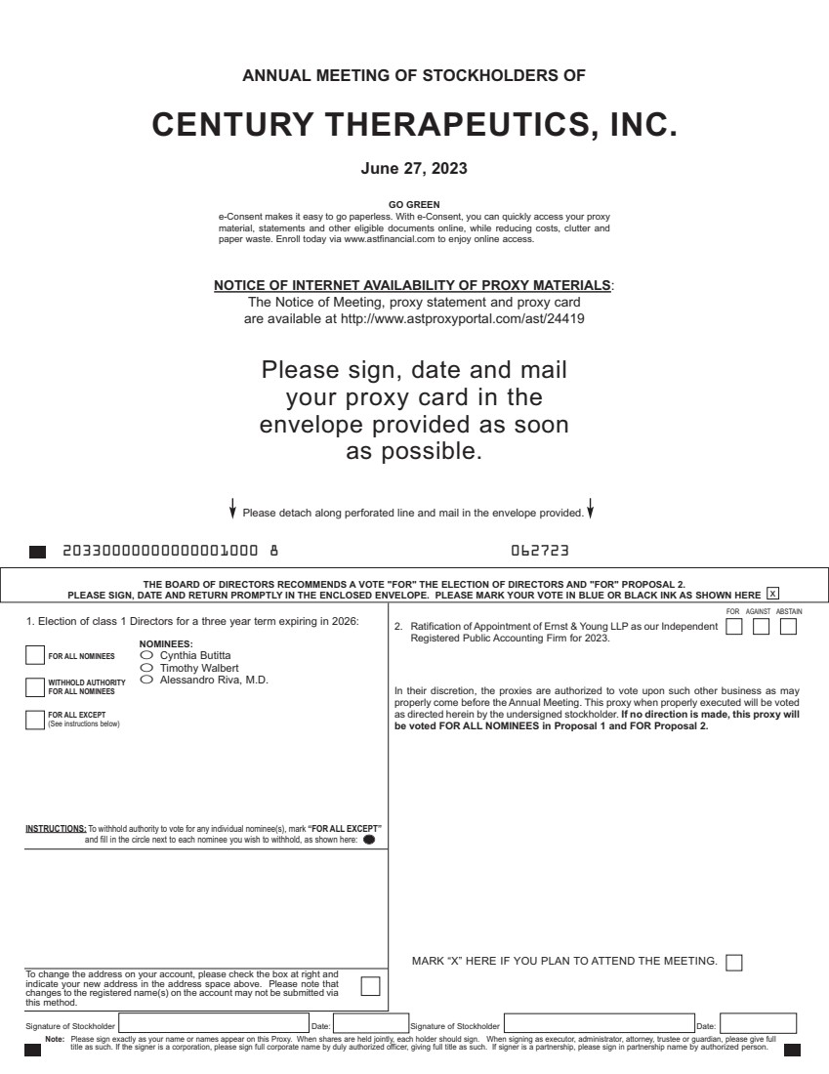 | ANNUAL MEETING OF STOCKHOLDERS OF CENTURY THERAPEUTICS, INC. June 27, 2023 NOTICE OF INTERNET AVAILABILITY OF PROXY MATERIALS: The Notice of Meeting, proxy statement and proxy card are available at http://www.astproxyportal.com/ast/24419 Please sign, date and mail your proxy card in the envelope provided as soon as possible. Signature of Stockholder Date: Signature of Stockholder Date: Note: Please sign exactly as your name or names appear on this Proxy. When shares are held jointly, each holder should sign. When signing as executor, administrator, attorney, trustee or guardian, please give full title as such. If the signer is a corporation, please sign full corporate name by duly authorized officer, giving full title as such. If signer is a partnership, please sign in partnership name by authorized person. To change the address on your account, please check the box at right and indicate your new address in the address space above. Please note that changes to the registered name(s) on the account may not be submitted via this method. INSTRUCTIONS: To withhold authority to vote for any individual nominee(s), mark “FOR ALL EXCEPT” and fill in the circle next to each nominee you wish to withhold, as shown here: THE BOARD OF DIRECTORS RECOMMENDS A VOTE "FOR" THE ELECTION OF DIRECTORS AND "FOR" PROPOSAL 2. PLEASE SIGN, DATE AND RETURN PROMPTLY IN THE ENCLOSED ENVELOPE. PLEASE MARK YOUR VOTE IN BLUE OR BLACK INK AS SHOWN HERE x Please detach along perforated line and mail in the envelope provided. 20330000000000001000 8 062723 GO GREEN e-Consent makes it easy to go paperless. With e-Consent, you can quickly access your proxy material, statements and other eligible documents online, while reducing costs, clutter and paper waste. Enroll today via www.astfinancial.com to enjoy online access. 1. Election of class 1 Directors for a three year term expiring in 2026: O Cynthia Butitta O Timothy Walbert O Alessandro Riva, M.D. 2. Ratification of Appointment of Ernst & Young LLP as our Independent Registered Public Accounting Firm for 2023. In their discretion, the proxies are authorized to vote upon such other business as may properly come before the Annual Meeting. This proxy when properly executed will be voted as directed herein by the undersigned stockholder. If no direction is made, this proxy will be voted FOR ALL NOMINEES in Proposal 1 and FOR Proposal 2. FOR AGAINST ABSTAIN FOR ALL NOMINEES WITHHOLD AUTHORITY FOR ALL NOMINEES FOR ALL EXCEPT (See instructions below) NOMINEES: MARK “X” HERE IF YOU PLAN TO ATTEND THE MEETING.
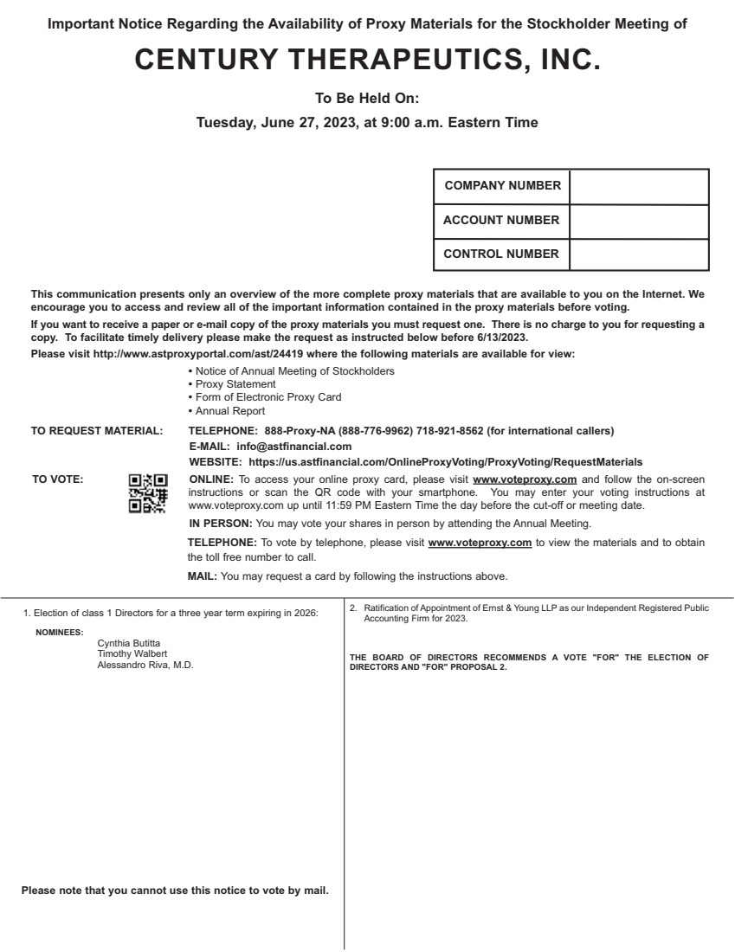 | 1. Election of class 1 Directors for a three year term expiring in 2026: Cynthia Butitta Timothy Walbert Alessandro Riva, M.D. 2. Ratification of Appointment of Ernst & Young LLP as our Independent Registered Public Accounting Firm for 2023. THE BOARD OF DIRECTORS RECOMMENDS A VOTE "FOR" THE ELECTION OF DIRECTORS AND "FOR" PROPOSAL 2. NOMINEES: This communication presents only an overview of the more complete proxy materials that are available to you on the Internet. We encourage you to access and review all of the important information contained in the proxy materials before voting. If you want to receive a paper or e-mail copy of the proxy materials you must request one. There is no charge to you for requesting a copy. To facilitate timely delivery please make the request as instructed below before 6/13/2023. Please visit http://www.astproxyportal.com/ast/24419 where the following materials are available for view: • Notice of Annual Meeting of Stockholders • Proxy Statement • Form of Electronic Proxy Card • Annual Report TO REQUEST MATERIAL: TELEPHONE: 888-Proxy-NA (888-776-9962) 718-921-8562 (for international callers) E-MAIL: info@astfinancial.com WEBSITE: https://us.astfinancial.com/OnlineProxyVoting/ProxyVoting/RequestMaterials TO VOTE: ONLINE: To access your online proxy card, please visit www.voteproxy.com and follow the on-screen instructions or scan the QR code with your smartphone. You may enter your voting instructions at www.voteproxy.com up until 11:59 PM Eastern Time the day before the cut-off or meeting date. IN PERSON: You may vote your shares in person by attending the Annual Meeting. TELEPHONE: To vote by telephone, please visit www.voteproxy.com to view the materials and to obtain the toll free number to call. MAIL: You may request a card by following the instructions above. COMPANY NUMBER ACCOUNT NUMBER CONTROL NUMBER JOHN SMITH 1234 MAIN STREET APT. 203 NEW YORK, NY 10038 Please note that you cannot use this notice to vote by mail. Important Notice Regarding the Availability of Proxy Materials for the Stockholder Meeting of CENTURY THERAPEUTICS, INC. To Be Held On: Tuesday, June 27, 2023, at 9:00 a.m. Eastern Time

