UNITED STATES
SECURITIES AND EXCHANGE COMMISSION
Washington, D.C. 20549

SCHEDULE 14A

Proxy Statement Pursuant to Section 14(a) of
the Securities Exchange Act of 1934 (Amendment No. )

Filed by the Registrant ☒
Filed by a Party other than the Registrant ☐
Check the appropriate box:
☐ | Preliminary Proxy Statement
☐ | Confidential, for Use of the Commission Only (as permitted by Rule 14a-6(e)(2))
☐ | Definitive Proxy Statement
☒ | Definitive Additional Materials
☐ | Soliciting Material under §240.14a-12
CENTURY THERAPEUTICS, INC.
(Name of Registrant as Specified in Its Charter)
(Name of Person(s) Filing Proxy Statement, if Other Than the Registrant)

Payment of Filing Fee (Check all boxes that apply):
☒ | No fee required
☐ | Fee paid previously with preliminary materials
☐ | Fee computed on table in exhibit required by Item 25(b) per Exchange Act Rules 14a-6(i)(1) and 0-11

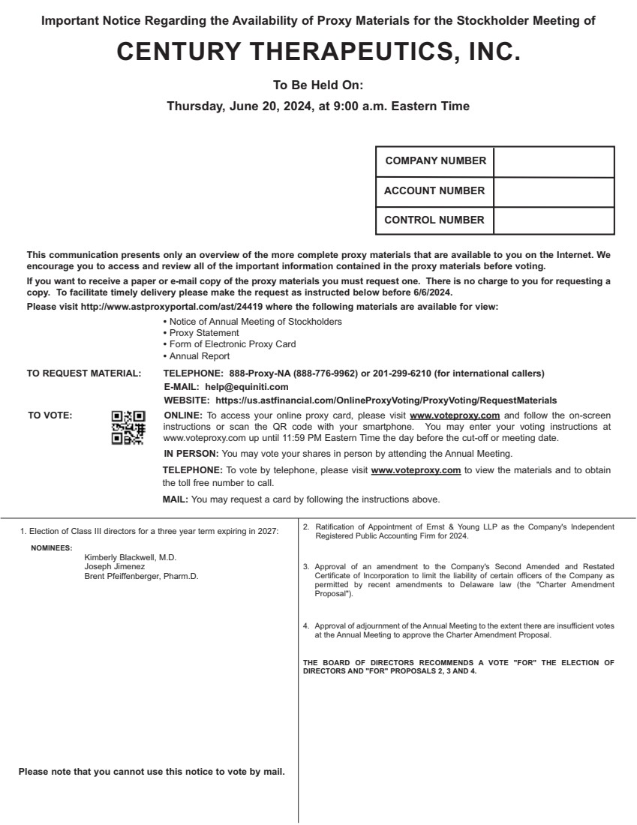 | 1. Election of Class III directors for a three year term expiring in 2027: Kimberly Blackwell, M.D. Joseph Jimenez Brent Pfeiffenberger, Pharm.D. 2. Ratification of Appointment of Ernst & Young LLP as the Company's Independent Registered Public Accounting Firm for 2024. 3. Approval of an amendment to the Company's Second Amended and Restated Certificate of Incorporation to limit the liability of certain officers of the Company as permitted by recent amendments to Delaware law (the "Charter Amendment Proposal"). 4. Approval of adjournment of the Annual Meeting to the extent there are insufficient votes at the Annual Meeting to approve the Charter Amendment Proposal. THE BOARD OF DIRECTORS RECOMMENDS A VOTE "FOR" THE ELECTION OF DIRECTORS AND "FOR" PROPOSALS 2, 3 AND 4. NOMINEES: This communication presents only an overview of the more complete proxy materials that are available to you on the Internet. We encourage you to access and review all of the important information contained in the proxy materials before voting. If you want to receive a paper or e-mail copy of the proxy materials you must request one. There is no charge to you for requesting a copy. To facilitate timely delivery please make the request as instructed below before 6/6/2024. Please visit http://www.astproxyportal.com/ast/24419 where the following materials are available for view: • Notice of Annual Meeting of Stockholders • Proxy Statement • Form of Electronic Proxy Card • Annual Report TO REQUEST MATERIAL: TELEPHONE: 888-Proxy-NA (888-776-9962) or 201-299-6210 (for international callers) E-MAIL: help@equiniti.com WEBSITE: https://us.astfinancial.com/OnlineProxyVoting/ProxyVoting/RequestMaterials TO VOTE: ONLINE: To access your online proxy card, please visit www.voteproxy.com and follow the on-screen instructions or scan the QR code with your smartphone. You may enter your voting instructions at www.voteproxy.com up until 11:59 PM Eastern Time the day before the cut-off or meeting date. IN PERSON: You may vote your shares in person by attending the Annual Meeting. TELEPHONE: To vote by telephone, please visit www.voteproxy.com to view the materials and to obtain the toll free number to call. MAIL: You may request a card by following the instructions above. COMPANY NUMBER ACCOUNT NUMBER CONTROL NUMBER JOHN SMITH 1234 MAIN STREET APT. 203 NEW YORK, NY 10038 Please note that you cannot use this notice to vote by mail. Important Notice Regarding the Availability of Proxy Materials for the Stockholder Meeting of CENTURY THERAPEUTICS, INC. To Be Held On: Thursday, June 20, 2024, at 9:00 a.m. Eastern Time

