SEC Form 3
FORM 3 | UNITED STATES SECURITIES AND EXCHANGE
 | COMMISSION
 | COMMISSION |  | OMB APPROVAL
 | Washington, D.C. 20549
 | Washington, D.C. 20549 |  | OMB Number: | 3235-
 | INITIAL STATEMENT OF BENEFICIAL OWNERSHIP OF |  | OMB Number: | 0104
 | INITIAL STATEMENT OF BENEFICIAL OWNERSHIP OF |  | Estimated average burden
 | SECURITIES |  |  | 0.5

hours per
response:

Filed pursuant to Section 16(a) of the Securities Exchange Act of 1934
or Section 30(h) of the Investment Company Act of 1940
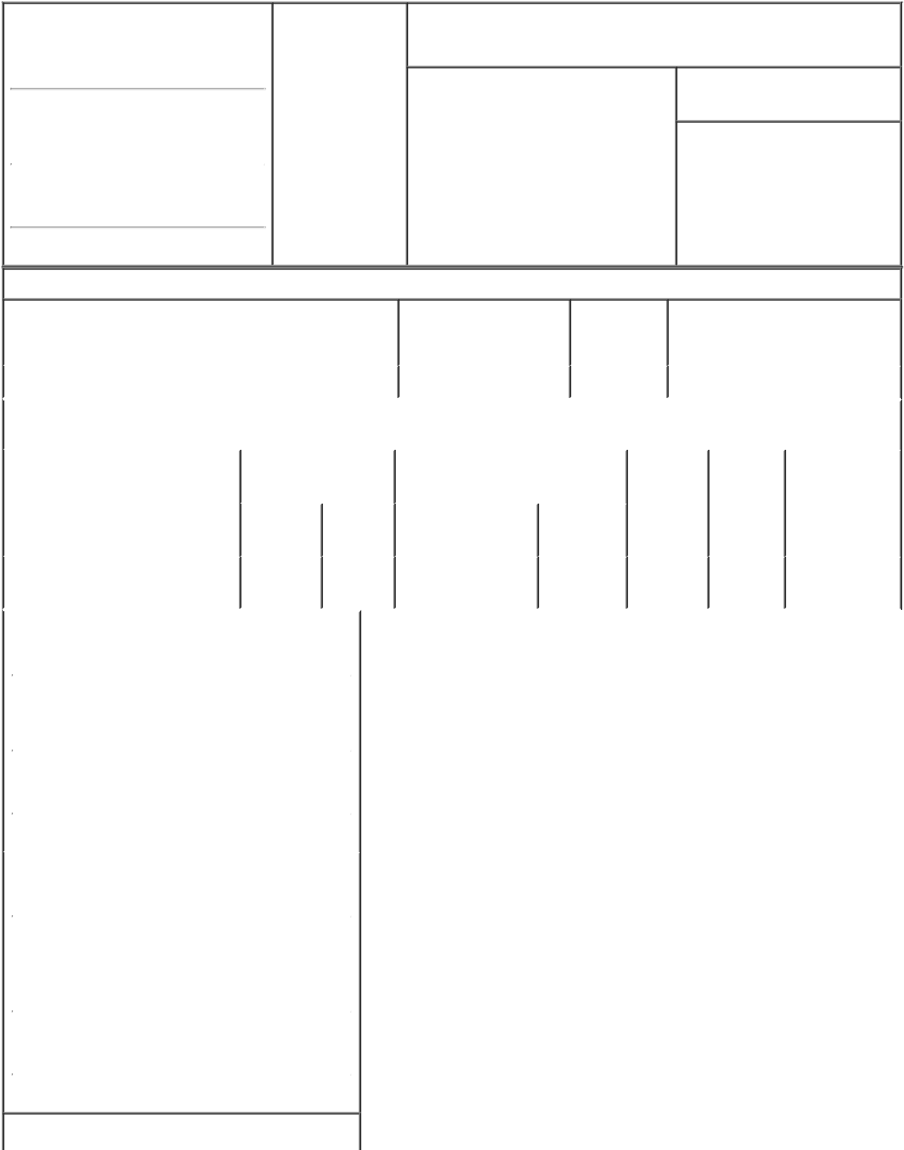

1. Name and Address of Reporting Person |  |  | * |  | 2. Date of Event
 |  |  |  |  | Requiring Statement
 | FUJIFILM Cellular Dynamics, |  |  |  | Requiring Statement
 |  |  |  |  | (Month/Day/Year)
 | Inc. |  |  |  | 06/17/2021

3. Issuer Name and Ticker or Trading Symbol

Century Therapeutics, Inc. [ IPSC ]

(Last) | (First) | (Middle)
525 SCIENCE DRIVE
(Street)
MADISON WI |  | 53711

- Relationship of Reporting Person(s) to Issuer
(Check all applicable)

Director X 10% Owner

Officer (give Other (specify
title below) below)

- If Amendment, Date of Original Filed (Month/Day/Year)

- Individual or Joint/Group Filing (Check Applicable Line)

Form filed by One Reporting Person

- Form filed by More than One Reporting Person

(City) (State) (Zip)

Table I - Non-Derivative Securities Beneficially Owned

 | 1. Title of Security (Instr. 4) |  |  |  |  |  |  |  |  |  |  | 2. Amount of Securities | 3. Ownership |  |  | 4. Nature of Indirect Beneficial
 |  |  |  |  |  |  |  |  |  |  |  | Beneficially Owned (Instr. Form: Direct |  |  |  | Ownership (Instr. 5)
 |  |  |  |  |  |  |  |  |  |  |  | 4) | (D) or Indirect
 |  |  |  |  |  |  |  |  |  |  |  |  | (I) (Instr. 5)
 | Common Stock |  |  |  |  |  |  |  |  |  |  | 2,980,803 | _{D}(1)
 |  |  |  |  |  |  | Table II - Derivative Securities Beneficially Owned
 |  |  |  |  |  | (e.g., puts, calls, warrants, options, convertible securities)
 | 1. Title of Derivative Security (Instr. 4) |  |  |  |  |  | 2. Date Exercisable and |  |  |  |  | 3. Title and Amount of Securities |  |  | 4. |  | 5. | 6. Nature of
 |  |  |  |  |  |  | Expiration Date |  |  |  |  | Underlying Derivative Security (Instr. |  |  | Conversion |  | Ownership | Indirect
 |  |  |  |  |  |  | (Month/Day/Year) |  |  |  |  | 4) |  |  | or Exercise |  | Form: | Beneficial
 |  |  |  |  |  |  |  |  |  |  |  |  |  |  | Price of |  | Direct (D) | Ownership (Instr.
 |  |  |  |  |  |  |  |  |  |  |  |  | Amount or |  |  |  | Direct (D)
 |  |  |  |  |  |  |  |  |  |  |  |  |  |  | Derivative |  | or Indirect | 5)
 |  |  |  |  |  |  | Date |  | Expiration |  |  | Title | Number of |  | Security |  | (I) (Instr. 5)
 |  |  |  |  |  |  | Exercisable |  | Date |  |  | Title | Shares
 | Series A Convertible Preferred |  |  |  |  | (2) |  |  | (2) |  |  | Common Stock | 3,974,404⁽²⁾ |  | (2) |  | _{D}(1)
 | Stock |  |  |  |  |  |  |  |  |  |  | Common Stock | 3,974,404⁽²⁾ |  | (2) |  | _{D}(1)
 | 1. Name and Address of Reporting Person*
 |  |  | FUJIFILM Cellular Dynamics, Inc.
 |  |  | (Last) | (First) |  |  | (Middle)
 |  |  | 525 SCIENCE DRIVE
 | (Street)
 |  |  | MADISON | WI |  | 53711
 |  |  | (City) | (State) |  |  | (Zip)
 | 1. Name and Address of Reporting Person*
 |  |  | FUJIFILM Corp
 |  |  | (Last) | (First) |  |  | (Middle)
 |  |  | 7-3 AKASAKA 9-CHOME
 |  |  | MINATO-KU
 | (Street)
 |  |  | TOKYO | M0 |  | 107-0052
 |  |  | (City) | (State) |  |  | (Zip)

1. Name and Address of Reporting Person*

FUJIFILM Holdings America Corp


 |  | (Last) | (First) | (Middle)
 |  | 200 SUMMIT LAKE DRIVE
(Street)
 |  | VALHALLA | NY | 10595-1356
 |  | (City) | (State) | (Zip)
1. Name and Address of Reporting Person*
 |  | FUJIFILM Holdings Corp
 |  | (Last) | (First) | (Middle)
 |  | 7-3, AKASAKA 9-CHOME, MINATO-KU
(Street)
 |  | TOKYO | M0 | 107-0052
 |  | (City) | (State) | (Zip)

Explanation of Responses:

- FUJIFILM Cellular Dynamics, Inc. is the direct owner of the reported securities. FUJIFILM Cellular Dynamics, Inc. is a wholly owned subsidiary of FUJIFILM Holdings America Corporation; FUJIFILM Holdings America Corporation is a wholly owned subsidiary of FUJIFILM Corporation; and FUJIFILM Corporation is a wholly owned subsidiary of FUJIFILM Holdings Corporation. Accordingly, each of FUJIFILM Holdings America Corporation, FUJIFILM Corporation and FUJIFILM Holdings Corporation beneficially owns the reported securities indirectly.

- FUJIFILM Cellular Dynamics, Inc. holds 10,000,000 shares of the issuer's Series A Convertible Preferred Stock. The Series A Convertible Preferred Stock is immediately convertible into shares of the issuer's common stock and has no expiration date. The 10,000,000 shares of Series A Convertible Preferred Stock will be automatically converted into 3,974,404 shares of the issuer's common stock upon the closing of the issuer's initial public offering.

Remarks:

Exhibit List: Exhibit 24 - Joint Filing Agreement and Power of Attorney Exhibit 99 - Joint Filer Information

 | /s/ Takeshi Yamamoto,
 | President and CEO of
 | FUJIFILM Cellular
 | Dynamics, Inc. and
 | attorney-in-fact for |  |  |  |  |  |  |  |  | 06/17/2021
 | FUJIFILM Holdings
 | America Corporation,
 | FUJIFILM Corporation
 | and FUJIFILM Holdings
 | Corporation
 | ** Signature of Reporting |  |  |  |  |  |  |  |  |  | Date
 | Person |  |  |  |  |  |  |  |  |  | Date
Reminder: Report on a separate line for each class of securities beneficially owned directly or indirectly.
* If the form is filed by more than one reporting person, see Instruction 5 (b)(v).

- Intentional misstatements or omissions of facts constitute Federal Criminal Violations See 18 U.S.C. 1001 and 15 U.S.C. 78ff(a). Note: File three copies of this Form, one of which must be manually signed. If space is insufficient, see Instruction 6 for procedure.
Persons who respond to the collection of information contained in this form are not required to respond unless the form displays a currently valid OMB Number.

Exhibit 24
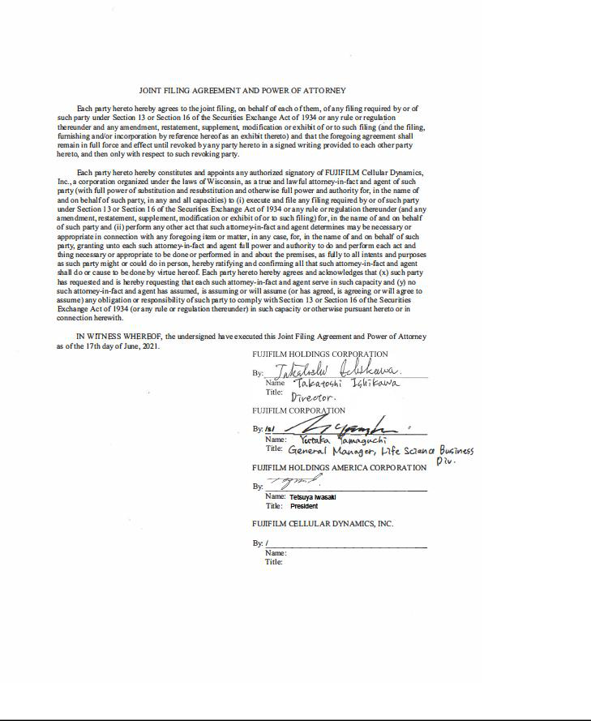

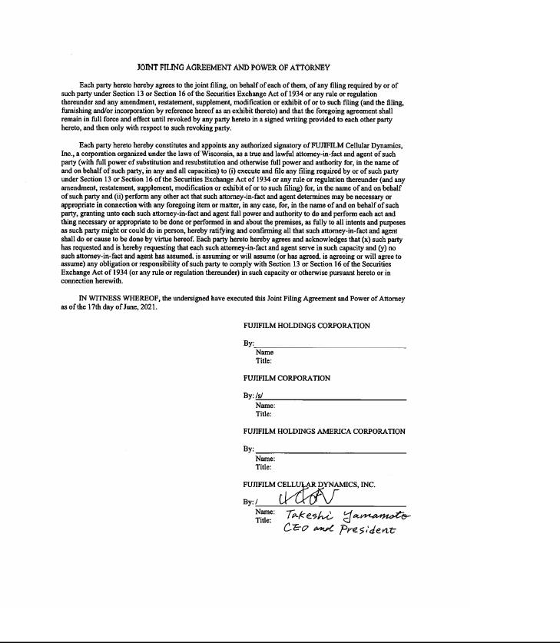

EXHIBIT 99.1

JOINT FILER INFORMATION

Name: FUJIFILM Cellular Dynamics, Inc.

Address: 500 Science Drive, Madison, WI 53711

Name: FUJIFILM Holdings America Corporation

Address: 200 Summit Lake Drive, Valhalla, New York, 10595-1356

Name: FUJIFILM Corporation

Address: 7-3 Akasaka 9-chome, Minato-ku, Tokyo 107-0052, Japan

Name: FUJIFILM Holdings Corporation

Address: 7-3 Akasaka 9-chome, Minato-ku, Tokyo 107-0052, Japan

