SEC Form 3
FORM 3 | UNITED STATES SECURITIES AND EXCHANGE
 | COMMISSION
 | COMMISSION |  | OMB APPROVAL
 | Washington, D.C. 20549
 | Washington, D.C. 20549 |  | OMB Number: | 3235-
 |  |  | OMB Number: | 0104
 | INITIAL STATEMENT OF BENEFICIAL OWNERSHIP OF |  |  | 0104
 | INITIAL STATEMENT OF BENEFICIAL OWNERSHIP OF |  | Estimated average burden
 | SECURITIES |  | response: | 0.5
 |  |  | hours per


Filed pursuant to Section 16(a) of the Securities Exchange Act of 1934

or Section 30(h) of the Investment Company Act of 1940
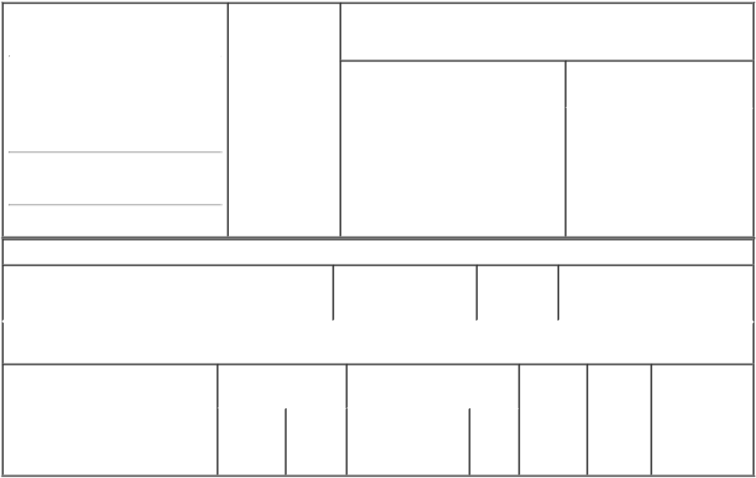

1. Name and Address of Reporting Person* |  |  | 2. Date of Event
 | Pfeiffenberger Brent |  | Requiring Statement
 |  |  | (Month/Day/Year)
 |  |  | 12/04/2023

(Last) (First) (Middle)

C/O CENTURY THERAPEUTICS, INC.

25 N 38TH STREET, 11TH FLOOR

(Street)
PHILADELPHIA PA | 19104

3. Issuer Name and Ticker or Trading Symbol

Century Therapeutics, Inc. [ IPSC ]

4. Relationship of Reporting Person(s) to |  |  | 5. | If Amendment, Date of Original
Issuer |  |  | Filed (Month/Day/Year)
(Check all applicable)
X | Director | 10% Owner
X | Director | 10% Owner | 6. | Individual or Joint/Group Filing
X | Officer (give | Other (specify | 6.
X | Officer (give | Other (specify | (Check Applicable Line)
 | title below) | below) |  | X | Form filed by One Reporting
 | President and CEO |  |  | X | Form filed by One Reporting
 |  |  |  |  | Person
Form filed by More than One
Reporting Person

(City) (State) (Zip)

Table I - Non-Derivative Securities Beneficially Owned

 | 1. Title of Security (Instr. 4) | 2. Amount of Securities | 3. Ownership | 4. Nature of Indirect Beneficial
 |  | Beneficially Owned (Instr. | Form: Direct | Ownership (Instr. 5)
 |  | 4) | (D) or Indirect
 |  |  | (I) (Instr. 5)

Table II - Derivative Securities Beneficially Owned

(e.g., puts, calls, warrants, options, convertible securities)

1. Title of Derivative Security (Instr. 4) | 2. Date Exercisable and |  | 3. Title and Amount of Securities |  | 4. | 5. | 6. Nature of
 | Expiration Date |  | Underlying Derivative Security |  | Conversion | Ownership | Indirect Beneficial
 | (Month/Day/Year) |  | (Instr. 4) |  | or Exercise | Form: | Ownership (Instr.
 |  |  |  |  | Price of | Direct (D) | 5)
 |  |  |  | Amount | Price of | Direct (D) | 5)
 |  |  |  | Amount | Derivative | or Indirect
 |  |  |  | or | Security | (I) (Instr. 5)
 |  |  |  | Number
 | Date | Expiration |  | of
 | Exercisable | Date | Title | Shares

Explanation of Responses:

Remarks:

Exhibit 24 - Power of Attorney

No securities are beneficially owned.

 | /s/ Michael Diem, |  |  | 12/06/2023
 | Attorney-in-Fact |  |  | 12/06/2023
 | ** Signature of Reporting |  |  | Date
 | Person |  |  | Date
Reminder: Report on a separate line for each class of securities beneficially owned directly or indirectly.
* If the form is filed by more than one reporting person, see Instruction 5 (b)(v).

- Intentional misstatements or omissions of facts constitute Federal Criminal Violations See 18 U.S.C. 1001 and 15 U.S.C. 78ff(a). Note: File three copies of this Form, one of which must be manually signed. If space is insufficient, see Instruction 6 for procedure.

Persons who respond to the collection of information contained in this form are not required to respond unless the form displays a currently valid OMB Number.

Exhibit 24


