UNITED STATES
SECURITIES AND EXCHANGE COMMISSION
Washington, DC 20549

FORM 8-K

CURRENT REPORT
Pursuant to Section 13 or 15(d)
of the Securities Exchange Act of 1934

Date of Report (Date of earliest event reported): December 12, 2025

Century Therapeutics, Inc.
(Exact name of registrant as specified in its charter)

Delaware |  | 001-40498 |  | 84-2040295
(State or other jurisdiction of  incorporation or organization) |  | (Commission File Number) |  | (I.R.S. Employer  Identification No.)

25 North 38th Street, 11th Floor  Philadelphia, Pennsylvania |  | 19104
(Address of principal executive offices) |  | (Zip Code)

Registrant’s telephone number, including area code: (267) 817-5790

Not Applicable
(Former name or former address, if changed since last report)

Check the appropriate box below if the Form 8-K filing is intended to simultaneously satisfy the filing obligation of the registrant under any of the following provisions (see General Instruction A.2. below):

☐ | Written communications pursuant to Rule 425 under the Securities Act (17 CFR 230.425)
☐ | Soliciting material pursuant to Rule 14a-12 under the Exchange Act (17 CFR 240.14a-12)
☐ | Pre-commencement communications pursuant to Rule 14d-2(b) under the Exchange Act (17 CFR 240.14d-2(b))
☐ | Pre-commencement communications pursuant to Rule 13e-4(c) under the Exchange Act (17 CFR 240.13e-4(c))

Securities registered pursuant to Section 12(b) of the Act:

Title of Each Class |  | Trading Symbol |  | Name of Exchange on Which Registered
Common Stock, par value $0.0001 per share |  | IPSC |  | Nasdaq Capital Market

Indicate by check mark whether the registrant is an emerging growth company as defined in Rule 405 of the Securities Act of 1933 (§230.405 of this chapter) or Rule 12b-2 of the Securities Exchange Act of 1934 (§240.12b-2 of this chapter).

Emerging growth company x

If an emerging growth company, indicate by check mark if the registrant has elected not to use the extended transition period for complying with any new or revised financial accounting standards provided pursuant to Section 13(a) of the Exchange Act. ☐

Item 7.01 | Regulation FD Disclosure

On December 12, 2025, Century Therapeutics, Inc. (the “Company”) updated information reflected in a slide presentation, which is attached as Exhibit 99.1 to this Current Report on Form 8-K and is incorporated herein by reference. Representatives of the Company will use the updated presentation in various meetings with investors from time to time.

The information contained in this Item 7.01 (including Exhibit 99.1) is being furnished and shall not be deemed “filed” for purposes of Section 18 of the Securities Exchange Act of 1934, as amended (the “Exchange Act”), or otherwise subject to the liabilities of that section and shall not be deemed incorporated by reference in any filing under the Securities Act of 1933, as amended (the “Securities Act”) or the Exchange Act, except as shall be expressly set forth by specific reference in such filing.

Item 9.01 | Financial Statements and Exhibits

(d) Exhibits

Exhibit  No. |  | Document
99.1 |  | Investor Presentation of Century Therapeutics, Inc., dated December 12, 2025
104 |  | Cover Page Interactive Data File (embedded within the Inline XBRL document)

SIGNATURES

Pursuant to the requirements of the Securities Exchange Act of 1934, the registrant has duly caused this report to be signed on its behalf by the undersigned hereunto duly authorized.

 | CENTURY THERAPEUTICS, INC.
 | By: | /s/ Brent Pfeiffenberger, PharmD, MBA
 | Name: | Brent Pfeiffenberger, PharmD, MBA
 | Title: | President and Chief Executive Officer

Date: December 12, 2025

Exhibit 99.1

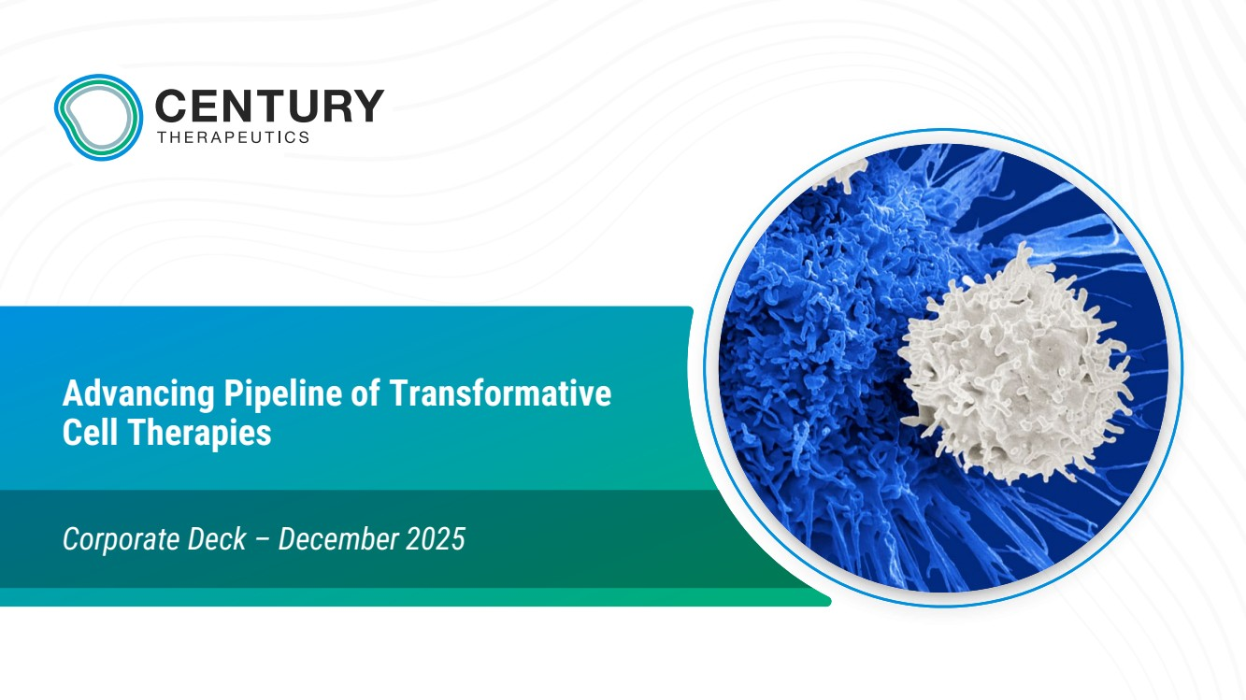 | Advancing Pipeline of Transformative Cell Therapies Corporate Deck – December 2025
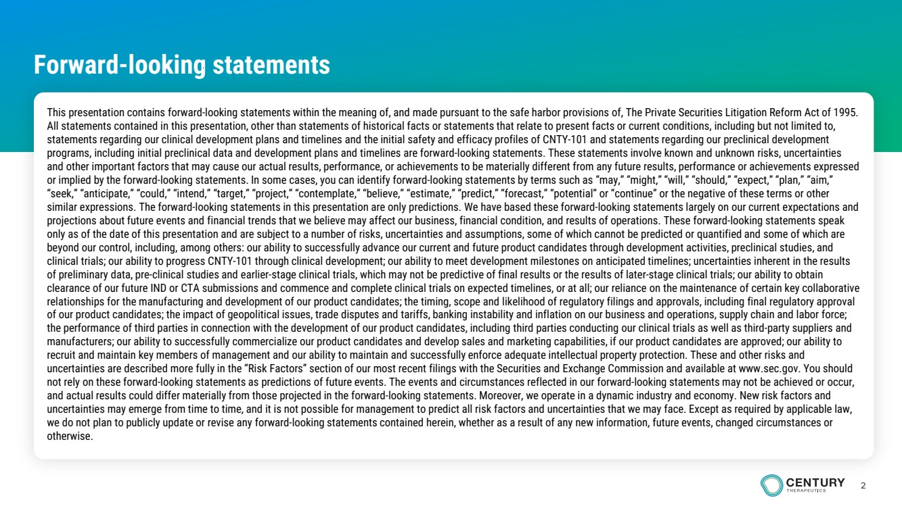 | 2 Forward-looking statements This presentation contains forward-looking statements within the meaning of, and made pursuant to the safe harbor provisions of, The Private Securities Litigation Reform Act of 1995. All statements contained in this presentation, other than statements of historical facts or statements that relate to present facts or current conditions, including but not limited to, statements regarding our clinical development plans and timelines and the initial safety and efficacy profiles of CNTY-101 and statements regarding our preclinical development programs, including initial preclinical data and development plans and timelines are forward-looking statements. These statements involve known and unknown risks, uncertainties and other important factors that may cause our actual results, performance, or achievements to be materially different from any future results, performance or achievements expressed or implied by the forward-looking statements. In some cases, you can identify forward-looking statements by terms such as “may,” “might,” “will,” “should,” “expect,” “plan,” “aim,” “seek,” “anticipate,” “could,” “intend,” “target,” “project,” “contemplate,” “believe,” “estimate,” “predict,” “forecast,” “potential” or “continue” or the negative of these terms or other similar expressions. The forward-looking statements in this presentation are only predictions. We have based these forward-looking statements largely on our current expectations and projections about future events and financial trends that we believe may affect our business, financial condition, and results of operations. These forward-looking statements speak only as of the date of this presentation and are subject to a number of risks, uncertainties and assumptions, some of which cannot be predicted or quantified and some of which are beyond our control, including, among others: our ability to successfully advance our current and future product candidates through development activities, preclinical studies, and clinical trials; our ability to progress CNTY-101 through clinical development; our ability to meet development milestones on anticipated timelines; uncertainties inherent in the results of preliminary data, pre-clinical studies and earlier-stage clinical trials, which may not be predictive of final results or the results of later-stage clinical trials; our ability to obtain clearance of our future IND or CTA submissions and commence and complete clinical trials on expected timelines, or at all; our reliance on the maintenance of certain key collaborative relationships for the manufacturing and development of our product candidates; the timing, scope and likelihood of regulatory filings and approvals, including final regulatory approval of our product candidates; the impact of geopolitical issues, trade disputes and tariffs, banking instability and inflation on our business and operations, supply chain and labor force; the performance of third parties in connection with the development of our product candidates, including third parties conducting our clinical trials as well as third-party suppliers and manufacturers; our ability to successfully commercialize our product candidates and develop sales and marketing capabilities, if our product candidates are approved; our ability to recruit and maintain key members of management and our ability to maintain and successfully enforce adequate intellectual property protection. These and other risks and uncertainties are described more fully in the “Risk Factors” section of our most recent filings with the Securities and Exchange Commission and available at www.sec.gov. You should not rely on these forward-looking statements as predictions of future events. The events and circumstances reflected in our forward-looking statements may not be achieved or occur, and actual results could differ materially from those projected in the forward-looking statements. Moreover, we operate in a dynamic industry and economy. New risk factors and uncertainties may emerge from time to time, and it is not possible for management to predict all risk factors and uncertainties that we may face. Except as required by applicable law, we do not plan to publicly update or revise any forward-looking statements contained herein, whether as a result of any new information, future events, changed circumstances or otherwise.
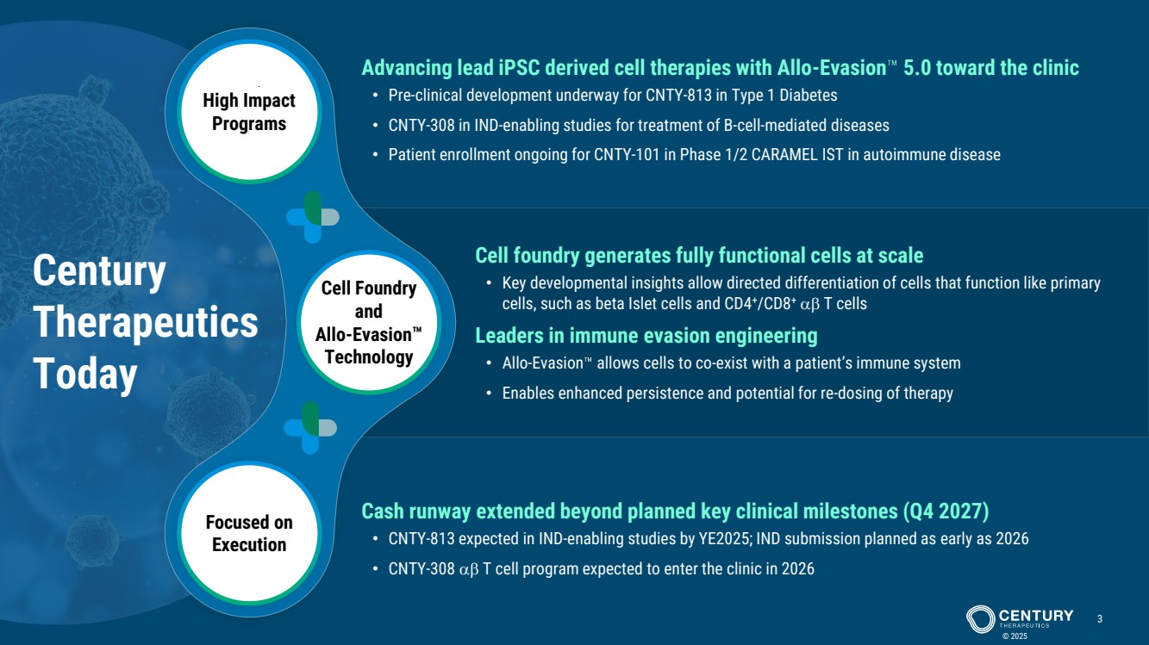 | Cell Foundry and Allo-Evasion Technology High Impact Programs Focused on Execution Century Therapeutics Today © 2025 3 Cell foundry generates fully functional cells at scale • Key developmental insights allow directed differentiation of cells that function like primary cells, such as beta Islet cells and CD4+/CD8+ αβ T cells Leaders in immune evasion engineering • Allo-Evasion allows cells to co-exist with a patient’s immune system • Enables enhanced persistence and potential for re-dosing of therapy Advancing lead iPSC derived cell therapies with Allo-Evasion 5.0 toward the clinic • Pre-clinical development underway for CNTY-813 in Type 1 Diabetes • CNTY-308 in IND-enabling studies for treatment of B-cell-mediated diseases • Patient enrollment ongoing for CNTY-101 in Phase 1/2 CARAMEL IST in autoimmune disease Cash runway extended beyond planned key clinical milestones (Q4 2027) • CNTY-813 expected in IND-enabling studies by YE2025; IND submission planned as early as 2026 • CNTY-308 αβ T cell program expected to enter the clinic in 2026
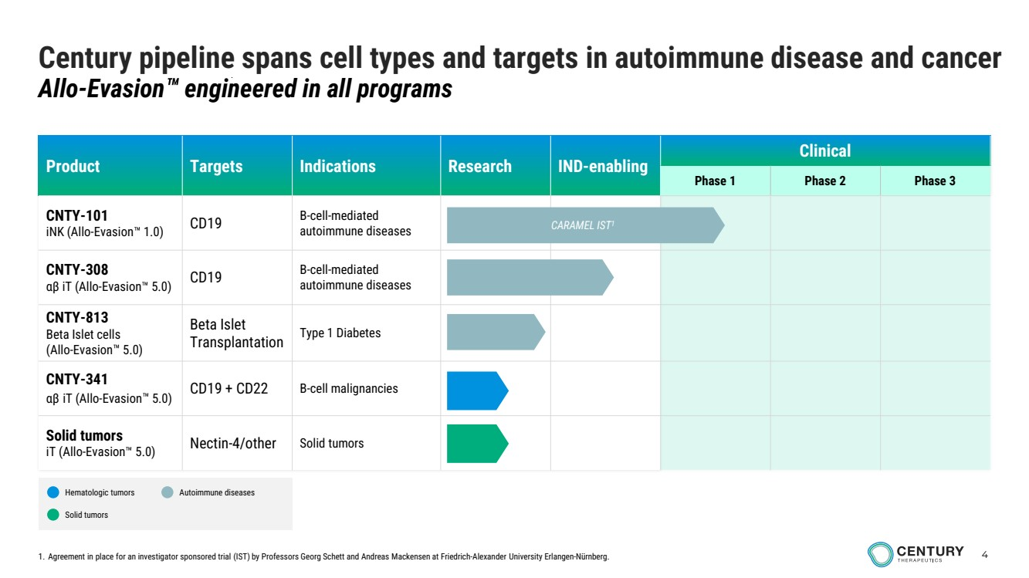 | 4 Product Targets Indications Research IND-enabling Clinical Phase 1 Phase 2 Phase 3 CNTY-101 iNK (Allo-Evasion 1.0) CD19 B-cell-mediated autoimmune diseases CNTY-308 αβ iT (Allo-Evasion 5.0) CD19 B-cell-mediated autoimmune diseases CNTY-813 Beta Islet cells (Allo-Evasion 5.0) Beta Islet Transplantation Type 1 Diabetes CNTY-341 αβ iT (Allo-Evasion 5.0) CD19 + CD22 B-cell malignancies Solid tumors iT (Allo-Evasion 5.0) Nectin-4/other Solid tumors Century pipeline spans cell types and targets in autoimmune disease and cancer Allo-Evasion engineered in all programs CARAMEL IST1 Hematologic tumors Solid tumors Autoimmune diseases 1. Agreement in place for an investigator sponsored trial (IST) by Professors Georg Schett and Andreas Mackensen at Friedrich-Alexander University Erlangen-Nürnberg.
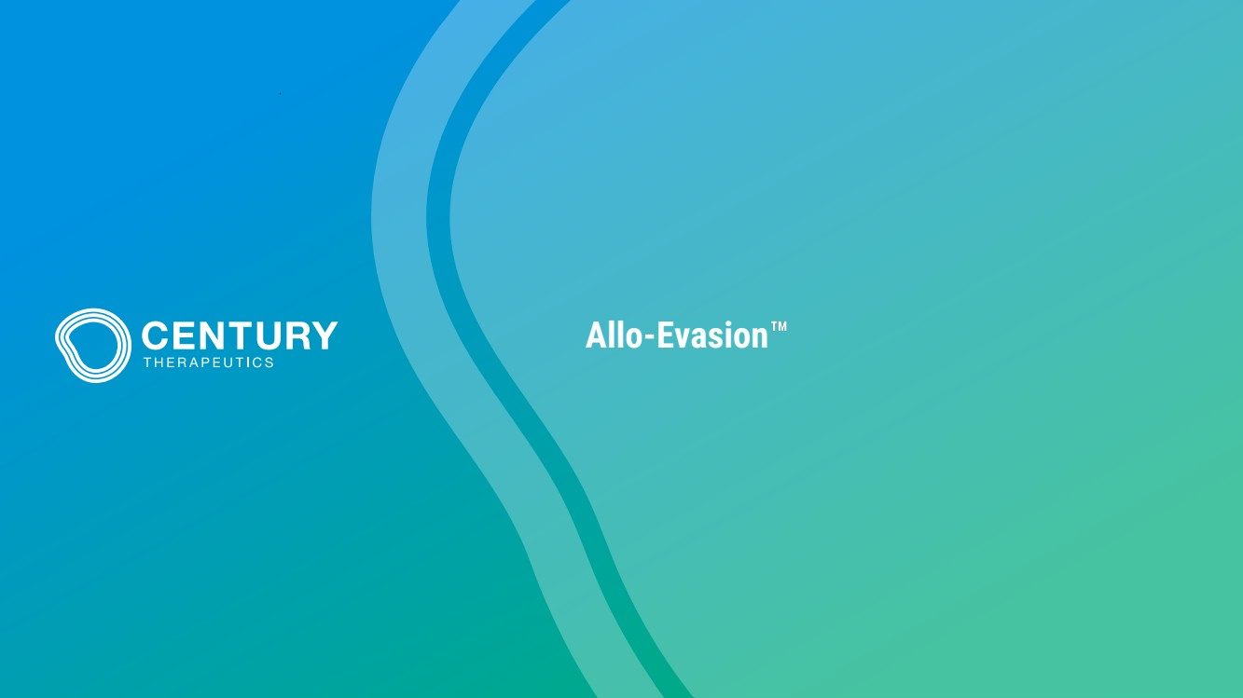 | Allo-Evasion
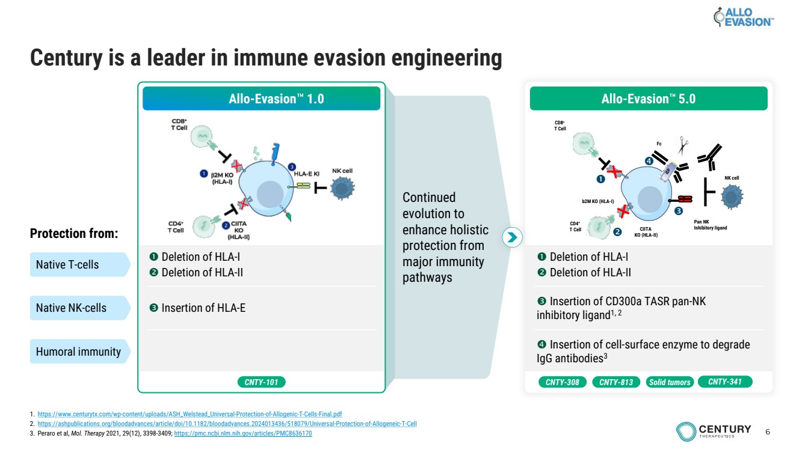 | 6 Continued evolution to enhance holistic protection from major immunity pathways Century is a leader in immune evasion engineering Allo-Evasion 1.0 Deletion of HLA-I Deletion of HLA-II Insertion of HLA-E Protection from: Native T-cells Native NK-cells Humoral immunity CNTY-101 CNTY-308 CNTY-813 Solid tumors Deletion of HLA-I Deletion of HLA-II Insertion of CD300a TASR pan-NK inhibitory ligand1, 2 Insertion of cell-surface enzyme to degrade IgG antibodies3 b2M KO (HLA-I) CIITA KO (HLA-II) CD8+ T Cell CD4+ T Cell Pan NK Inhibitory ligand Fc NK cell Allo-Evasion 5.0 CNTY-341 1. https://www.centurytx.com/wp-content/uploads/ASH_Welstead_Universal-Protection-of-Allogenic-T-Cells-Final.pdf 2. https://ashpublications.org/bloodadvances/article/doi/10.1182/bloodadvances.2024013436/518079/Universal-Protection-of-Allogeneic-T-Cell 3. Peraro et al, Mol. Therapy 2021, 29(12), 3398-3409; https://pmc.ncbi.nlm.nih.gov/articles/PMC8636170
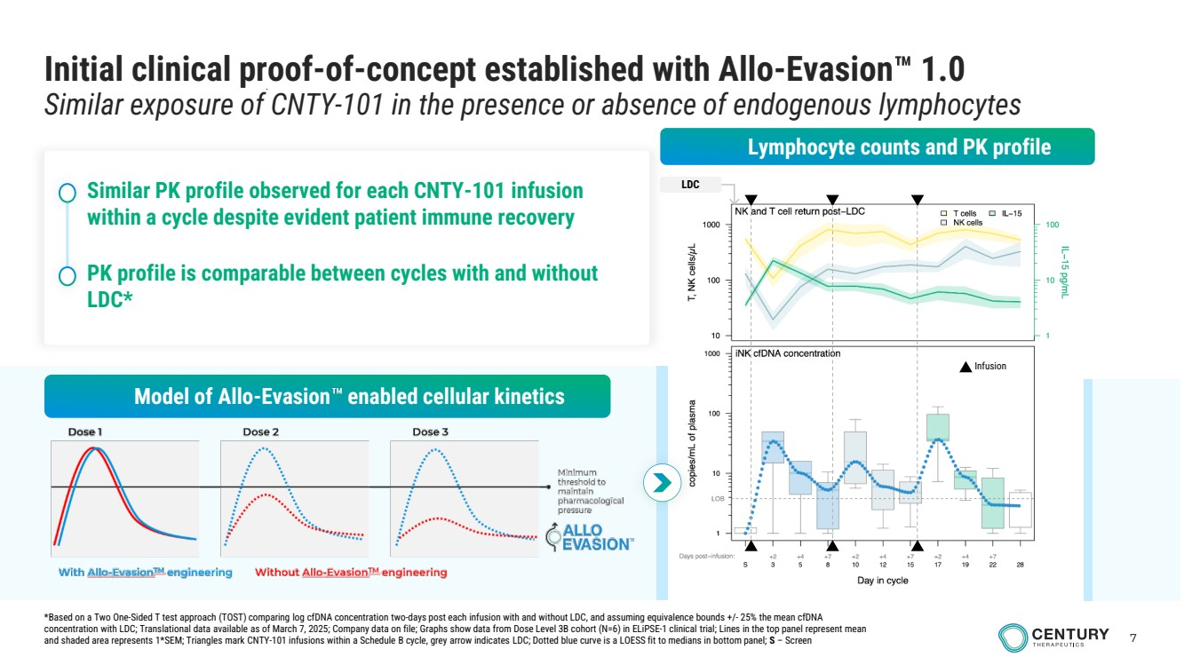 | 7 Infusion LDC • Similar PK profile observed for each CNTY-101 infusion within a cycle despite evident patient immune recovery • PK profile is comparable between cycles with and without LDC* Initial clinical proof-of-concept established with Allo-Evasion 1.0 Similar exposure of CNTY-101 in the presence or absence of endogenous lymphocytes Lymphocyte counts and PK profile Model of Allo-Evasion enabled cellular kinetics *Based on a Two One-Sided T test approach (TOST) comparing log cfDNA concentration two-days post each infusion with and without LDC, and assuming equivalence bounds +/- 25% the mean cfDNA concentration with LDC; Translational data available as of March 7, 2025; Company data on file; Graphs show data from Dose Level 3B cohort (N=6) in ELiPSE-1 clinical trial; Lines in the top panel represent mean and shaded area represents 1*SEM; Triangles mark CNTY-101 infusions within a Schedule B cycle, grey arrow indicates LDC; Dotted blue curve is a LOESS fit to medians in bottom panel; S – Screen
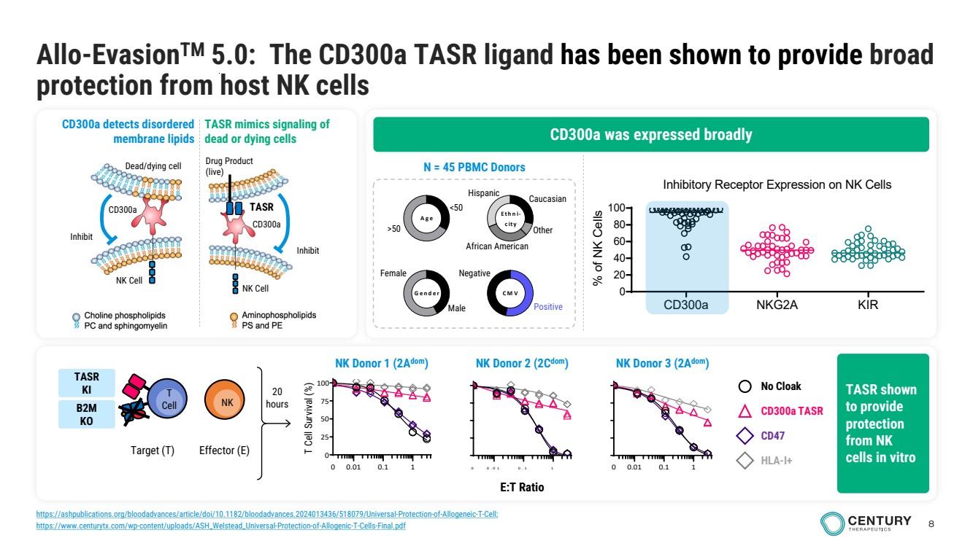 | 8 Allo-EvasionTM 5.0: The CD300a TASR ligand has been shown to provide broad protection from host NK cells Male Female <50 >50 Gender Age Ethni-city CMV Caucasian Other African American Hispanic Negative Positive N = 45 PBMC Donors 0.01 0.1 1 0 0 .0 1 0 .1 1 0 25 50 75 100 0 E:T Ratio T Cell Survival (%) 0 0.01 0.1 1 No Cloak CD300a TASR CD47 HLA-I+ 20 hours Target (T) T Cell NK Effector (E) CD300a NKG2A KIR 0 20 40 60 80 100 Inhibitory Receptor Expression on NK Cells (n = 46 donors) % of NK Cells CD300a was expressed broadly CD300a detects disordered membrane lipids TASR mimics signaling of dead or dying cells Drug Product (live) Inhibit NK Cell TASR CD300a Dead/dying cell NK Cell Inhibit CD300a TASR shown to provide protection from NK cells in vitro NK Donor 2 (2Cdom NK Donor 1 (2A ) dom) NK Donor 3 (2Adom) TASR KI B2M KO https://ashpublications.org/bloodadvances/article/doi/10.1182/bloodadvances.2024013436/518079/Universal-Protection-of-Allogeneic-T-Cell; https://www.centurytx.com/wp-content/uploads/ASH_Welstead_Universal-Protection-of-Allogenic-T-Cells-Final.pdf
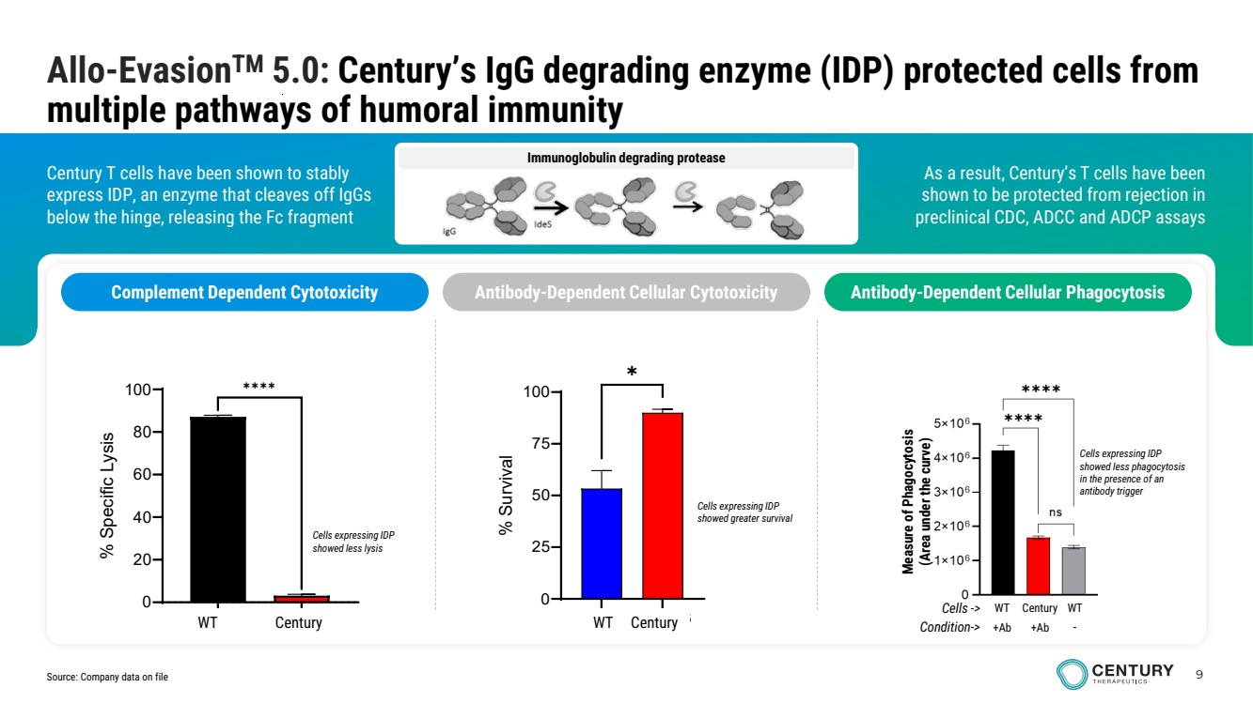 | 9 Immunoglobulin degrading protease As a result, Century’s T cells have been shown to be protected from rejection in preclinical CDC, ADCC and ADCP assays Century T cells have been shown to stably express IDP, an enzyme that cleaves off IgGs below the hinge, releasing the Fc fragment Allo-EvasionTM 5.0: Century’s IgG degrading enzyme (IDP) protected cells from multiple pathways of humoral immunity Complement Dependent Cytotoxicity Antibody-Dependent Cellular Cytotoxicity Antibody-Dependent Cellular Phagocytosis Measure of Phagocytosis (Area under the curve) Cells expressing IDP showed less phagocytosis in the presence of an antibody trigger Cells -> WT Century WT Condition-> +Ab +Ab - Cells expressing IDP showed greater survival GFP IdeStm 0 20 40 60 80 100 % Specific Lysis ✱✱✱✱ WT Century Cells expressing IDP showed less lysis WT Gen 2.3 0 25 50 75 100 % Survival ✱ WT Century Source: Company data on file
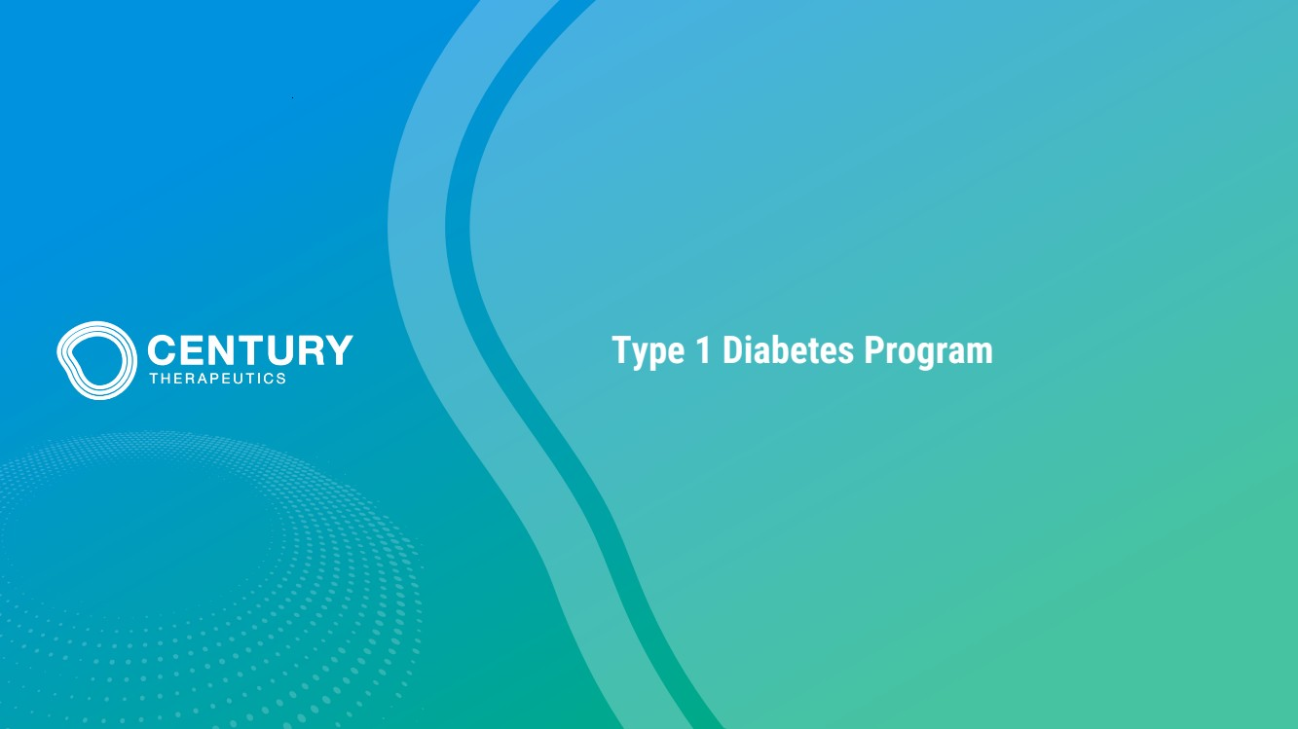 | Type 1 Diabetes Program
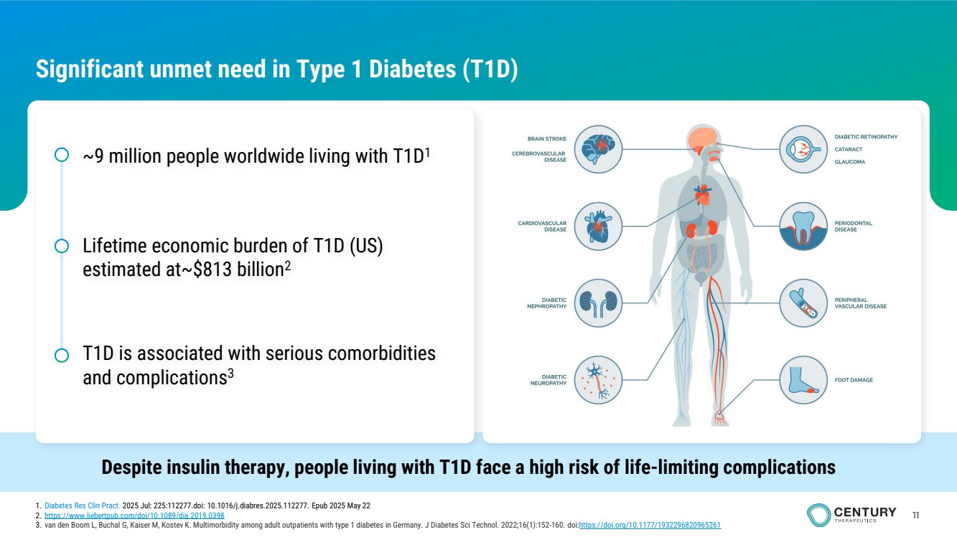 | 11 Significant unmet need in Type 1 Diabetes (T1D) Despite insulin therapy, people living with T1D face a high risk of life-limiting complications ~9 million people worldwide living with T1D1 Lifetime economic burden of T1D (US) estimated at~$813 billion2 T1D is associated with serious comorbidities and complications3 1. Diabetes Res Clin Pract. 2025 Jul: 225:112277.doi: 10.1016/j.diabres.2025.112277. Epub 2025 May 22 2. https://www.liebertpub.com/doi/10.1089/dia.2019.0398 3. van den Boom L, Buchal G, Kaiser M, Kostev K. Multimorbidity among adult outpatients with type 1 diabetes in Germany. J Diabetes Sci Technol. 2022;16(1):152-160. doi:https://doi.org/10.1177/1932296820965261
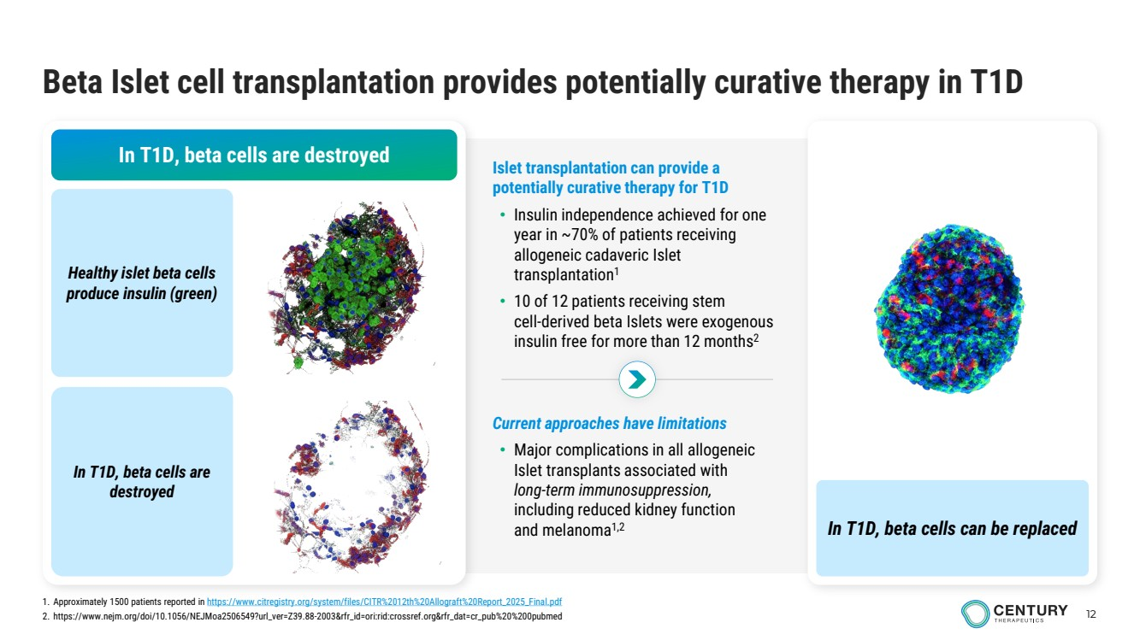 | 12 Beta Islet cell transplantation provides potentially curative therapy in T1D In T1D, beta cells are destroyed Healthy islet beta cells produce insulin (green) In T1D, beta cells are destroyed In T1D, beta cells can be replaced Current approaches have limitations • Major complications in all allogeneic Islet transplants associated with long-term immunosuppression, including reduced kidney function and melanoma1,2 Islet transplantation can provide a potentially curative therapy for T1D • Insulin independence achieved for one year in ~70% of patients receiving allogeneic cadaveric Islet transplantation1 • 10 of 12 patients receiving stem cell-derived beta Islets were exogenous insulin free for more than 12 months2 1. Approximately 1500 patients reported in https://www.citregistry.org/system/files/CITR%2012th%20Allograft%20Report_2025_Final.pdf 2. https://www.nejm.org/doi/10.1056/NEJMoa2506549?url_ver=Z39.88-2003&rfr_id=ori:rid:crossref.org&rfr_dat=cr_pub%20%200pubmed
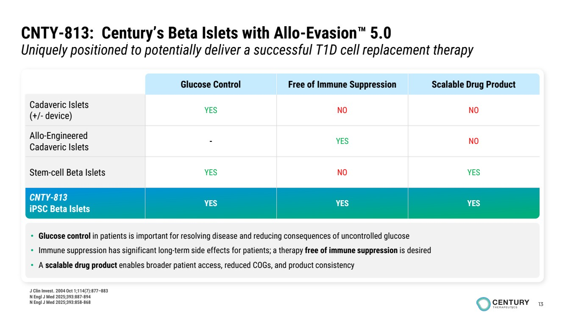 | 13 CNTY-813: Century’s Beta Islets with Allo-Evasion 5.0 Uniquely positioned to potentially deliver a successful T1D cell replacement therapy • Glucose control in patients is important for resolving disease and reducing consequences of uncontrolled glucose • Immune suppression has significant long-term side effects for patients; a therapy free of immune suppression is desired • A scalable drug product enables broader patient access, reduced COGs, and product consistency Glucose Control Free of Immune Suppression Scalable Drug Product Cadaveric Islets (+/- device) YES NO NO Allo-Engineered Cadaveric Islets - YES NO Stem-cell Beta Islets YES NO YES CNTY-813 iPSC Beta Islets YES YES YES J Clin Invest. 2004 Oct 1;114(7):877–883 N Engl J Med 2025;393:887-894 N Engl J Med 2025;393:858-868
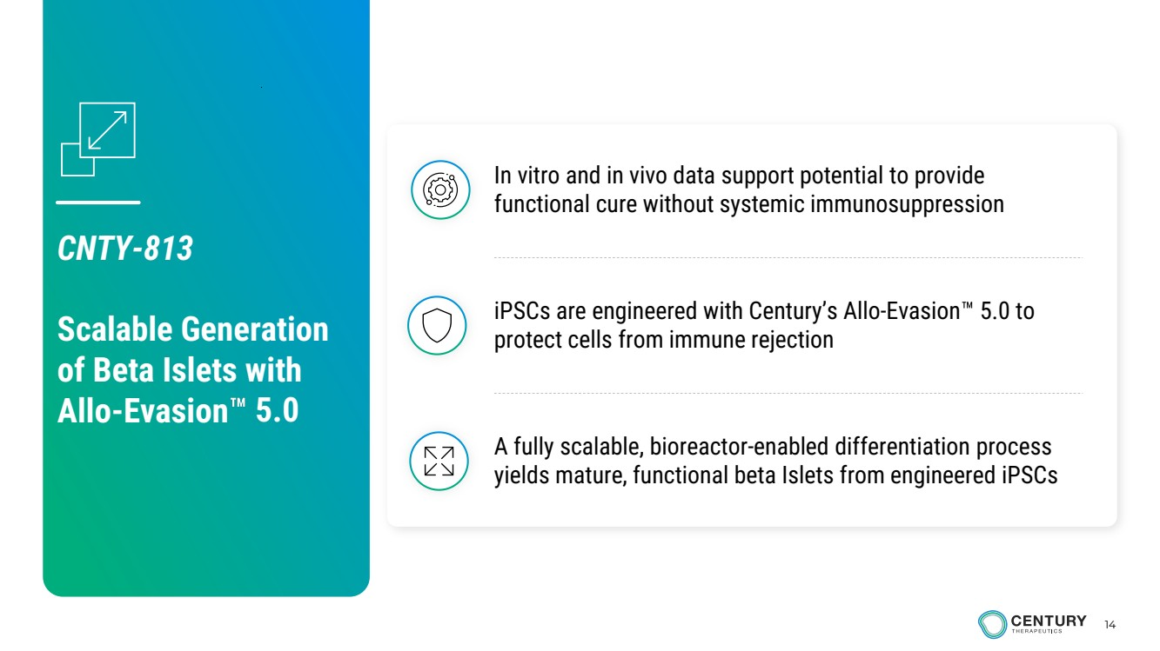 | 14 A fully scalable, bioreactor-enabled differentiation process yields mature, functional beta Islets from engineered iPSCs iPSCs are engineered with Century’s Allo-Evasion 5.0 to protect cells from immune rejection In vitro and in vivo data support potential to provide functional cure without systemic immunosuppression CNTY-813 Scalable Generation of Beta Islets with Allo-Evasion 5.0
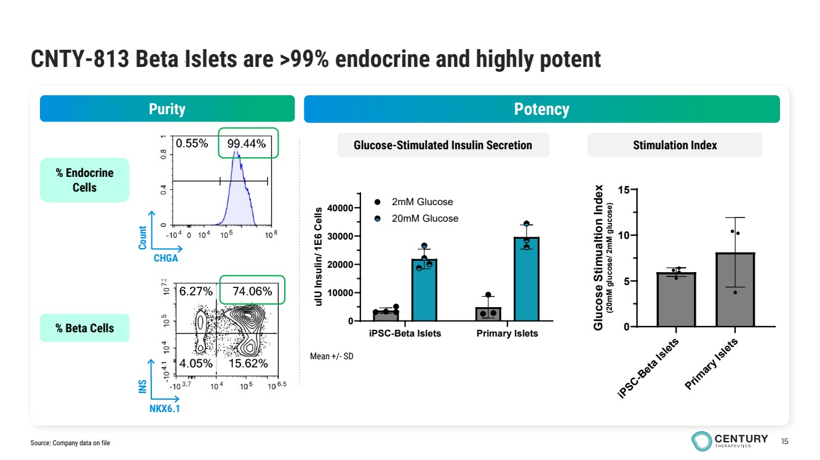 | 15 CNTY-813 Beta Islets are >99% endocrine and highly potent % Endocrine Cells % Beta Cells CHGA Count NKX6.1 INS iPSC-Beta Islets Primary Islets 0 10000 20000 30000 40000 uIU Insulin/ 1E6 Cells 2mM Glucose 20mM Glucose iPSC-Beta Islets Primary Islets 0 5 10 15 Glucose Stimualtion Index (20mM glucose/ 2mM glucose) Purity Potency Glucose-Stimulated Insulin Secretion Stimulation Index Source: Company data on file Mean +/- SD
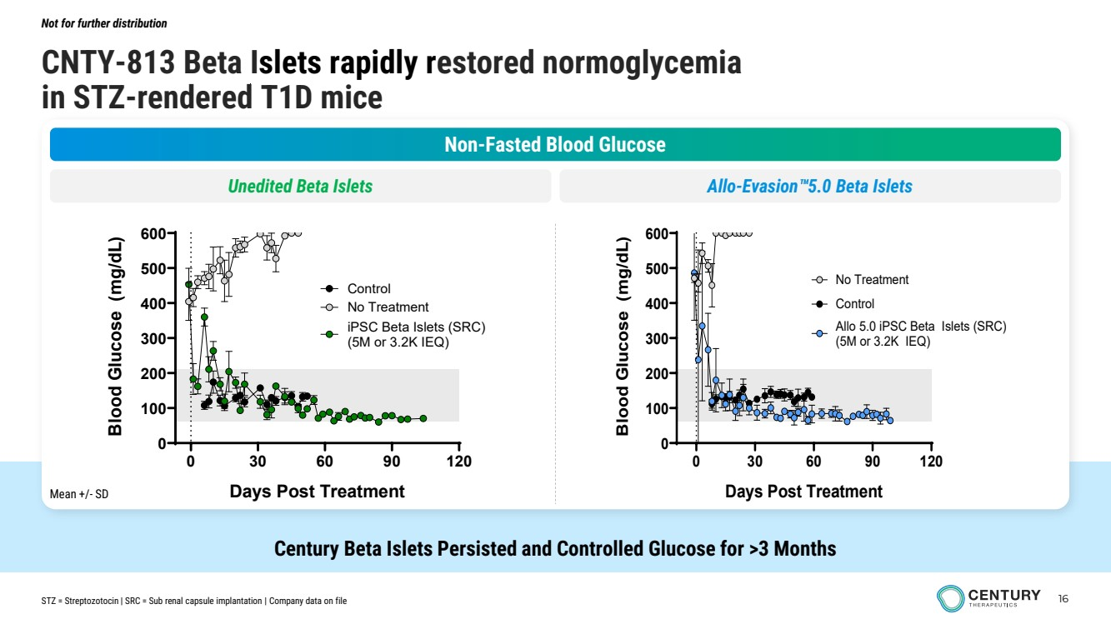 | 16 CNTY-813 Beta Islets rapidly restored normoglycemia in STZ-rendered T1D mice Not for further distribution Century Beta Islets Persisted and Controlled Glucose for >3 Months Non-Fasted Blood Glucose Unedited Beta Islets Allo-Evasion 5.0 Beta Islets 0 30 60 90 120 0 100 200 300 400 500 600 Days Post Treatment Blood Glucose (mg/dL) No Treatment iPSC Beta Islets (SRC) (5M or 3.2K IEQ) Control 0 30 60 90 120 0 100 200 300 400 500 600 Days Post Treatment Blood Glucose (mg/dL) No Treatment Allo 5.0 iPSC Beta Islets (SRC) (5M or 3.2K IEQ) Control STZ = Streptozotocin | SRC = Sub renal capsule implantation | Company data on file Mean +/- SD
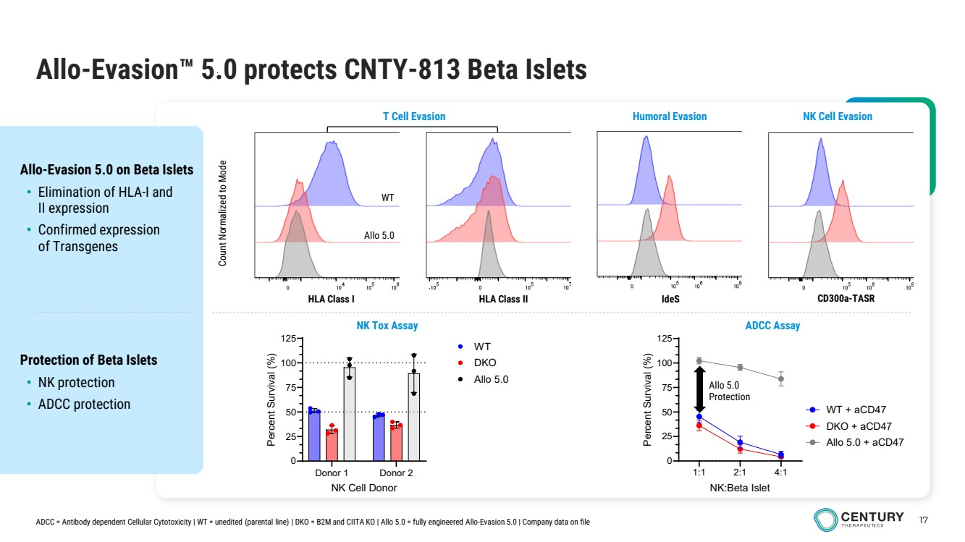 | 17 Allo-Evasion 5.0 protects CNTY-813 Beta Islets ADCC Assay Protection of Beta Islets • NK protection • ADCC protection Allo-Evasion 5.0 on Beta Islets • Elimination of HLA-I and II expression • Confirmed expression of Transgenes Count Normalized to Mode HLA Class I HLA Class II IdeS CD300a-TASR T Cell Evasion Humoral Evasion NK Cell Evasion Donor 1 Donor 2 0 25 50 75 100 125 NK Cell Donor Percent Survival (%) WT DKO Allo 5.0 1:1 2:1 4:1 0 25 50 75 100 125 NK:Beta Islet Percent Survival (%) WT + aCD47 DKO + aCD47 Allo 5.0 + aCD47 Allo 5.0 Protection NK Tox Assay WT Allo 5.0 ADCC = Antibody dependent Cellular Cytotoxicity | WT = unedited (parental line) | DKO = B2M and CIITA KO | Allo 5.0 = fully engineered Allo-Evasion 5.0 | Company data on file
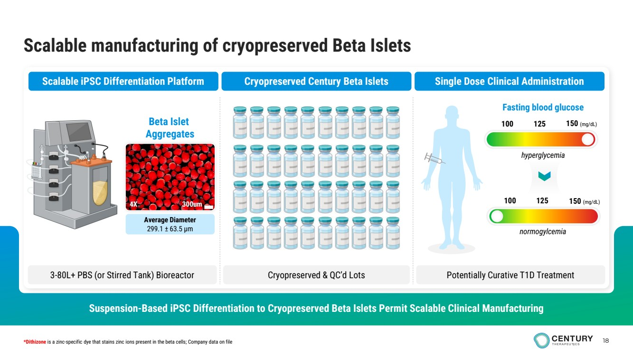 | 18 Scalable manufacturing of cryopreserved Beta Islets Suspension-Based iPSC Differentiation to Cryopreserved Beta Islets Permit Scalable Clinical Manufacturing Scalable iPSC Differentiation Platform Cryopreserved Century Beta Islets Single Dose Clinical Administration 3-80L+ PBS (or Stirred Tank) Bioreactor Cryopreserved & QC’d Lots Potentially Curative T1D Treatment Average Diameter 299.1 ± 63.5 μm Beta Islet Aggregates 4X 300um 100 125 150 (mg/dL) Fasting blood glucose 100 125 150 (mg/dL) *Dithizone is a zinc-specific dye that stains zinc ions present in the beta cells; Company data on file hyperglycemia normogylcemia
 | Autoimmune Disease Programs
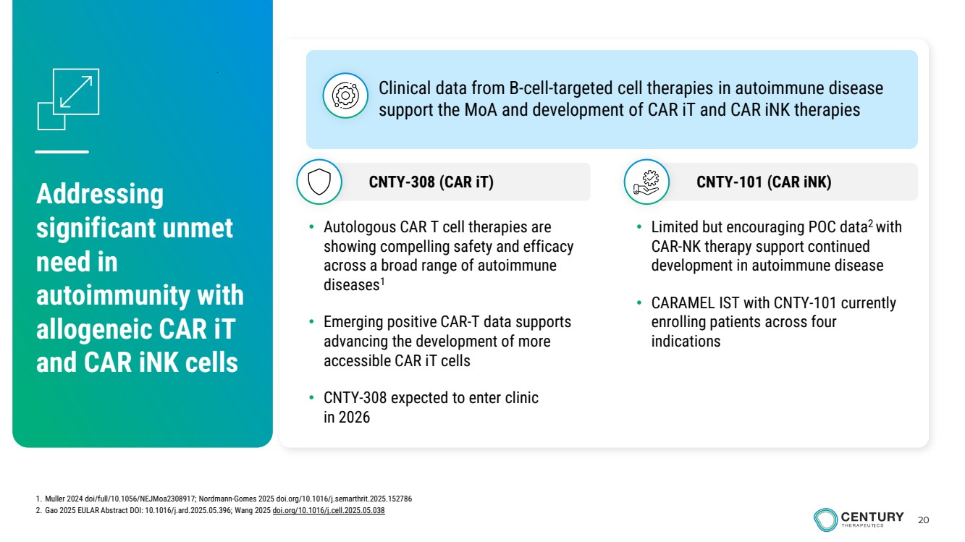 | 20 Addressing significant unmet need in autoimmunity with allogeneic CAR iT and CAR iNK cells • Limited but encouraging POC data2 with CAR-NK therapy support continued development in autoimmune disease • CARAMEL IST with CNTY-101 currently enrolling patients across four indications • Autologous CAR T cell therapies are showing compelling safety and efficacy across a broad range of autoimmune diseases1 • Emerging positive CAR-T data supports advancing the development of more accessible CAR iT cells • CNTY-308 expected to enter clinic in 2026 Clinical data from B-cell-targeted cell therapies in autoimmune disease support the MoA and development of CAR iT and CAR iNK therapies CNTY-308 (CAR iT) CNTY-101 (CAR iNK) 1. Muller 2024 doi/full/10.1056/NEJMoa2308917; Nordmann-Gomes 2025 doi.org/10.1016/j.semarthrit.2025.152786 2. Gao 2025 EULAR Abstract DOI: 10.1016/j.ard.2025.05.396; Wang 2025 doi.org/10.1016/j.cell.2025.05.038
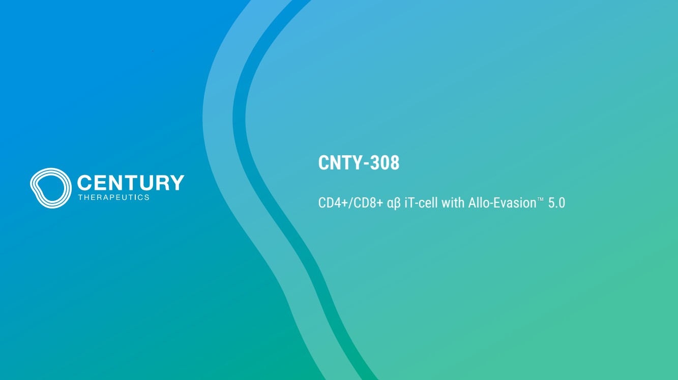 | CNTY-308 CD4+/CD8+ αβ iT-cell with Allo-Evasion 5.0
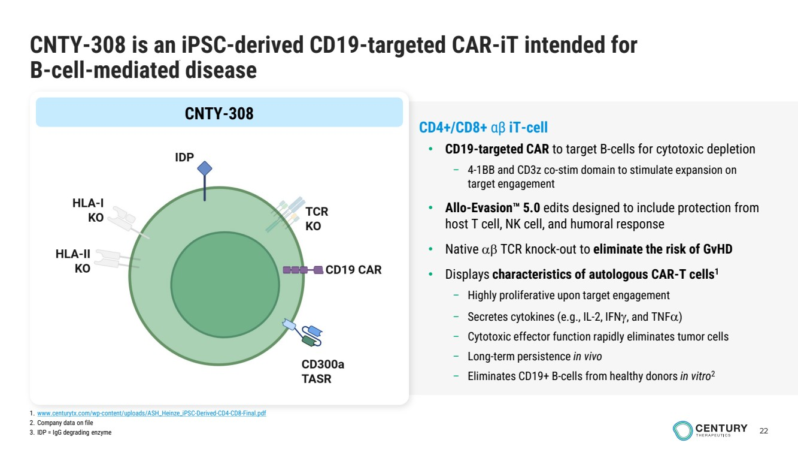 | 22 CNTY-308 is an iPSC-derived CD19-targeted CAR-iT intended for B-cell-mediated disease CNTY-308 CD4+/CD8+ αβ iT-cell • CD19-targeted CAR to target B-cells for cytotoxic depletion – 4-1BB and CD3z co-stim domain to stimulate expansion on target engagement • Allo-Evasion 5.0 edits designed to include protection from host T cell, NK cell, and humoral response • Native αβ TCR knock-out to eliminate the risk of GvHD • Displays characteristics of autologous CAR-T cells1 – Highly proliferative upon target engagement – Secretes cytokines (e.g., IL-2, IFNγ, and TNFα) – Cytotoxic effector function rapidly eliminates tumor cells – Long-term persistence in vivo – Eliminates CD19+ B-cells from healthy donors in vitro2 1. www.centurytx.com/wp-content/uploads/ASH_Heinze_iPSC-Derived-CD4-CD8-Final.pdf 2. Company data on file 3. IDP = IgG degrading enzyme
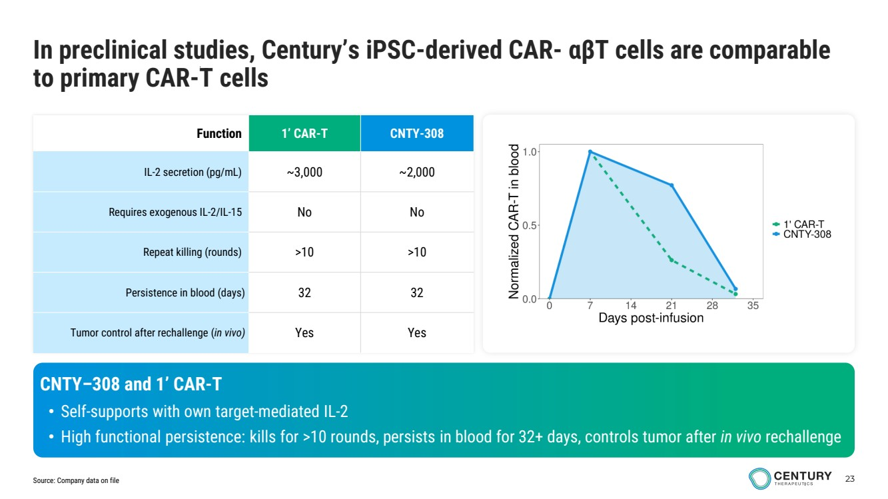 | 23 Function 1’ CAR-T CNTY-308 IL-2 secretion (pg/mL) ~3,000 ~2,000 Requires exogenous IL-2/IL-15 No No Repeat killing (rounds) >10 >10 Persistence in blood (days) 32 32 Tumor control after rechallenge (in vivo) Yes Yes CNTY–308 and 1’ CAR-T • Self-supports with own target-mediated IL-2 • High functional persistence: kills for >10 rounds, persists in blood for 32+ days, controls tumor after in vivo rechallenge In preclinical studies, Century’s iPSC-derived CAR- αβT cells are comparable to primary CAR-T cells Source: Company data on file
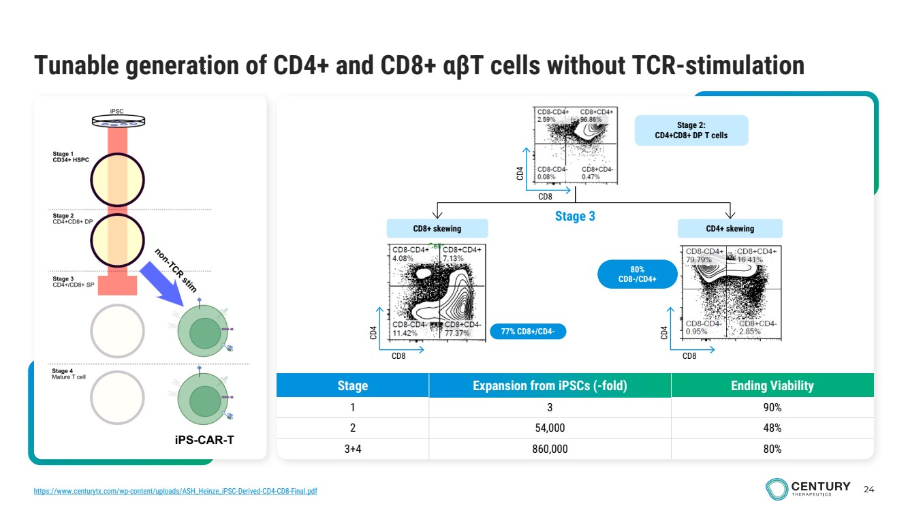 | 24 Tunable generation of CD4+ and CD8+ αβT cells without TCR-stimulation Stage Expansion from iPSCs (-fold) Ending Viability 1 3 90% 2 54,000 48% 3+4 860,000 80% 77% CD8+/CD4- CD8+ skewing CD4+ skewing Stage 3 Stage 2: CD4+CD8+ DP T cells CD8 CD4 CD8 CD4 CD8 CD4 80% CD8-/CD4+ https://www.centurytx.com/wp-content/uploads/ASH_Heinze_iPSC-Derived-CD4-CD8-Final.pdf
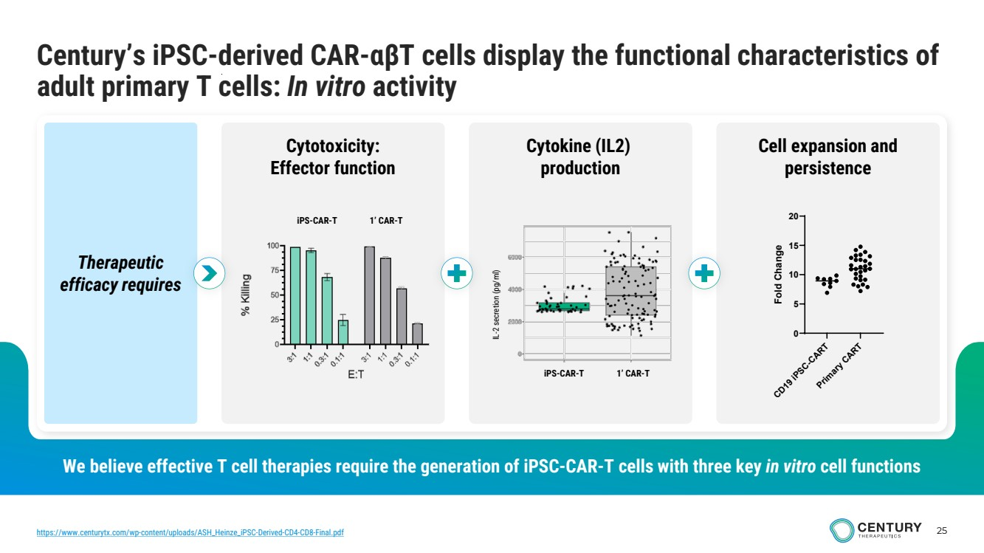 | 25 We believe effective T cell therapies require the generation of iPSC-CAR-T cells with three key in vitro cell functions Century’s iPSC-derived CAR-αβT cells display the functional characteristics of adult primary T cells: In vitro activity Therapeutic efficacy requires Cytotoxicity: Effector function Cell expansion and persistence Cytokine (IL2) production IL-2 secretion (pg/ml) iPS-CAR-T 1’ CAR-T iPS-CAR-T 1’ CAR-T CD19 iPSC-CART Primary CART 0 5 10 15 20 Fold Change https://www.centurytx.com/wp-content/uploads/ASH_Heinze_iPSC-Derived-CD4-CD8-Final.pdf
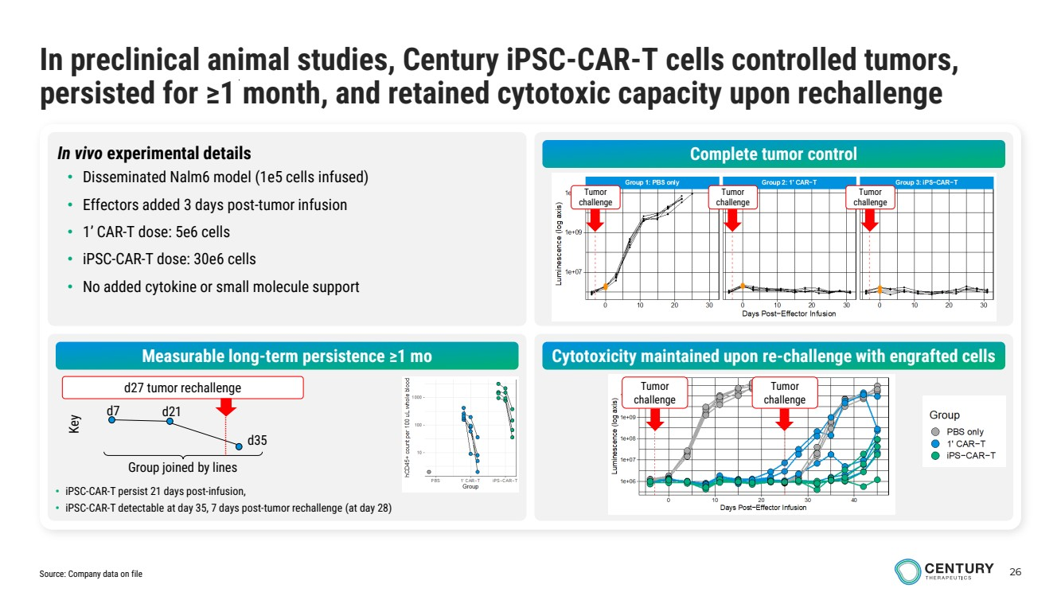 | 26 In preclinical animal studies, Century iPSC-CAR-T cells controlled tumors, persisted for ≥1 month, and retained cytotoxic capacity upon rechallenge In vivo experimental details • Disseminated Nalm6 model (1e5 cells infused) • Effectors added 3 days post-tumor infusion • 1’ CAR-T dose: 5e6 cells • iPSC-CAR-T dose: 30e6 cells • No added cytokine or small molecule support Complete tumor control Measurable long-term persistence ≥1 mo Cytotoxicity maintained upon re-challenge with engrafted cells Tumor challenge Tumor challenge Tumor challenge Tumor challenge Tumor challenge • iPSC-CAR-T persist 21 days post-infusion, • iPSC-CAR-T detectable at day 35, 7 days post-tumor rechallenge (at day 28) Group joined by lines d7 d21 d35 Key d27 tumor rechallenge Source: Company data on file
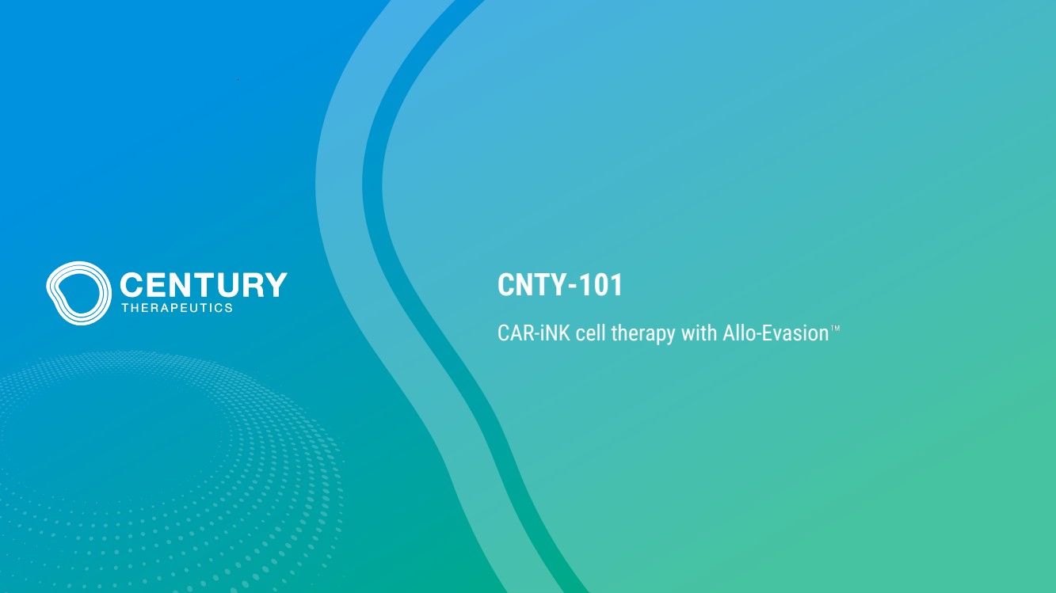 | CNTY-101 CAR-iNK cell therapy with Allo-Evasion
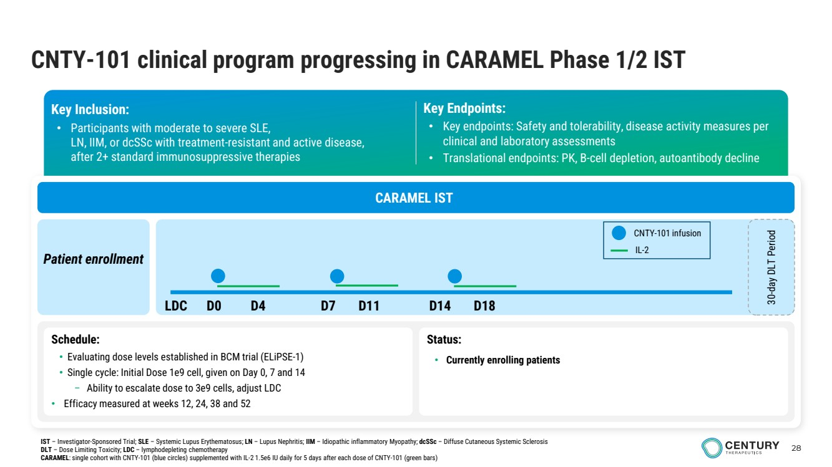 | 28 CNTY-101 clinical program progressing in CARAMEL Phase 1/2 IST Key Inclusion: • Participants with moderate to severe SLE, LN, IIM, or dcSSc with treatment-resistant and active disease, after 2+ standard immunosuppressive therapies Key Endpoints: • Key endpoints: Safety and tolerability, disease activity measures per clinical and laboratory assessments • Translational endpoints: PK, B-cell depletion, autoantibody decline CARAMEL IST Patient enrollment 30-day DLT Period Schedule: • Evaluating dose levels established in BCM trial (ELiPSE-1) • Single cycle: Initial Dose 1e9 cell, given on Day 0, 7 and 14 – Ability to escalate dose to 3e9 cells, adjust LDC • Efficacy measured at weeks 12, 24, 38 and 52 Status: • Currently enrolling patients IST – Investigator-Sponsored Trial; SLE – Systemic Lupus Erythematosus; LN – Lupus Nephritis; IIM – Idiopathic inflammatory Myopathy; dcSSc – Diffuse Cutaneous Systemic Sclerosis DLT – Dose Limiting Toxicity; LDC – lymphodepleting chemotherapy CARAMEL: single cohort with CNTY-101 (blue circles) supplemented with IL-2 1.5e6 IU daily for 5 days after each dose of CNTY-101 (green bars) LDC D0 D4 D7 D11 D14 D18 CNTY-101 infusion IL-2
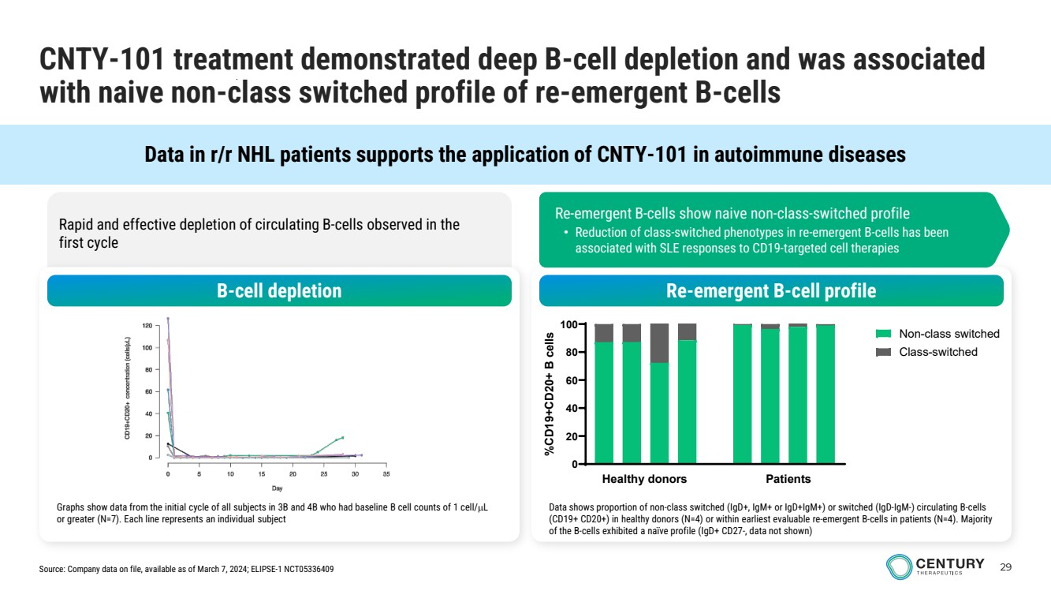 | 29 Data in r/r NHL patients supports the application of CNTY-101 in autoimmune diseases Rapid and effective depletion of circulating B-cells observed in the first cycle CNTY-101 treatment demonstrated deep B-cell depletion and was associated with naive non-class switched profile of re-emergent B-cells B-cell depletion Re-emergent B-cell profile Graphs show data from the initial cycle of all subjects in 3B and 4B who had baseline B cell counts of 1 cell/µL or greater (N=7). Each line represents an individual subject Data shows proportion of non-class switched (IgD+, IgM+ or IgD+IgM+) or switched (IgD-IgM-) circulating B-cells (CD19+ CD20+) in healthy donors (N=4) or within earliest evaluable re-emergent B-cells in patients (N=4). Majority of the B-cells exhibited a naïve profile (IgD+ CD27-, data not shown) 0 20 40 60 80 100 %CD19+CD20+ B cells Non-class switched Class-switched Healthy donors Patients Re-emergent B-cells show naive non-class-switched profile • Reduction of class-switched phenotypes in re-emergent B-cells has been associated with SLE responses to CD19-targeted cell therapies Source: Company data on file, available as of March 7, 2024; ELIPSE-1 NCT05336409
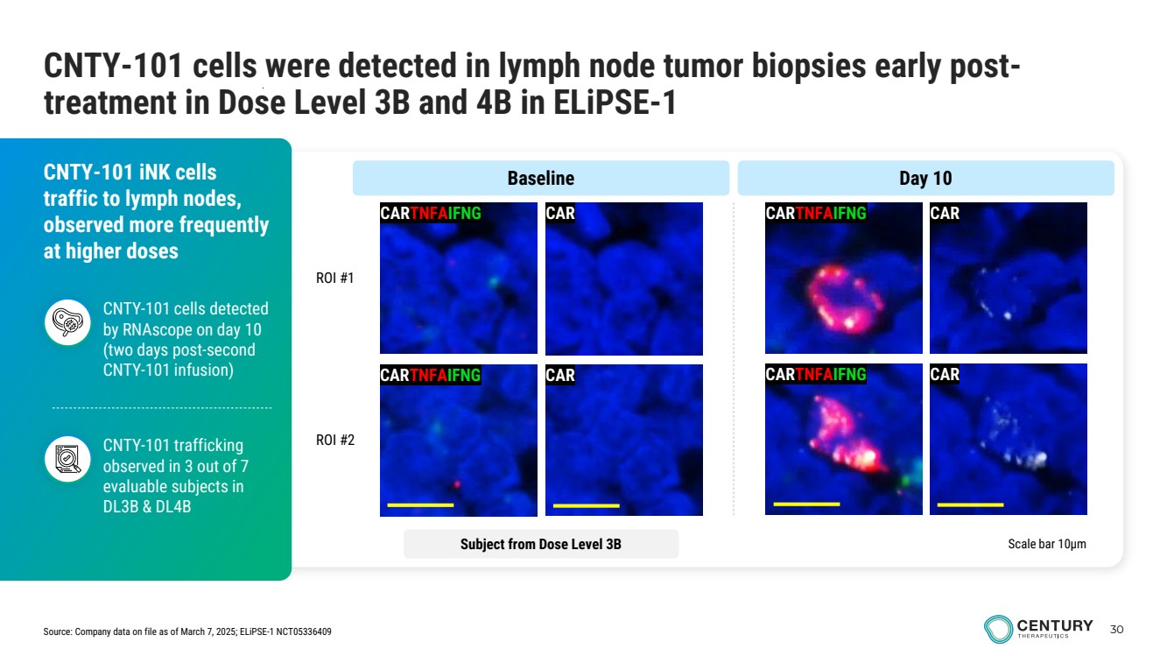 | 30 CNTY-101 cells were detected in lymph node tumor biopsies early post-treatment in Dose Level 3B and 4B in ELiPSE-1 CARTNFAIFNG CARTNFAIFNG CAR CAR Scale bar 10µm CNTY-101 iNK cells traffic to lymph nodes, observed more frequently at higher doses CNTY-101 trafficking observed in 3 out of 7 evaluable subjects in DL3B & DL4B CNTY-101 cells detected by RNAscope on day 10 (two days post-second CNTY-101 infusion) ROI #1 ROI #2 CARTNFAIFNG CAR CARTNFAIFNG CAR Subject from Dose Level 3B Baseline Day 10 Source: Company data on file as of March 7, 2025; ELiPSE-1 NCT05336409
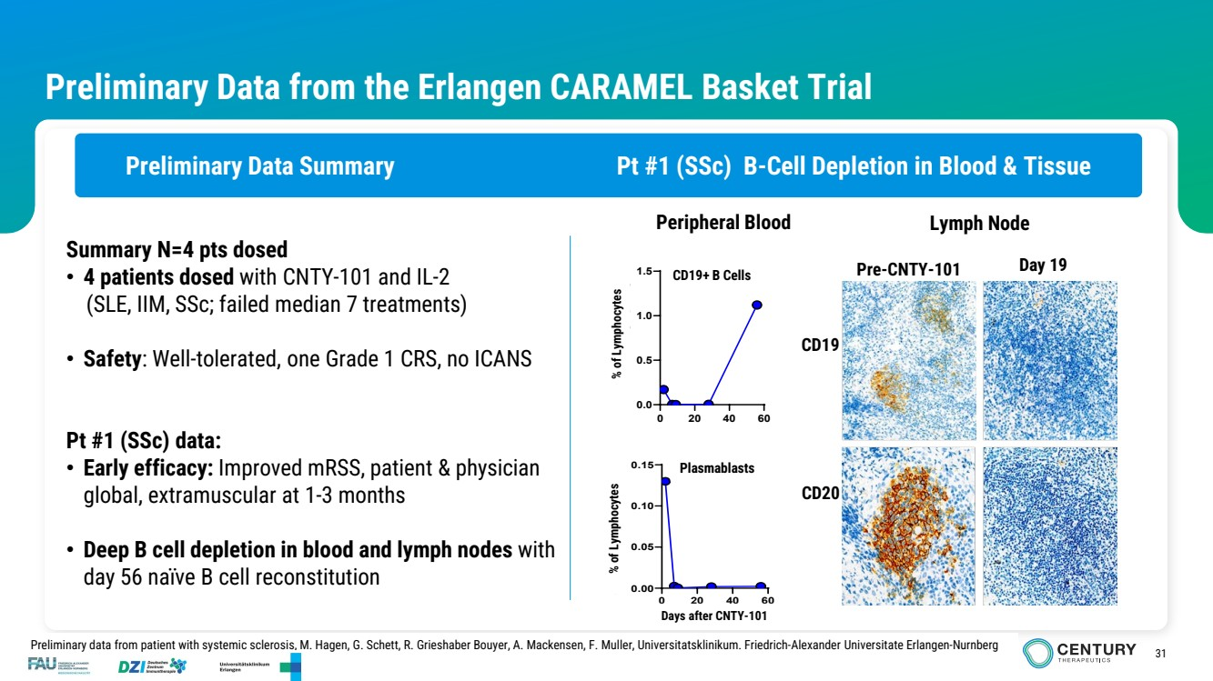 | 31 Preliminary Data from the Erlangen CARAMEL Basket Trial Preliminary Data Summary Pt #1 (SSc) B-Cell Depletion in Blood & Tissue 0 20 40 60 0.0 0.5 1.0 1.5 % cells in vital lymphocytes 0 20 40 60 0.00 0.05 0.10 0.15 Time after first CAR infusion % cells in vital lymphocytes CD19 Pre-CNTY-101 Day 19 Peripheral Blood Lymph Node Summary N=4 pts dosed • 4 patients dosed with CNTY-101 and IL-2 (SLE, IIM, SSc; failed median 7 treatments) • Safety: Well-tolerated, one Grade 1 CRS, no ICANS Pt #1 (SSc) data: • Early efficacy: Improved mRSS, patient & physician global, extramuscular at 1-3 months • Deep B cell depletion in blood and lymph nodes with day 56 naïve B cell reconstitution Preliminary data from patient with systemic sclerosis, M. Hagen, G. Schett, R. Grieshaber Bouyer, A. Mackensen, F. Muller, Universitatsklinikum. Friedrich-Alexander Universitate Erlangen-Nurnberg Plasmablasts CD19+ B Cells CD20 Days after CNTY-101 % of Lymphocytes % of Lymphocytes
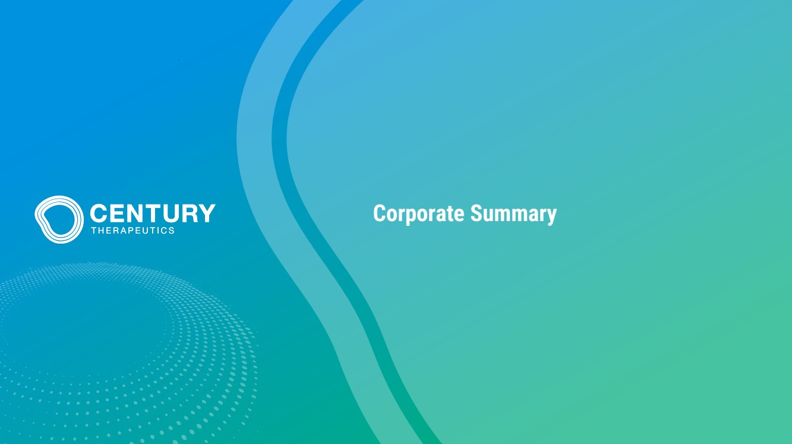 | Corporate Summary
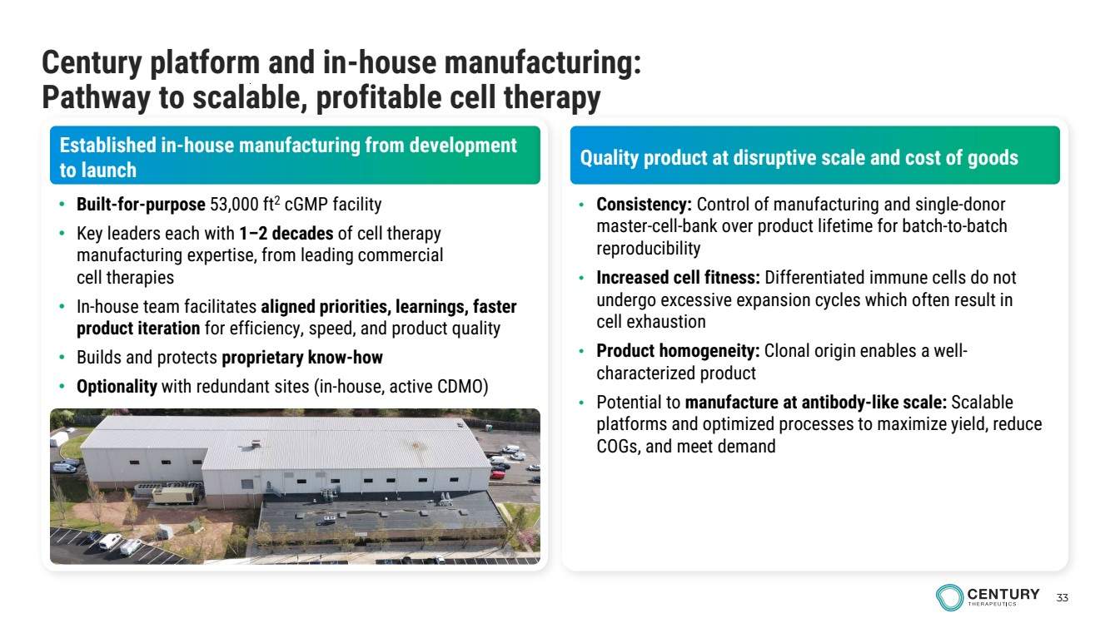 | 33 Century platform and in-house manufacturing: Pathway to scalable, profitable cell therapy Established in-house manufacturing from development to launch Quality product at disruptive scale and cost of goods • Built-for-purpose 53,000 ft2 cGMP facility • Key leaders each with 1–2 decades of cell therapy manufacturing expertise, from leading commercial cell therapies • In-house team facilitates aligned priorities, learnings, faster product iteration for efficiency, speed, and product quality • Builds and protects proprietary know-how • Optionality with redundant sites (in-house, active CDMO) • Consistency: Control of manufacturing and single-donor master-cell-bank over product lifetime for batch-to-batch reproducibility • Increased cell fitness: Differentiated immune cells do not undergo excessive expansion cycles which often result in cell exhaustion • Product homogeneity: Clonal origin enables a well-characterized product • Potential to manufacture at antibody-like scale: Scalable platforms and optimized processes to maximize yield, reduce COGs, and meet demand
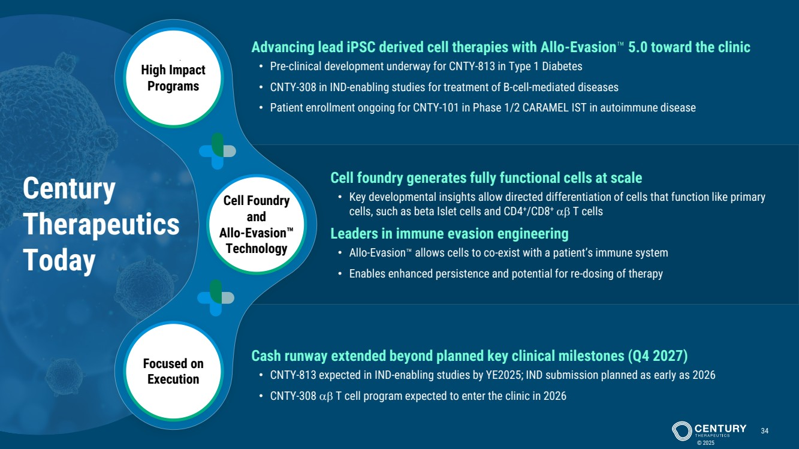 | Cell Foundry and Allo-Evasion Technology High Impact Programs Focused on Execution Century Therapeutics Today © 2025 34 Cell foundry generates fully functional cells at scale • Key developmental insights allow directed differentiation of cells that function like primary cells, such as beta Islet cells and CD4+/CD8+ αβ T cells Leaders in immune evasion engineering • Allo-Evasion allows cells to co-exist with a patient’s immune system • Enables enhanced persistence and potential for re-dosing of therapy Advancing lead iPSC derived cell therapies with Allo-Evasion 5.0 toward the clinic • Pre-clinical development underway for CNTY-813 in Type 1 Diabetes • CNTY-308 in IND-enabling studies for treatment of B-cell-mediated diseases • Patient enrollment ongoing for CNTY-101 in Phase 1/2 CARAMEL IST in autoimmune disease Cash runway extended beyond planned key clinical milestones (Q4 2027) • CNTY-813 expected in IND-enabling studies by YE2025; IND submission planned as early as 2026 • CNTY-308 αβ T cell program expected to enter the clinic in 2026
 | www.centurytx.com

