UNITED STATES

SECURITIES AND EXCHANGE COMMISSION

Washington, DC 20549

FORM 8-K

CURRENT REPORT

Pursuant to Section 13 or 15(d)

of the Securities Exchange Act of 1934

Date of Report (Date of earliest event reported): November 13, 2025

Century Therapeutics, Inc.

(Exact name of registrant as specified in its charter)

Delaware

(State or other jurisdiction of

incorporation or organization)

001-40498

(Commission File Number)

84-2040295

(I.R.S. Employer

Identification No.)

25 North 38th Street, 11th Floor

Philadelphia, Pennsylvania

(Address of principal executive offices)

19104

(Zip Code)

Registrant’s telephone number, including area code: (267) 817-5790

Not Applicable

(Former name or former address, if changed since last report)

Check the appropriate box below if the Form 8-K filing is intended to simultaneously satisfy the filing obligation of the registrant under any of the following provisions (see General Instruction A.2. below):

- Written communications pursuant to Rule 425 under the Securities Act (17 CFR 230.425)

- Soliciting material pursuant to Rule 14a-12 under the Exchange Act (17 CFR 240.14a-12)

- Pre-commencement communications pursuant to Rule 14d-2(b) under the Exchange Act (17 CFR 240.14d-2(b))

- Pre-commencement communications pursuant to Rule 13e-4(c) under the Exchange Act (17 CFR 240.13e-4(c))

Securities registered pursuant to Section 12(b) of the Act:
Title of Each Class |  | Trading Symbol |  | Name of Exchange on Which Registered
Common Stock, par value $0.0001 per share |  | IPSC |  | Nasdaq Capital Market

Indicate by check mark whether the registrant is an emerging growth company as defined in Rule 405 of the Securities Act of 1933 (§230.405 of this chapter) or Rule 12b-2 of the Securities Exchange Act of 1934 (§240.12b-2 of this chapter).

Emerging growth company x

If an emerging growth company, indicate by check mark if the registrant has elected not to use the extended transition period for complying with any new or revised financial accounting standards provided pursuant to Section 13(a) of the Exchange Act. ☐

Item 2.02 Results of Operations and Financial Condition

On November 13, 2025, Century Therapeutics, Inc. (the “Company”) issued a press release announcing its financial results for the quarter ended September 30, 2025. A copy of the press release is furnished as Exhibit 99.1 to this Current Report on Form 8-K and is incorporated herein by reference.

The information contained in this Item 2.02 (including Exhibit 99.1) is being furnished and shall not be deemed “filed” for purposes of Section 18 of the Securities Exchange Act of 1934, as amended (the “Exchange Act”), or otherwise subject to the liabilities of that section and shall not be deemed to be incorporated by reference in any filing under the Securities Act of 1933, as amended (the “Securities Act”), or the Exchange Act, except as shall be expressly set forth by specific reference in such filing.

Item 7.01 Regulation FD Disclosure

On November 13, 2025, the Company updated information reflected in a slide presentation, which is attached as Exhibit 99.2 to this Current Report on Form 8-K and is incorporated herein by reference. Representatives of the Company will use the updated presentation in various meetings with investors from time to time.

The information contained in this Item 7.01 (including Exhibit 99.2) is being furnished and shall not be deemed “filed” for purposes of Section 18 of the Exchange Act, or otherwise subject to the liabilities of that section and shall not be deemed incorporated by reference in any filing under the Securities Act or the Exchange Act, except as shall be expressly set forth by specific reference in such filing.

Item 8.01 Other Events

On November 13, 2025, the Company also issued a press release announcing its first program for Type 1 diabetes, CNTY-813. A copy of the press release is furnished herewith as Exhibit 99.3, and incorporated herein by reference.

Item 9.01 |  | Financial Statements and Exhibits
(d) Exhibits
Exhibit
No. |  |  |  |  |  |  | Document
99.1 |  |  | Earnings Press Release of Century Therapeutics, Inc., dated November 13, 2025
99.2 |  |  | Investor Presentation of Century Therapeutics, Inc., dated November 13, 2025
99.3 |  |  | Press Release of Century Therapeutics, Inc., dated November 13, 2025.
104 |  |  | Cover Page Interactive Data File (embedded within the Inline XBRL document)

SIGNATURES

Pursuant to the requirements of the Securities Exchange Act of 1934, the registrant has duly caused this report to be signed on its behalf by the undersigned hereunto duly authorized.

CENTURY THERAPEUTICS, INC.

By: | /s/ Brent Pfeiffenberger, PharmD, MBA
Name: | Brent Pfeiffenberger, PharmD, MBA
Title: | President and Chief Executive Officer

Date: November 13, 2025

Exhibit 99.1

Century Therapeutics Reports Third Quarter 2025 Financial Results and Provides Business Update

- Announced iPSC derived beta islet cell program for Type 1 diabetes (T1D); Investigational New Drug (IND)-enabling studies expected to initiate by year-end 2025; IND submission planned in 2026

- CNTY-308 advancing through IND-enabling studies to support planned clinical study initiation in 2026

- Estimated cash runway into 4Q 2027

PHILADELPHIA, Nov. 13, 2025 -- Century Therapeutics, Inc. (‘Century’, NASDAQ: IPSC), a biotechnology company developing induced pluripotent stem cell (iPSC)-derived cell therapies for autoimmune diseases and cancer, today reported financial results for the third quarter ended September 30, 2025, and provided a business update.

“Today we announced our iPSC derived beta islet program for T1D. We have generated a compelling preclinical data package that underscores the tremendous opportunity to potentially deliver a functional cure for T1D. We are moving with urgency and anticipate initiating IND-enabling studies by the end of 2025, with a projected IND submission as early as 2026. In parallel, we continue to advance CNTY-308 with plans to enter the clinic next year, supported by a strong and growing body of evidence from autologous CD19 CAR-T experience in autoimmune diseases,” said Brent Pfeiffenberger, Pharm.D., Chief Executive Officer of Century Therapeutics. “Our priority remains on developing innovative therapies for high-impact areas. Consequently, we are focusing our resources and expertise on these two programs. With our iPSC Cell Foundry, Allo-Evasion™ 5.0 technology, and manufacturing know-how, we believe Century is uniquely positioned to deliver potentially curative cell therapies, and we are eager to advance our lead programs into the clinic as soon as possible.”

Third Quarter 2025 and Recent Highlights

- Announced lead beta islet program, CNTY-813, for Type 1 diabetes: Today, Century announced its lead iPSC derived beta islet program for T1D. The company is leveraging its deep expertise in selective iPSC differentiation to advance this program, engineered with Allo-Evasion™ 5.0, toward clinical evaluation subject to regulatory clearance. Century has generated in vitro and in vivo data sets that validate a potentially best-in-class profile: rapid and sustained glucose control without the need for chronic immune suppression along with a scalable platform. Based on the company’s current timelines and expectations, the company is poised to move CNTY-813 into IND-enabling studies by the end of 2025 and anticipates submitting an IND as early as 2026.

- CNTY-308 advancing through IND-enabling studies as a potential treatment for B-cell-mediated diseases: Century continues to make progress in IND-enabling studies with CNTY-308, a CD19-targeted CD4+/CD8+ ab CAR-iT cell therapy functionally comparable to primary T cells and engineered with Allo-Evasion™ 5.0. CNTY-308 is being developed as a potential treatment for B-cell-mediated diseases. Following successful completion of these IND-enabling studies, and the receipt of requisite regulatory approval, Century expects to initiate clinical studies in 2026.

- Pursuing clinical advancement of CNTY-101 in CARAMEL IST with initial clinical data expected in December: Today, Century announced that CNTY-101 clinical development activities will continue in CARAMEL, a Phase 1/2 investigator-sponsored trial (IST) led by Professors Georg Schett and Andreas Mackensen and sponsored by the Friedrich-Alexander University Erlangen-Nürnberg. As of November 12, 2025, three B-cell-mediated autoimmune disease patients were treated in this IST. Initial clinical data from CARAMEL is expected to be presented by the trial investigators at the 14th Annual BMT & Cell Therapy Workshop on December 5, 2025. As part of the company’s clinical development re-prioritization efforts, Century will be discontinuing its company-sponsored CALiPSO-1 trial in which five patients have been treated with a favorable safety profile with no DLTs, no CRS >grade 2, and no ICANS. In addition, the limited but emerging clinical data suggests encouraging clinical activity in refractory patient populations.

Third Quarter 2025 Financial Results

- Cash Position: Cash, cash equivalents, and marketable securities were $132.7 million as of September 30, 2025, as compared to $220.1 million as of December 31, 2024. The company estimates its cash, cash equivalents, and investments will support operations into the fourth quarter of 2027.

- Research and Development (R&D) Expenses: R&D expenses were $22.5 million for the three months ended September 30, 2025, compared to $27.2 million for the same period in 2024. The decrease in R&D expenses was primarily due to a reduction of personnel and manufacturing costs, offset by an increase in research and laboratory costs to progress clinical trials and preclinical programs.

- General and Administrative (G&A) Expenses: G&A expenses were $6.8 million for the three months ended September 30, 2025, compared to $8.4 million for the same period in 2024. The decrease in G&A expenses was primarily due to a gain on lease modification of $1.4 million.

- Net Income (Loss): Net loss was $34.4 million for the three months ended September 30, 2025, compared to net loss of $31.2 million for the same period in 2024.

About Century Therapeutics

Century Therapeutics (NASDAQ: IPSC) is a biotechnology company advancing a pipeline of induced pluripotent stem cell (iPSC)-derived cell therapies with the potential to meaningfully address autoimmune diseases and cancer. The company’s therapies are derived from its iPSC cell foundry and leverage its novel immune evasion engineering technology, Allo-Evasion™. Century believes its approach to developing off-the-shelf cell therapies will expand patient access and provide advantages over existing cell therapies which will ultimately advance the course of care. For more information on Century Therapeutics, please visit www.centurytx.com and connect with us on LinkedIn.

Forward-Looking Statements

This press release contains forward-looking statements within the meaning of, and made pursuant to the safe harbor provisions of, The Private Securities Litigation Reform Act of 1995. All statements contained in this press release, other than statements of historical facts or statements that relate to present facts or current conditions, including but not limited to, statements our timing and expectations regarding our preclinical and clinical development programs, including their planned development, therapeutic potential and market opportunity, ongoing and planned regulatory interactions, the achievement of developmental milestones, corporate strategies, and our financial resources and expected cash runway are forward-looking statements. These statements involve known and unknown risks, uncertainties and other important factors that may cause our actual results, performance, or achievements to be materially different from any future results, performance or achievements expressed or implied by the forward-looking statements. In some cases, you can identify forward-looking statements by terms such as “may,” “might,” “will,” “should,” “expect,” “plan,” “aim,” “seek,” “anticipate,” “could,” “intend,” “target,” “project,” “contemplate,” “believe,” “estimate,” “predict,” “forecast,” “potential” or “continue” or the negative of these terms or other similar expressions. The forward-looking statements in this press release are only predictions. We have based these forward-looking statements largely on our current expectations and projections about future events and financial trends that we believe may affect our business, financial condition, and results of operations. These forward-looking statements speak only as of the date of this press release and are subject to a number of risks, uncertainties and assumptions, some of which cannot be predicted or quantified and some of which are beyond our control, including, among others: our ability to successfully advance our current and future product candidates through development activities, preclinical studies, and clinical trials; our ability to meet development milestones on anticipated timelines; uncertainties inherent in the results of preliminary data, pre-clinical studies and earlier-stage clinical trials, which may not be predictive of final results or the results of later-stage clinical trials; our ability to obtain clearance of our future IND or CTA submissions and commence and complete clinical trials on expected timelines, or at all; our reliance on the maintenance of certain key collaborative relationships for the manufacturing and development of our product candidates; the timing, scope and likelihood of regulatory filings and approvals, including final regulatory approval of our product candidates; the impact of geopolitical issues, trade disputes and tariffs, banking instability and inflation on our business and operations, supply chain and labor force; the performance of third parties in connection with the development of our product candidates, including third parties conducting our clinical trials as well as third-party suppliers and manufacturers; our ability to successfully commercialize our product candidates and develop sales and marketing capabilities, if our product candidates are approved; our ability to recruit and maintain key members of management and our ability to maintain and successfully enforce adequate intellectual property protection. These and other risks and uncertainties are described more fully in the “Risk Factors” section of our most recent filings with the Securities and Exchange Commission and available at www.sec.gov. You should not rely on these forward-looking statements as predictions of future events. The events and circumstances reflected in our forward-looking statements may not be achieved or occur, and actual results could differ materially from those projected in the forward-looking statements. Moreover, we operate in a dynamic industry and economy. New risk factors and uncertainties may emerge from time to time, and it is not possible for management to predict all risk factors and uncertainties that we may face. Except as required by applicable law, we do not plan to publicly update or revise any forward-looking statements contained herein, whether as a result of any new information, future events, changed circumstances or otherwise.

For More Information:

Century Therapeutics

Douglas Carr

Senior Vice President, Finance

investor.relations@centurytx.com

JPA Health

Sarah McCabe

smccabe@jpa.com

Century Therapeutics, Inc

Condensed Balance Sheets

(unaudited, in thousands)

 |  | September 30, |  |  | December 31,
 |  | 2025 |  |  | 2024
Assets
Current Assets:
Cash and cash equivalents | $ | 55,515 |  | $ | 58,441
Short-term investments |  | 77,234 |  |  | 130,851
Prepaid expenses and other current assets |  | 4,960 |  |  | 4,759
Total current assets |  | 137,709 |  |  | 194,051
Property and equipment, net |  | 53,715 |  |  | 62,141
Operating lease right-of-use assets, net |  | 16,566 |  |  | 28,706
Restricted Cash |  | 2,314 |  |  | 2,772
Long-term investments |  | - |  |  | 30,818
Intangible assets |  | 34,200 |  |  | 34,200
Other long-term assets |  | 213 |  |  | 528
Total assets | $ | 244,717 |  | $ | 353,216
Liabilities, convertible preferred stock, and stockholders' equity
Current liabilities:
Accounts payable | $ | 2,617 |  | $ | 3,075
Accrued expenses and other liabilities |  | 11,071 |  |  | 17,543
Contingent consideration liability, short term |  | 8,338 |  |  | -
Deferred revenue, current |  | - |  |  | 109,164
Total current liabilities |  | 22,026 |  |  | 129,782
Operating lease liability, noncurrent |  | 41,185 |  |  | 48,960
Contingent consideration liability, long term |  | 784 |  |  | 8,738
Deferred tax liability |  | 4,374 |  |  | 4,374
Total liabilities |  | 68,369 |  |  | 191,854
Stockholders' equity
Preferred stock |  | - |  |  | -
Common stock |  | 9 |  |  | 9
Additional paid-in capital |  | 949,015 |  |  | 943,366
Accumulated deficit |  | (772,740) |  |  | (782,337)
Accumulated other comprehensive loss |  | 64 |  |  | 324
Total stockholders' equity |  | 176,348 |  |  | 161,362
Total liabilities and stockholders' equity | $ | 244,717 |  | $ | 353,216

Century Therapeutics, Inc

Condensed consolidated statements of operations

(unaudited, in thousands, except share and per share amounts)

 |  | Three |  |  | Three |  |  | Nine |  |  | Nine
 |  | Months |  |  | Months |  |  | Months |  |  | Months
 |  | Ended |  |  | Ended |  |  | Ended |  |  | Ended
 |  | September |  |  | September |  |  | September |  |  | September
 |  | 30, 2025 |  |  | 30, 2024 |  |  | 30, 2025 |  |  | 30, 2024
Collaboration Revenue | $ | - |  | $ | 791 |  | $ | 109,164 |  | $ | 2,416
Operating Expenses
Research and development |  | 22,526 |  |  | 27,228 |  |  | 75,972 |  |  | 77,869
General and administrative |  | 6,835 |  |  | 8,352 |  |  | 23,047 |  |  | 25,400
Impairment of long-lived assets |  | 6,763 |  |  | - |  |  | 6,763 |  |  | -
Total operating expenses |  | 36,124 |  |  | 35,580 |  |  | 105,782 |  |  | 103,269
Income (loss) from operations |  | (36,124) |  |  | (34,789) |  |  | 3,382 |  |  | (100,853)
Interest income |  | 1,605 |  |  | 3,305 |  |  | 6,037 |  |  | 10,126
Other income, net |  | 97 |  |  | 250 |  |  | 172 |  |  | 248
Income (loss) before provision for income taxes |  | (34,422) |  |  | (31,234) |  |  | 9,591 |  |  | (90,479)
Benefit (provision) for income taxes |  | - |  |  | 8 |  |  | - |  |  | (14)
Net income (loss) | $ | (34,422) |  | $ | (31,226) |  | $ | 9,591 |  | $ | (90,493)
Unrealized gain (loss) on investments |  | (19) |  |  | 1,075 |  |  | (260) |  |  | 622
Foreign currency translation adjustment gain (loss) |  | - |  |  | (8) |  |  | - |  |  | 28
Comprehensive income (loss) | $ | (34,441) |  | $ | (30,159) |  | $ | 9,331 |  | $ | (89,843)
Net income (loss) per common share Basic |  | (0.40) |  |  | (0.37) |  |  | 0.11 |  |  | (1.18)
Net income (loss) per common share Diluted |  | (0.40) |  |  | (0.37) |  |  | 0.11 |  |  | (1.18)
Weighted average common shares outstanding Basic |  | 86,464,066 |  |  | 84,704,352 |  |  | 86,312,863 |  |  | 76,394,266
Weighted average common shares outstanding Diluted |  | 86,464,066 |  |  | 84,704,352 |  |  | 86,390,294 |  |  | 76,394,266

Exhibit 99.2
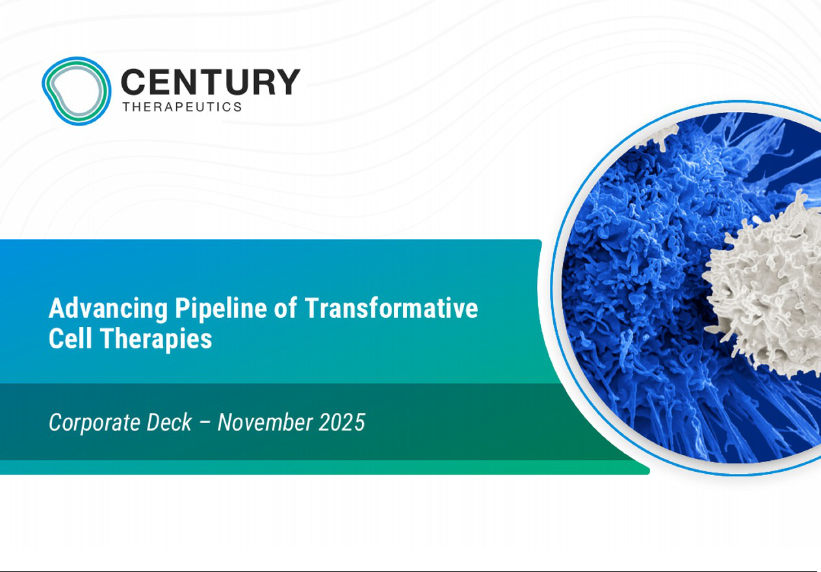

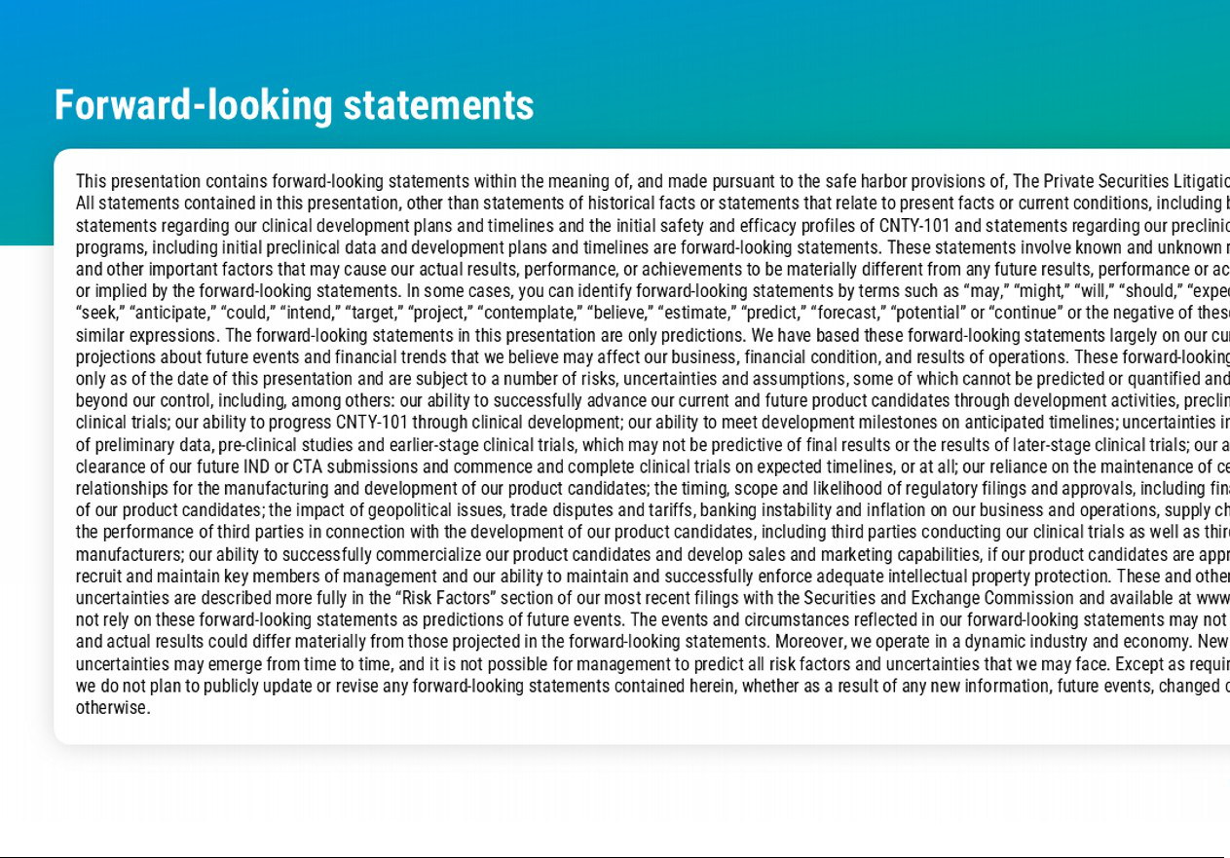

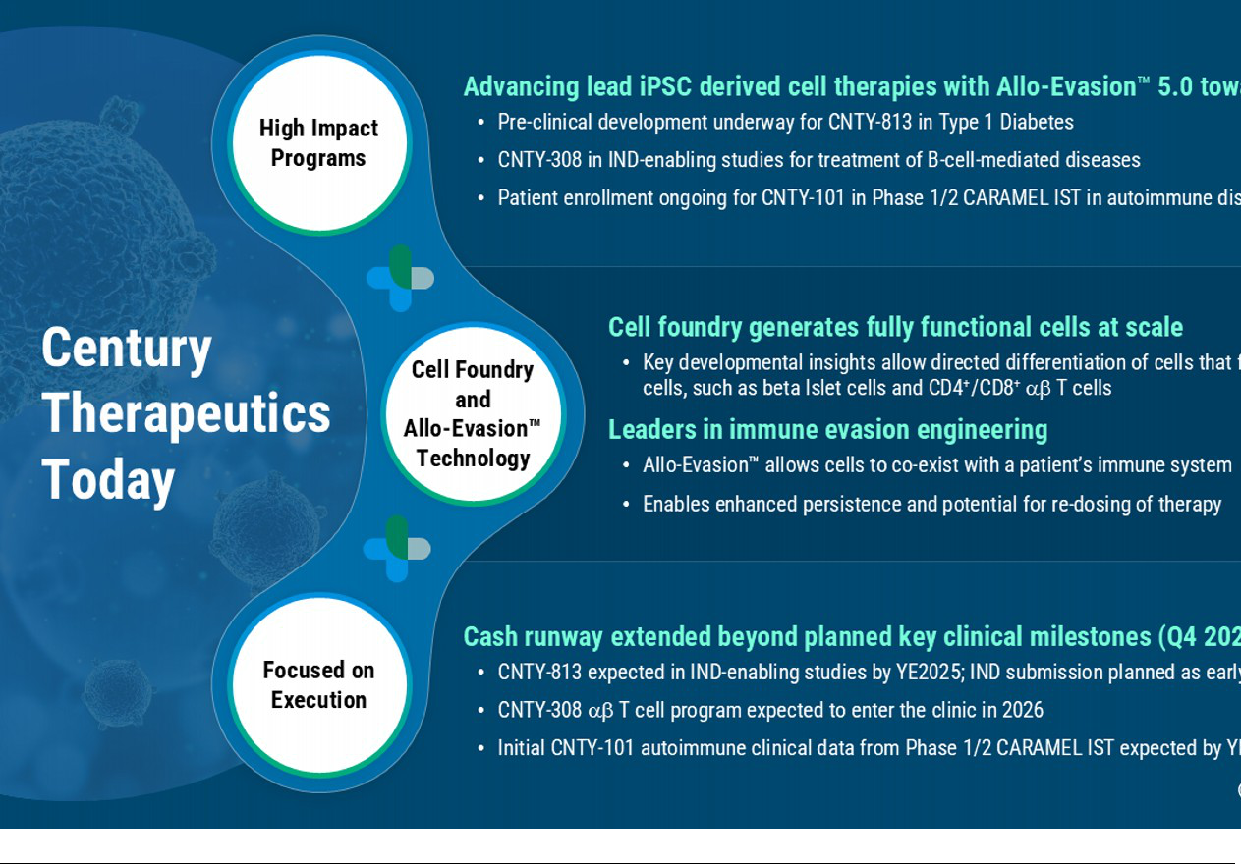

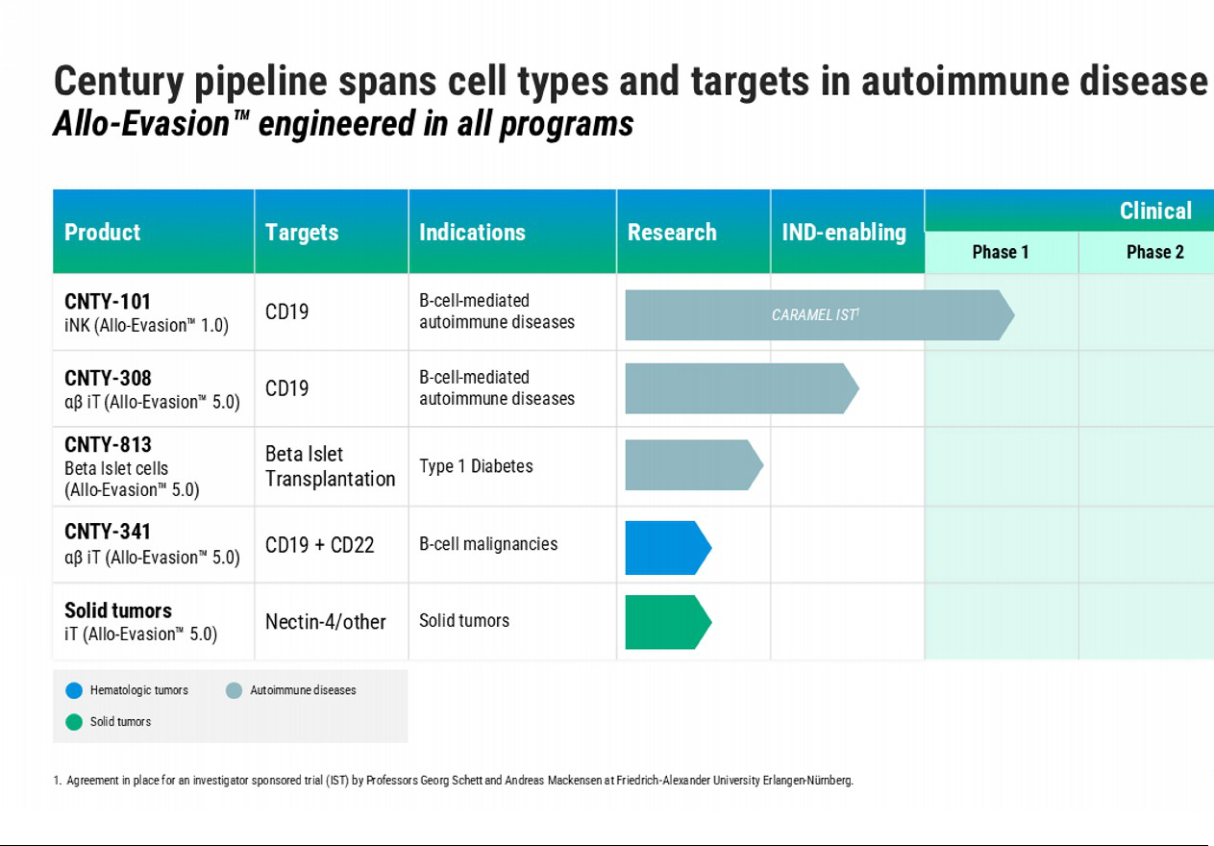

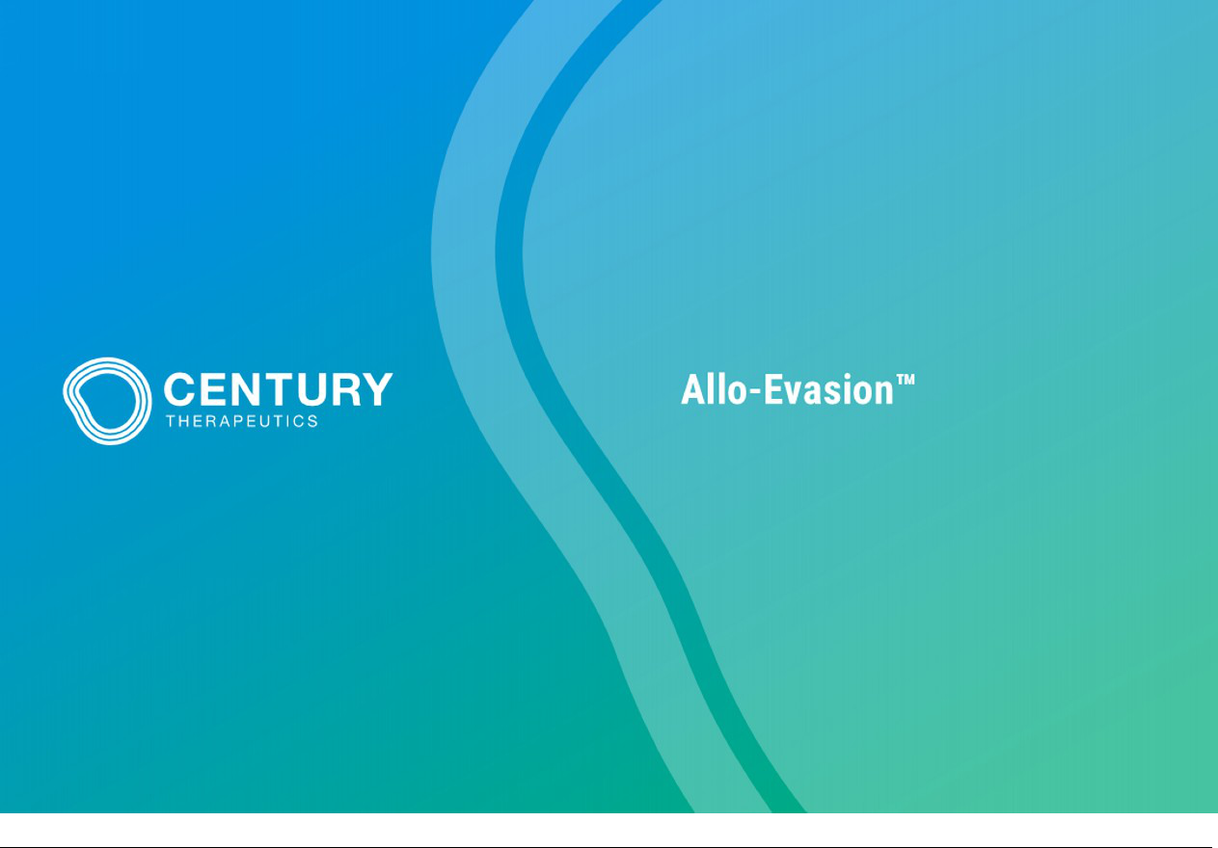

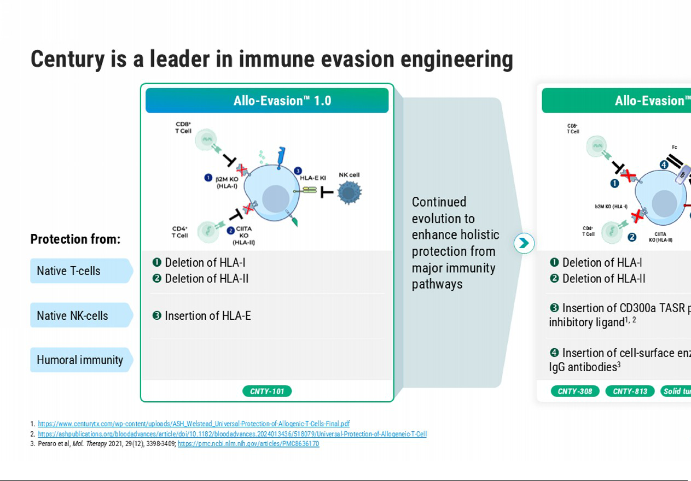

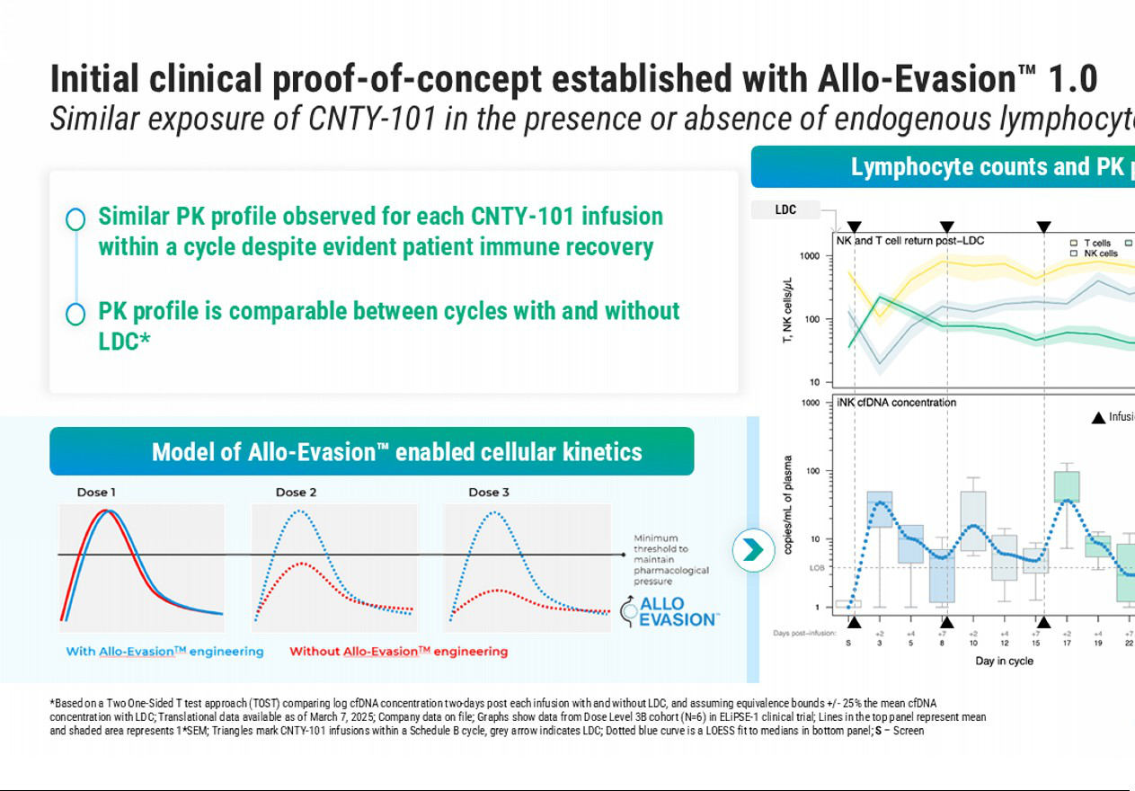

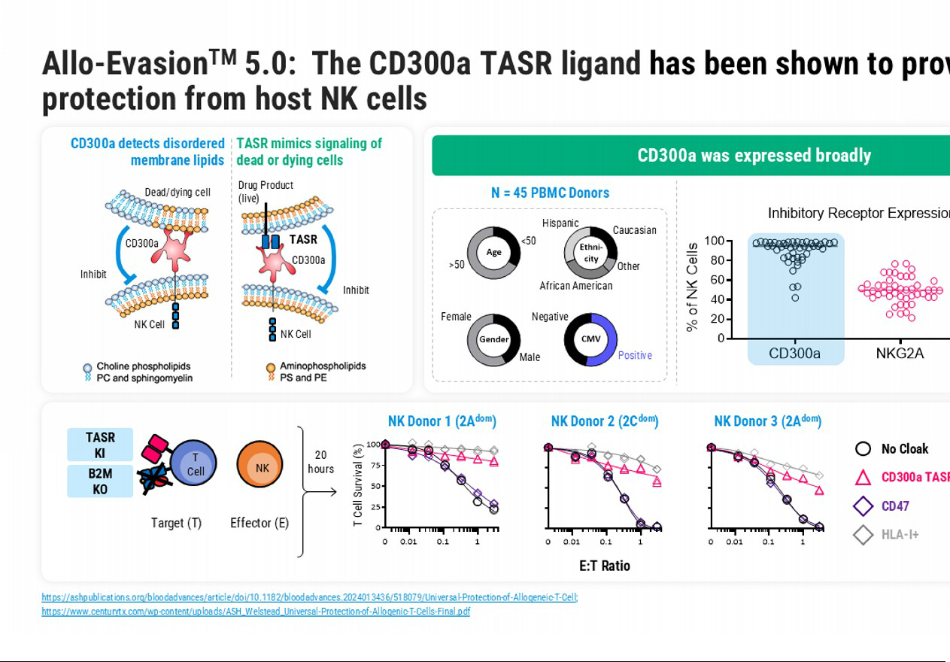

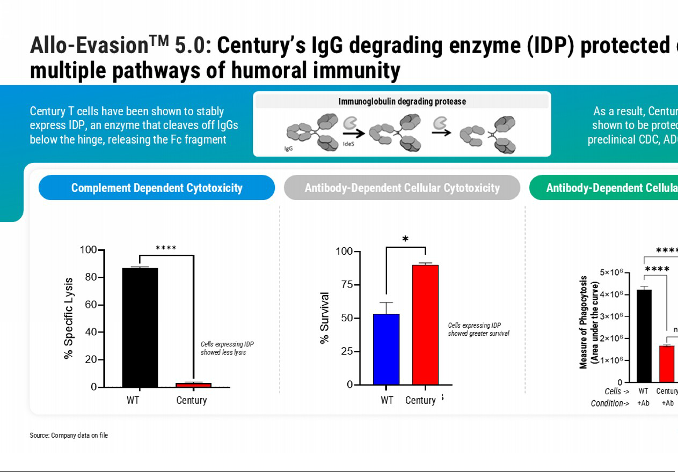

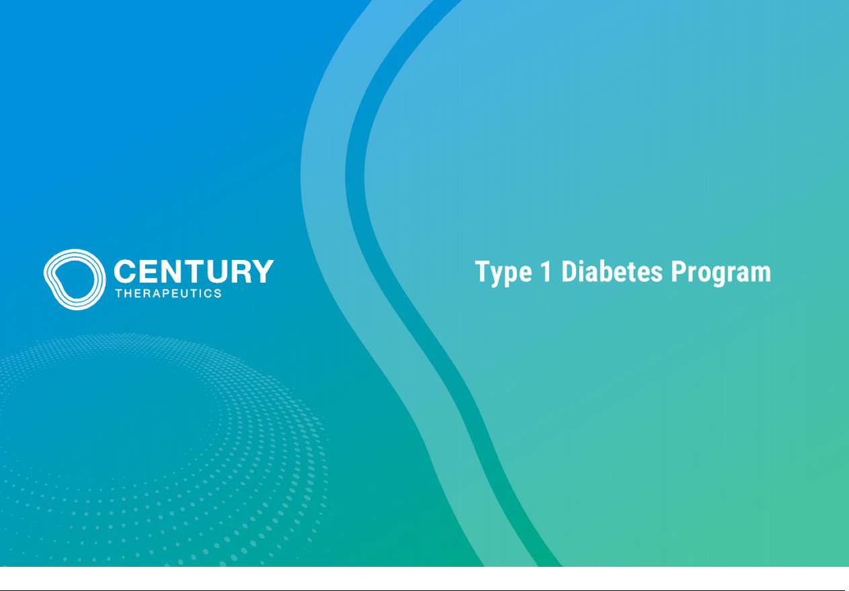

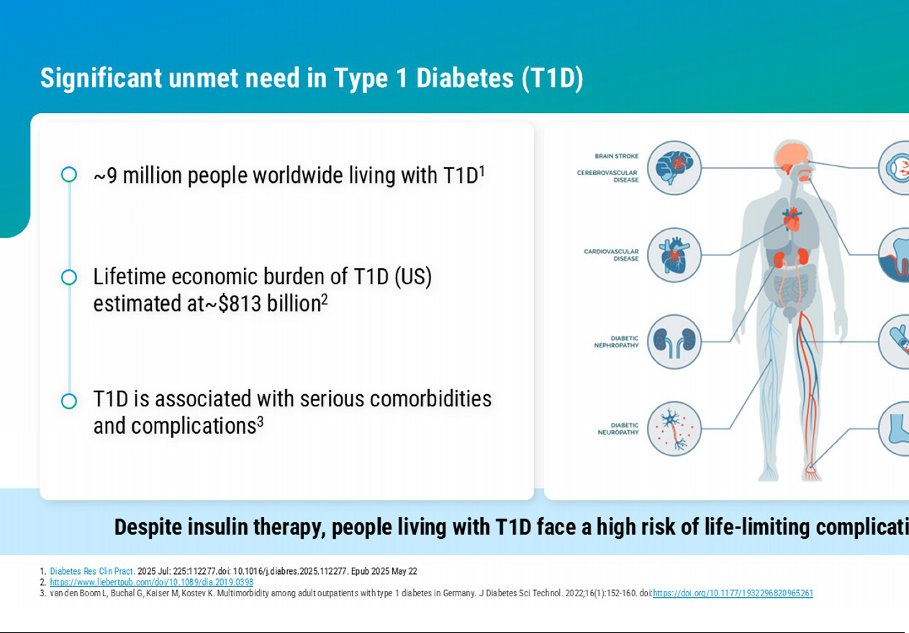

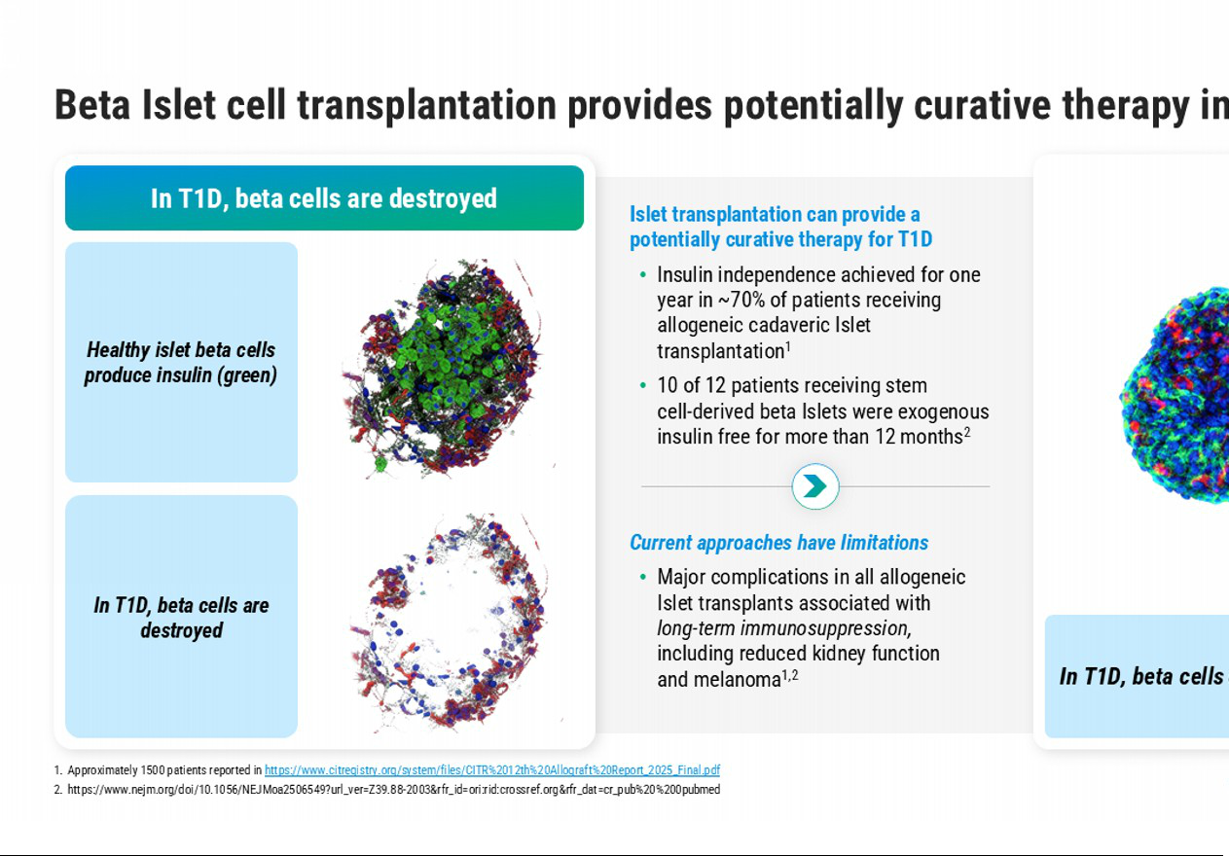

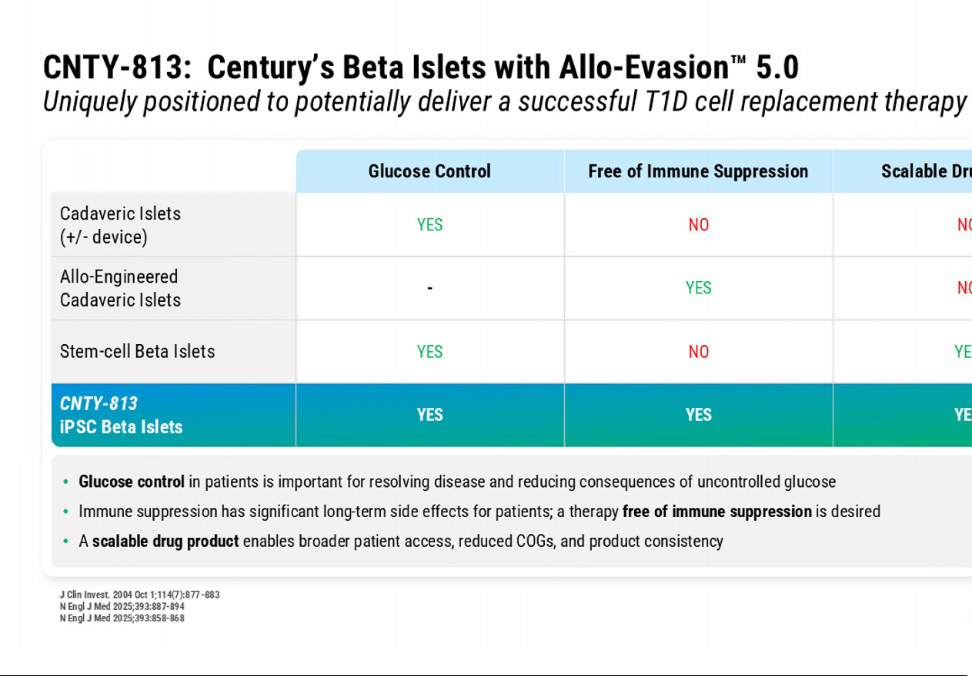

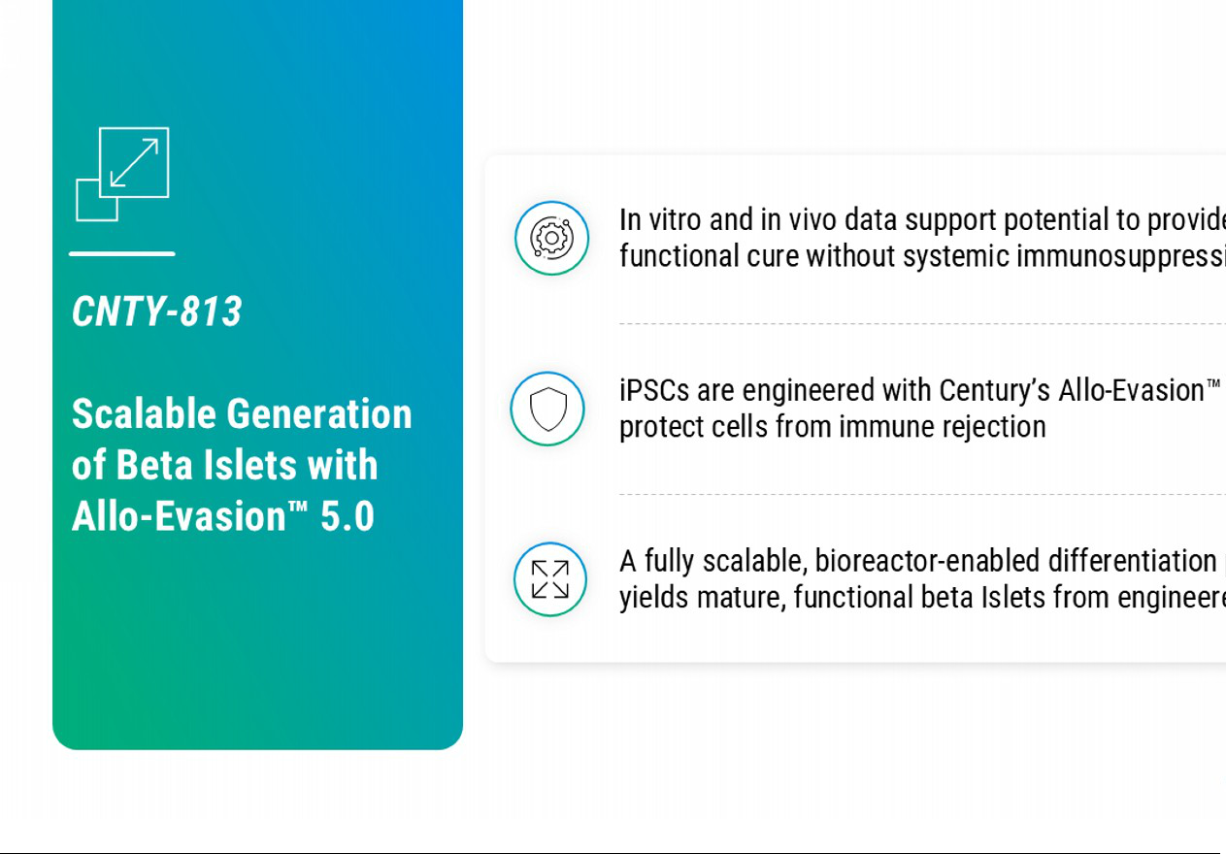

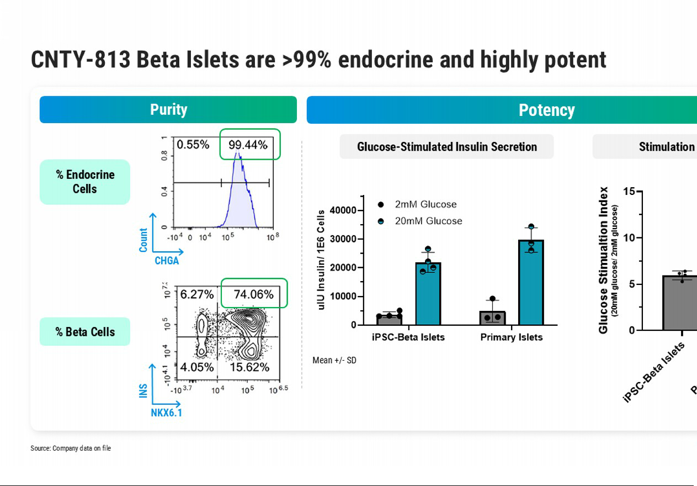

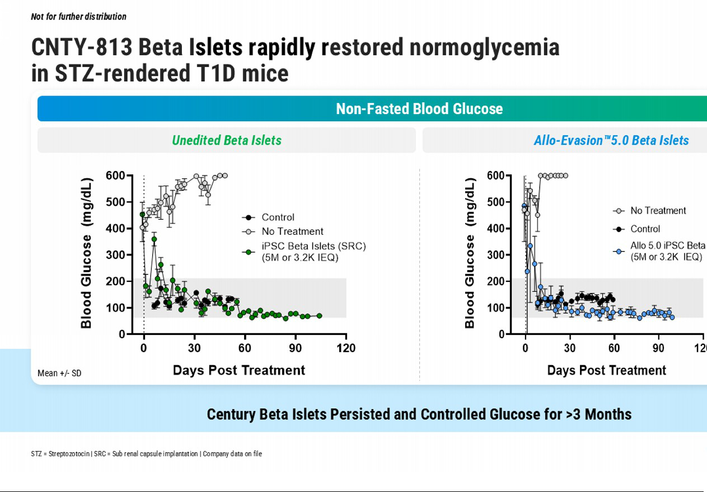

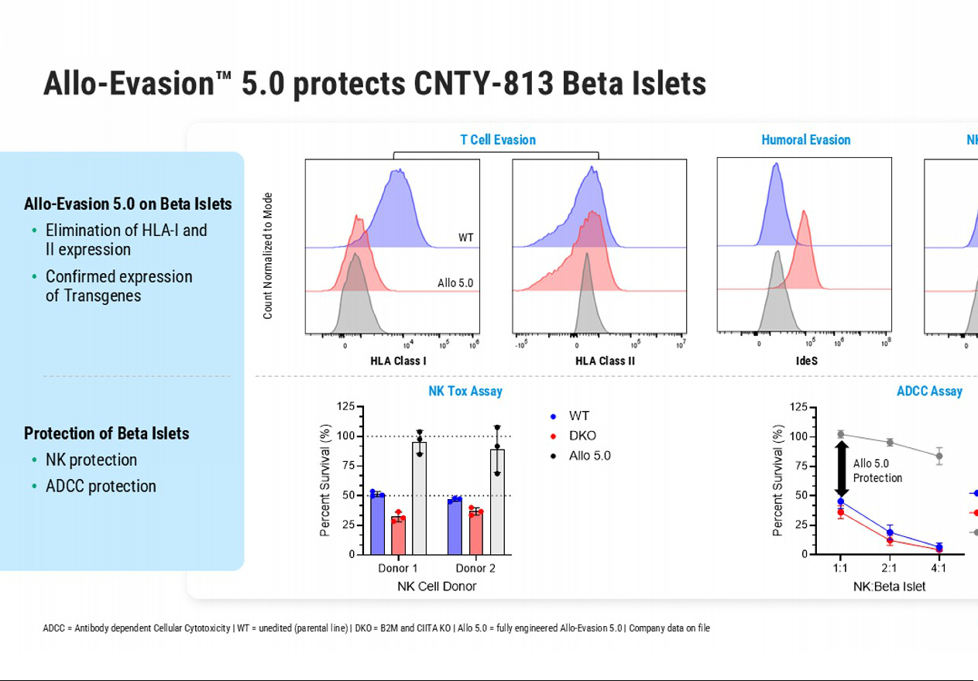

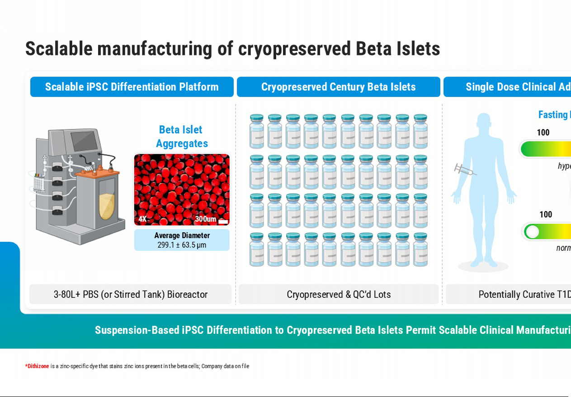



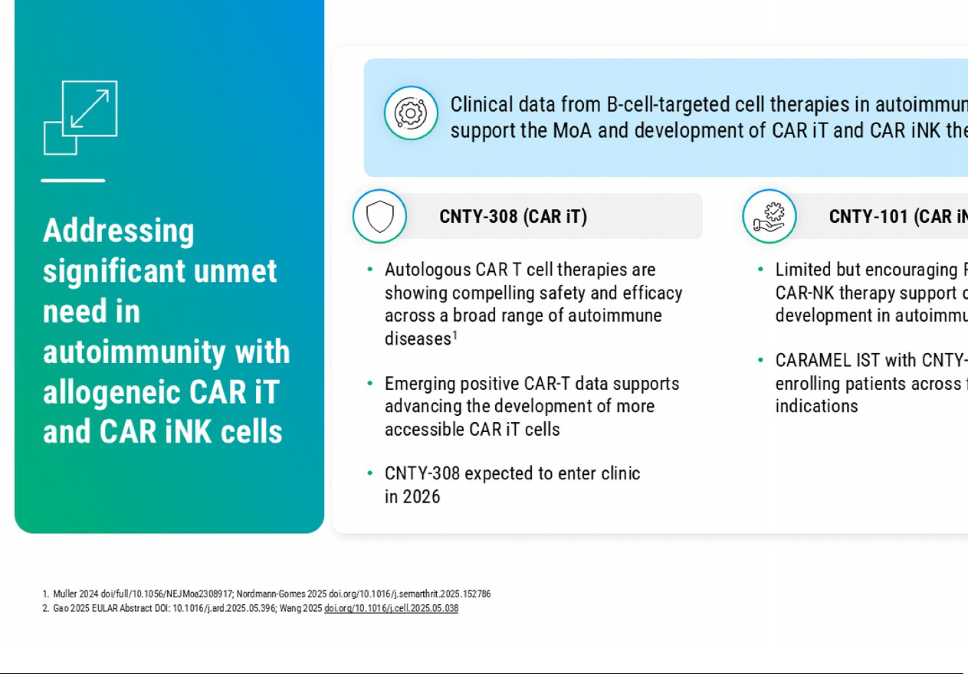

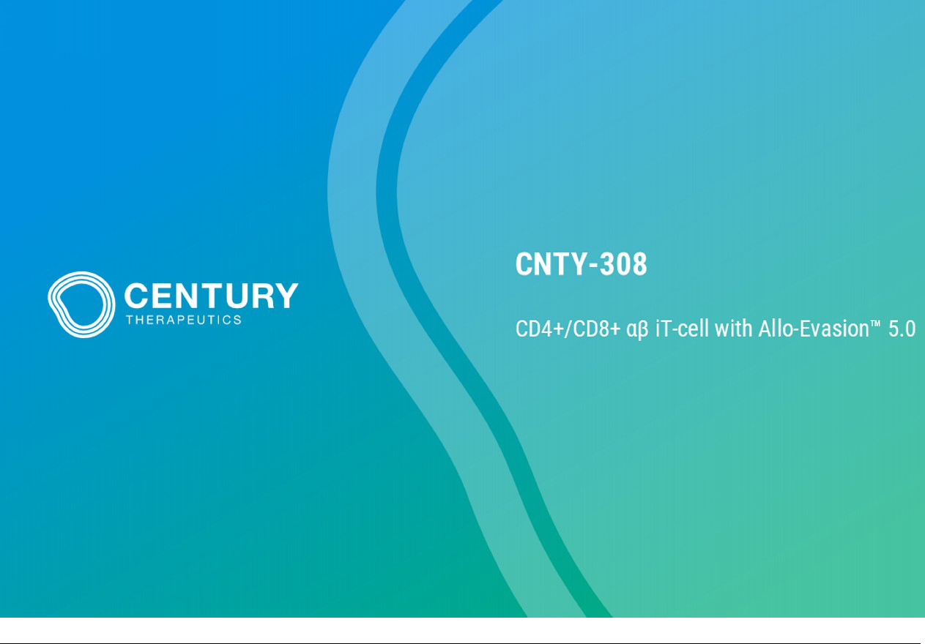

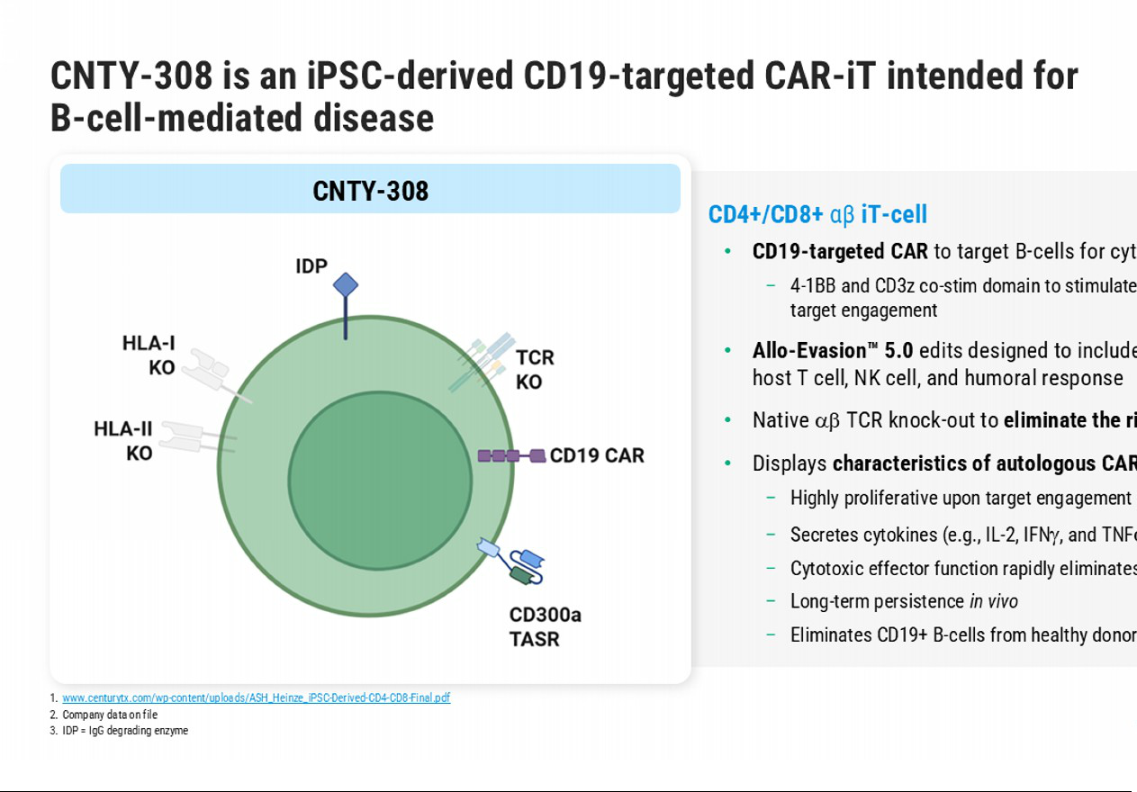

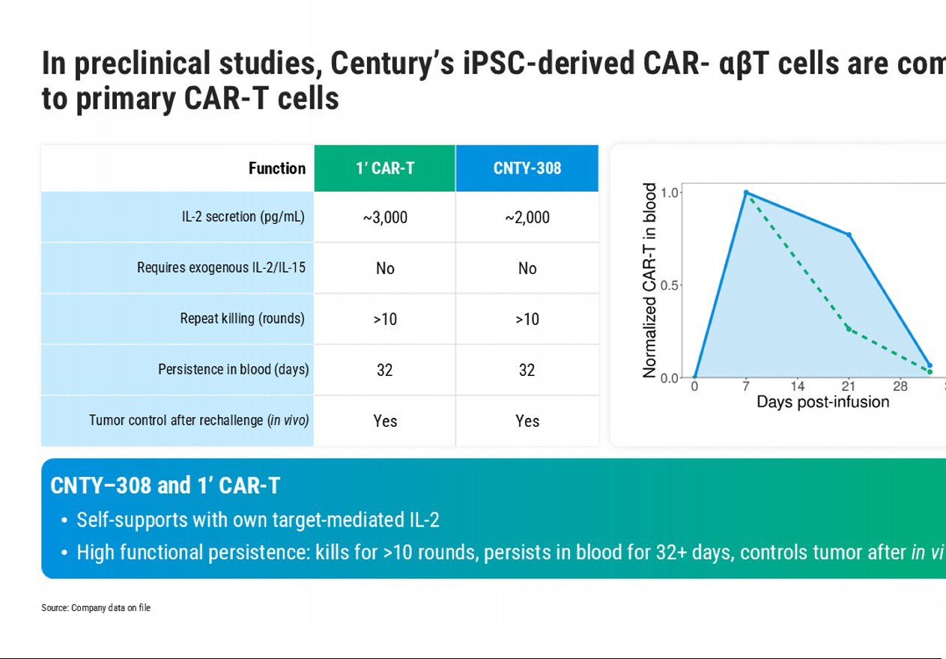

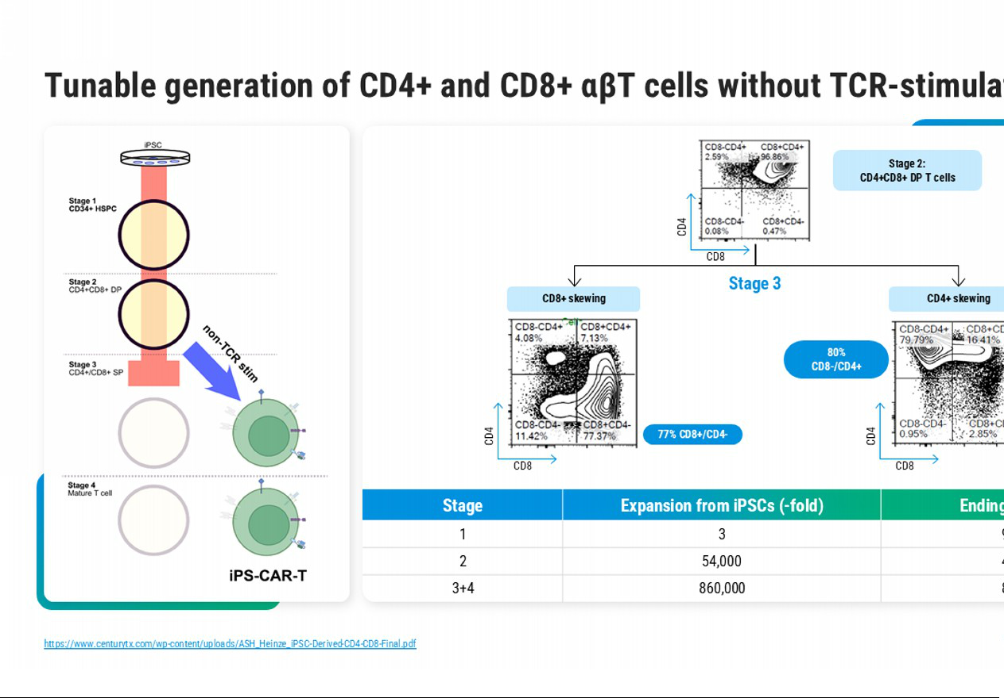

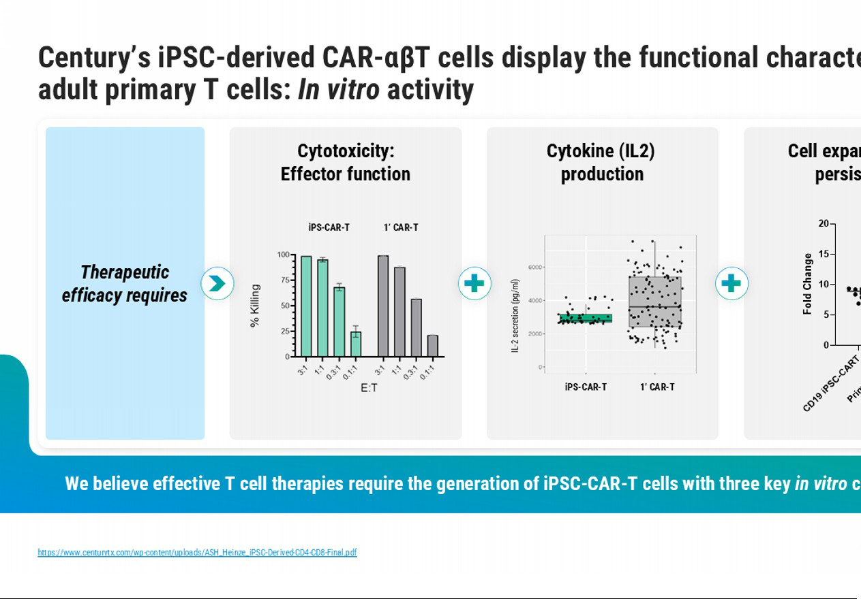

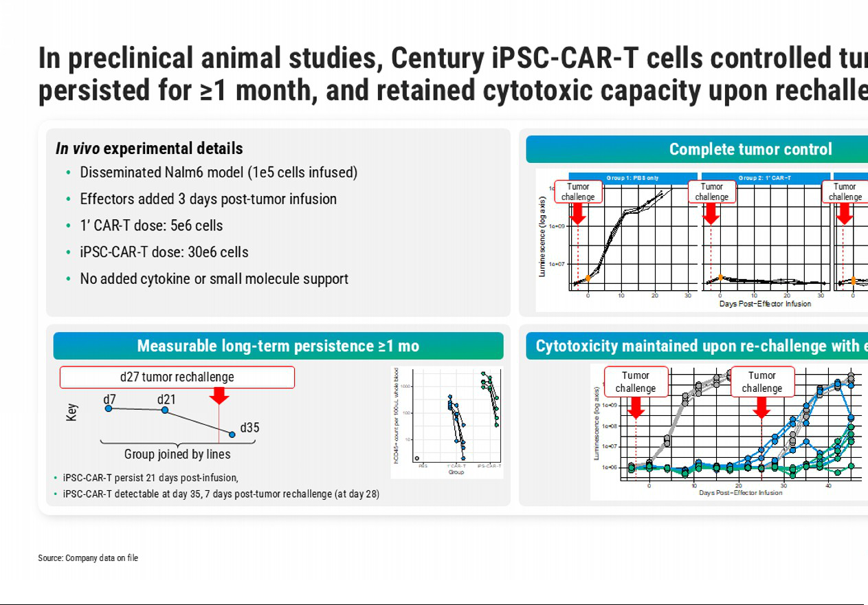

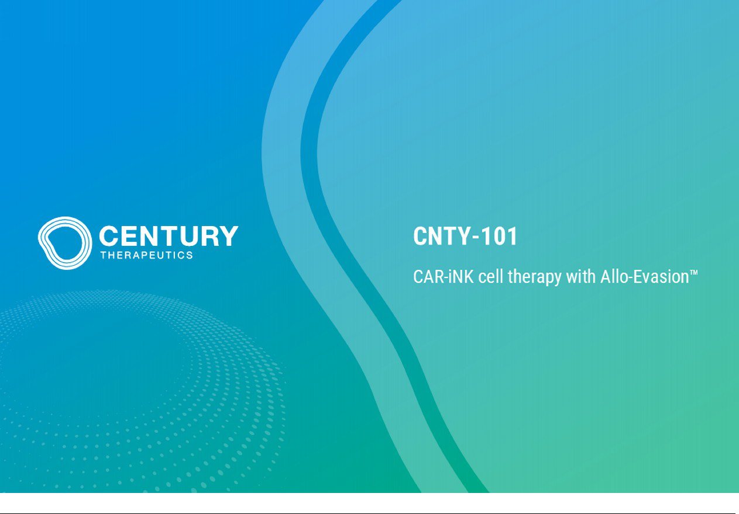

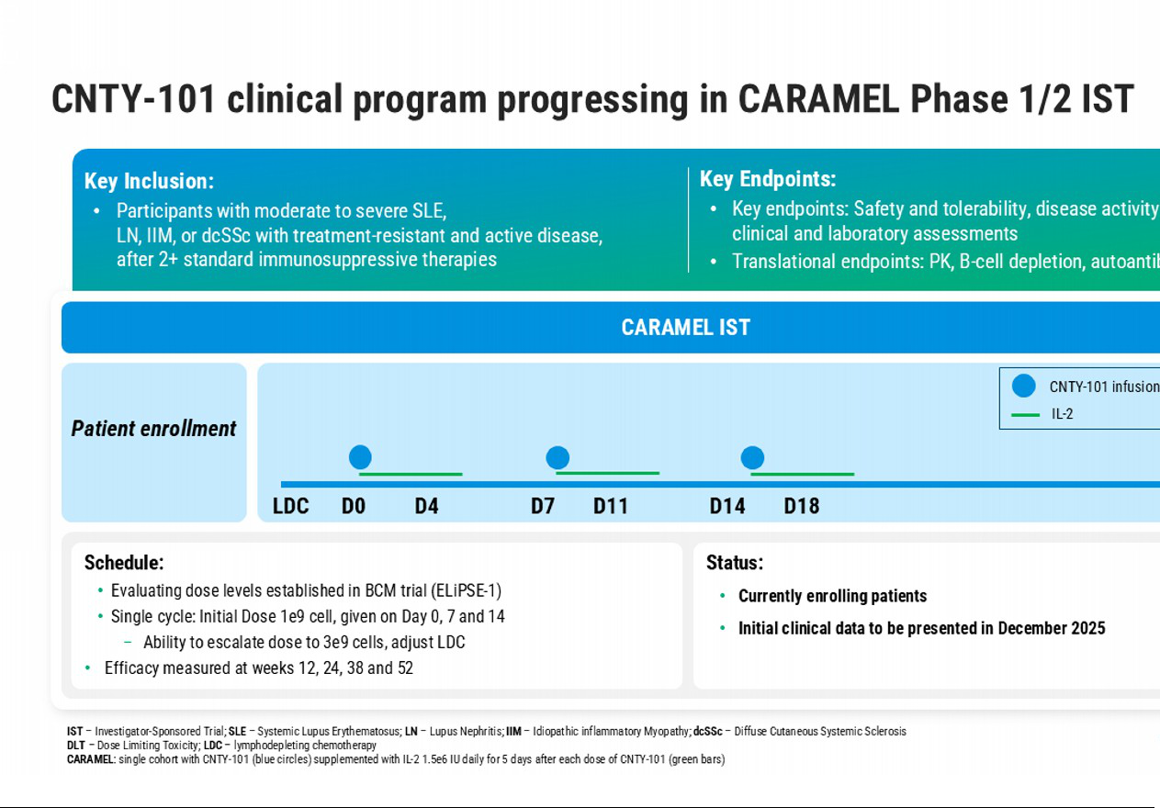

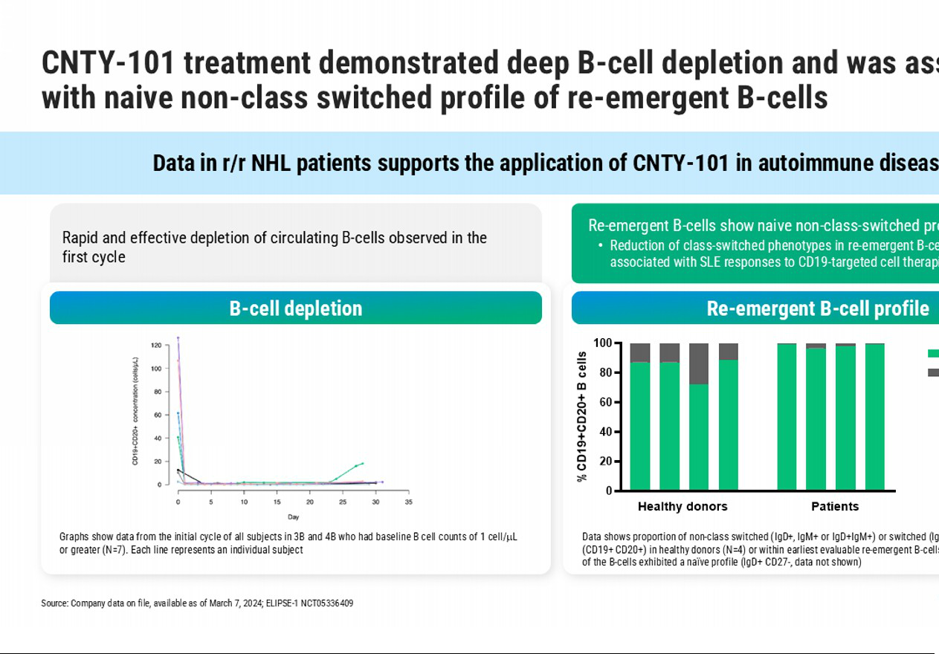

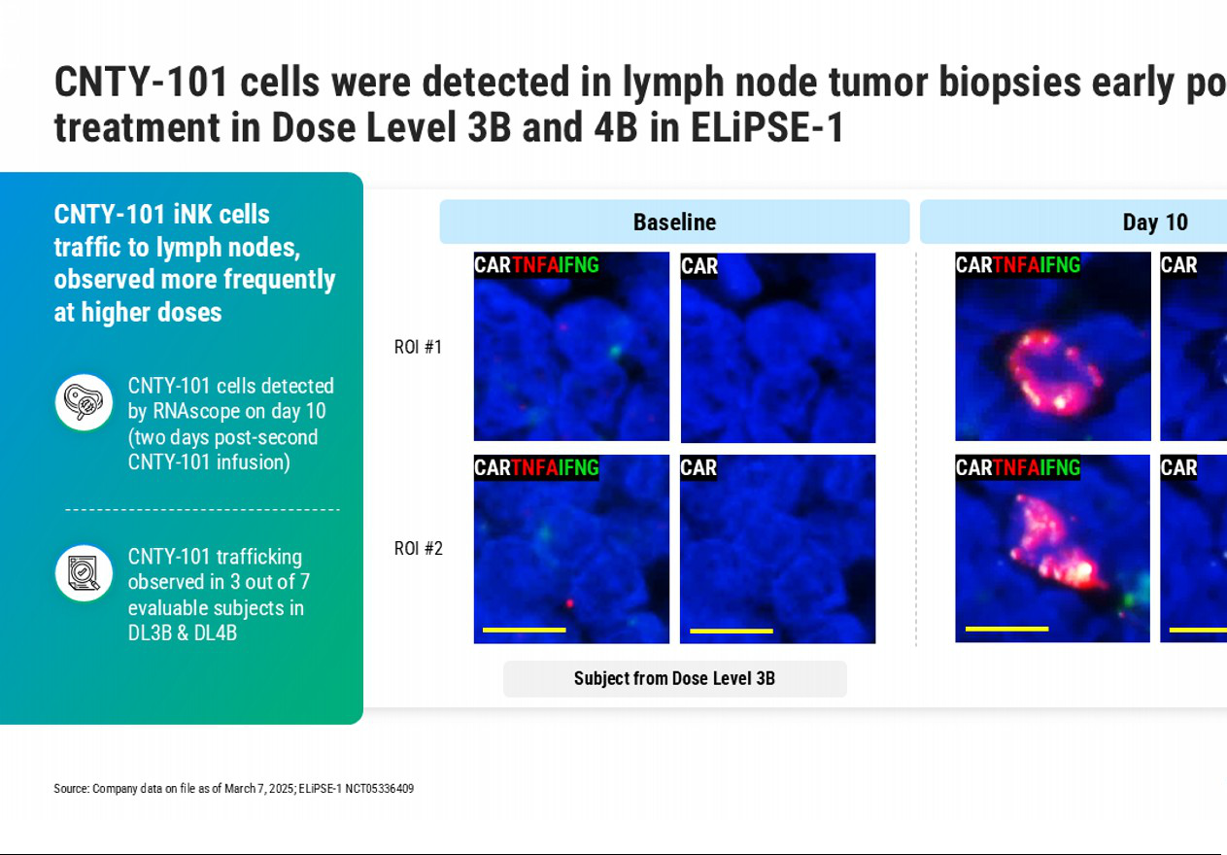

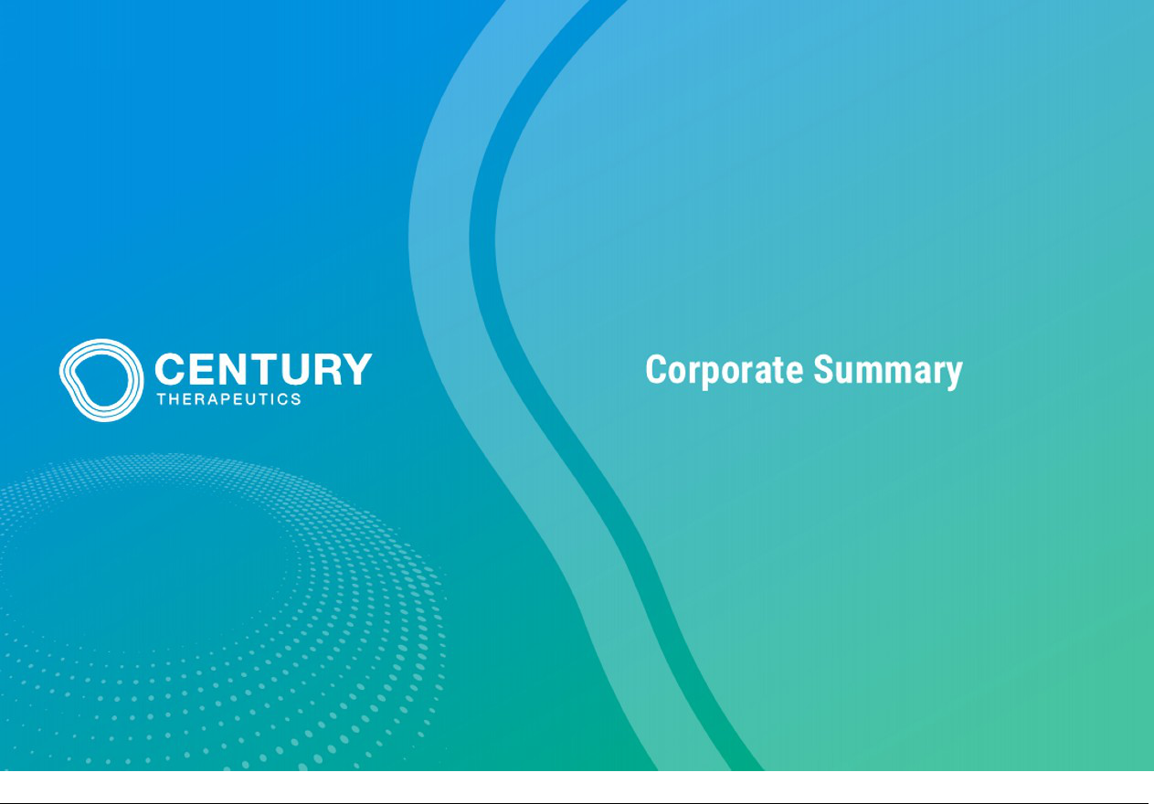

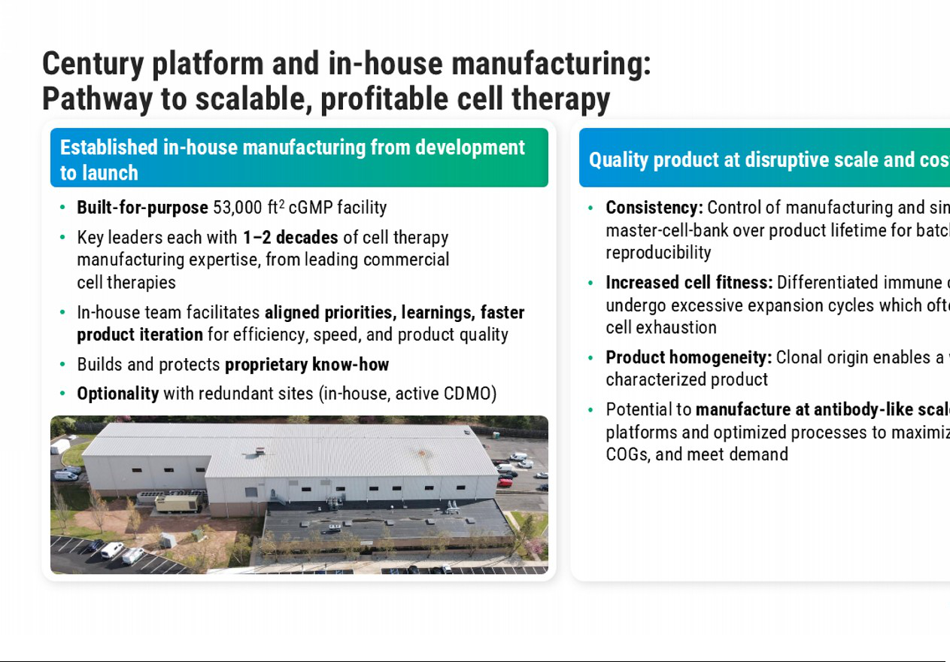



Exhibit 99.3

Century Therapeutics Announces New Beta Islet Program for Type 1 Diabetes

- Allo-Evasion™ 5.0-engineered iPSC beta islets are designed to overcome immune rejection and provide durable glucose control without chronic immunosuppression

- Compelling preclinical data demonstrate rapid reversal of diabetes and sustained normoglycemia, human C-peptide production and mature GSIS, supported by scalable bioreactor-based manufacturing

- Investigational New Drug (IND)-enabling studies on track to initiate by year-end 2025; IND submission planned as early as 2026

PHILADELPHIA, Nov. 13, 2025 -- Century Therapeutics, Inc. (‘Century’, NASDAQ: IPSC), a biotechnology company developing induced pluripotent stem cell (iPSC)-derived cell therapies for autoimmune diseases and cancer, today announced its first program for Type 1 diabetes (T1D), CNTY-813. The program comprises iPSC-derived beta islets engineered with the company’s proprietary Allo-Evasion™ 5.0 technology, designed to protect from T cell, NK cell and humoral immune rejection, with the goal of durable glycemic control without the need for systemic immunosuppression.

“With our cell foundry and Allo-Evasion™ 5.0 technology, we have engineered iPSC derived beta islets that we believe can deliver durable glycemic control without chronic immunosuppression,” said Chad Cowan, Ph.D., Chief Scientific Officer of Century Therapeutics. “After initiating discovery activities earlier this year, we have now generated compelling preclinical data that underscores the deep potential of this program, including rapid and sustained normalization of glucose in diabetic mouse models, significant glucose-stimulated insulin secretion with detectable human C-peptide and engineered resistance to NK cell-mediated killing and antibody-dependent cellular cytotoxicity. Additionally, our suspension bioreactor process is capable of delivering mature, functional beta islets at scale, which we believe positions us to produce a consistent drug product suitable for broad patient access, if approved by regulatory authorities. Considering the large, underserved T1D patient population, we believe this program has great promise to be a potentially curative new therapy.”

“Today, people with T1D struggle with unpredictable glucose swings, the burden of lifelong insulin, and diabetes related complications. An off-the-shelf, immune-evasive beta islet therapy that restores physiologic insulin production without systemic immunosuppression would represent a paradigm shift,” said James Markmann, M.D., Ph.D., Vice President for Transplantation Services, Perelman School of Medicine, University of Pennsylvania.

Century has generated in vitro and in vivo preclinical data demonstrating:

- Rapid and sustained glucose control in streptozotocin (STZ)-induced diabetic models following transplantation of iPSC-derived beta islets, including maintenance of normoglycemia and human C-peptide production.

- Significant in vitro function, including glucose-stimulated insulin secretion (GSIS) with stimulation indices consistent with mature beta cell phenotypes.

- Allo-Evasion™ 5.0 enables immune protection with knockout of human leukocyte antigen (HLA) class I and II, expression of CD300a-based pan-NK inhibitory ligand and immunoglobulin-degrading enzyme that reduces antibody-dependent cellular toxicity (ADCC), resulting in preserved cell survival in NK cytotoxicity and ADCC assays.

Century expects to initiate IND-enabling studies by year-end 2025 and plans to submit an IND application to the U.S. Food and Drug Administration (FDA) as early as 2026.

About Type 1 Diabetes (T1D)

T1D affects approximately 9 million people worldwide, including approximately 2 million in the U.S., with a significant subset facing persistent hypoglycemia, glycemic variability, and long-term complications despite exogenous insulin. The current treatment of T1D also places a significant burden on the healthcare system, with approximately $6-8 billion spent on insulin annually in the U.S. A scalable, off-the-shelf, immune-evasion-enabled beta islet therapy could reach broad patient segments and expand access relative to donor-dependent transplantation or device-limited solutions. Century’s beta islet program is designed to combine clinical impact with a path to profitable scalability, supporting the potential for long-term value creation.

About Century Therapeutics

Century Therapeutics (NASDAQ: IPSC) is a biotechnology company advancing a pipeline of induced pluripotent stem cell (iPSC)-derived cell therapies with the potential to meaningfully address autoimmune diseases and cancer. The company’s therapies are derived from its iPSC cell foundry and leverage its novel immune evasion engineering technology, Allo-Evasion™. Century believes its approach to developing off-the-shelf cell therapies will expand patient access and provide advantages over existing cell therapies which will ultimately advance the course of care. For more information on Century Therapeutics, please visit www.centurytx.com and connect with us on LinkedIn.

Forward-Looking Statements

This press release contains forward-looking statements within the meaning of, and made pursuant to the safe harbor provisions of, The Private Securities Litigation Reform Act of 1995. All statements contained in this press release, other than statements of historical facts or statements that relate to present facts or current conditions, including but not limited to, statements regarding our timing and expectations regarding our preclinical and clinical development programs, including their planned development, therapeutic potential and market opportunity, ongoing and planned regulatory interactions, the achievement of developmental milestones, and corporate strategies are forward-looking statements. These statements involve known and unknown risks, uncertainties and other important factors that may cause our actual results, performance, or achievements to be materially different from any future results, performance or achievements expressed or implied by the forward-looking statements. In some cases, you can identify forward-looking statements by terms such as “may,” “might,” “will,” “should,” “expect,” “plan,” “aim,” “seek,” “anticipate,” “could,” “intend,” “target,” “project,” “contemplate,” “believe,” “estimate,” “predict,” “forecast,” “potential” or “continue” or the negative of these terms or other similar expressions. The forward-looking statements in this press release are only predictions. We have based these forward-looking statements largely on our current expectations and projections about future events and financial trends that we believe may affect our business, financial condition, and results of operations. These forward-looking statements speak only as of the date of this press release and are subject to a number of risks, uncertainties and assumptions, some of which cannot be predicted or quantified and some of which are beyond our control, including, among others: our ability to successfully advance our current and future product candidates through development activities, preclinical studies, and clinical trials; our ability to meet development milestones on anticipated timelines; uncertainties inherent in the results of preliminary data, pre-clinical studies and earlier-stage clinical trials, which may not be predictive of final results or the results of later-stage clinical trials; our ability to obtain clearance of our future IND or Clinical Trial Application (CTA) submissions and commence and complete clinical trials on expected timelines, or at all; our reliance on the maintenance of certain key collaborative relationships for the manufacturing and development of our product candidates; the timing, scope and likelihood of regulatory filings and approvals, including final regulatory approval of our product candidates; the impact of geopolitical issues, trade disputes and tariffs, banking instability and inflation on our business and operations, supply chain and labor force; the performance of third parties in connection with the development of our product candidates, including third parties conducting our clinical trials as well as third-party suppliers and manufacturers; our ability to successfully commercialize our product candidates and develop sales and marketing capabilities, if our product candidates are approved; our ability to recruit and maintain key members of management and our ability to maintain and successfully enforce adequate intellectual property protection. These and other risks and uncertainties are described more fully in the “Risk Factors” section of our most recent filings with the Securities and Exchange Commission and available at www.sec.gov. You should not rely on these forward-looking statements as predictions of future events. The events and circumstances reflected in our forward-looking statements may not be achieved or occur, and actual results could differ materially from those projected in the forward-looking statements. Moreover, we operate in a dynamic industry and economy. New risk factors and uncertainties may emerge from time to time, and it is not possible for management to predict all risk factors and uncertainties that we may face. Except as required by applicable law, we do not plan to publicly update or revise any forward-looking statements contained herein, whether as a result of any new information, future events, changed circumstances or otherwise.

For More Information:

Century Therapeutics

Douglas Carr

Senior Vice President, Finance

investor.relations@centurytx.com

JPA Health

Sarah McCabe

smccabe@jpa.com

