UNITED STATES

SECURITIES AND EXCHANGE COMMISSION

Washington, DC 20549

FORM 8-K

CURRENT REPORT

Pursuant to Section 13 or 15(d)

of the Securities Exchange Act of 1934

Date of Report (Date of earliest event reported): January 5, 2023

Century Therapeutics, Inc.

(Exact name of registrant as specified in its charter)

Delaware

(State or other jurisdiction of

incorporation or organization)

001-40498

(Commission File Number)

84-2040295

(I.R.S. Employer

Identification No.)

3675 Market Street

Philadelphia, Pennsylvania

(Address of principal executive offices)

19104

(Zip Code)

Registrant’s telephone number, including area code: (267) 817-5790

Not Applicable

(Former name or former address, if changed since last report)

Check the appropriate box below if the Form 8-K filing is intended to simultaneously satisfy the filing obligation of the registrant under any of the following provisions (see General Instruction A.2. below):

- Written communications pursuant to Rule 425 under the Securities Act (17 CFR 230.425)

- Soliciting material pursuant to Rule 14a-12 under the Exchange Act (17 CFR 240.14a-12)

- Pre-commencement communications pursuant to Rule 14d-2(b) under the Exchange Act (17 CFR 240.14d-2(b))

- Pre-commencement communications pursuant to Rule 13e-4(c) under the Exchange Act (17 CFR 240.13e-4(c))

Securities registered pursuant to Section 12(b) of the Act:
 |  |  |  | Name of Exchange on Which
Title of Each Class |  | Trading Symbol |  | Registered
Common Stock, par value $0.0001 per share |  | IPSC |  | Nasdaq Global Select Market

Indicate by check mark whether the registrant is an emerging growth company as defined in Rule 405 of the Securities Act of 1933 (§230.405 of this chapter) or Rule 12b-2 of the Securities Exchange Act of 1934 (§240.12b-2 of this chapter).

Emerging growth company ☒

If an emerging growth company, indicate by check mark if the registrant has elected not to use the extended transition period for complying with any new or revised financial accounting standards provided pursuant to Section 13(a) of the Exchange Act. ☐

Item 7.01 Regulation FD Disclosure

On January 9, 2022, Century Therapeutics, Inc. (the “Company”) updated information reflected in a slide presentation, which is attached as Exhibit 99.1 to this Current Report on Form 8-K and is incorporated herein by reference. Representatives of the Company will use the updated presentation in various meetings with investors from time to time.

The information contained in this Item 7.01 (including Exhibit 99.1) is being furnished and shall not be deemed “filed” for purposes of Section 18 of the Exchange Act, as amended (the “Exchange Act”), or otherwise subject to the liabilities of that section and shall not be deemed to be incorporated by reference in any filing under the Securities Act of 1933, as amended, or the Exchange Act, except as shall be expressly set forth by specific reference in such filing.

Item 8.01 Other Events

On January 5, 2023, the Company issued a press release announcing its plan for internal portfolio prioritization to extend its cash runway into 2026. A copy of the press release is furnished as Exhibit 99.2 to this Current Report on Form 8-K and is incorporated herein by reference.

Item 9.01 Financial Statements and Exhibits

(d) Exhibits

Exhibit
No. |  |  |  | Document
99.1 |  |  | Investor Presentation of Century Therapeutics, Inc., dated January 9, 2022
99.2 |  |  | Press Release of Century Therapeutics, Inc., dated January 5, 2023
104 |  |  | Cover Page Interactive Data File (embedded within the Inline XBRL document)

SIGNATURES

Pursuant to the requirements of the Securities Exchange Act of 1934, the registrant has duly caused this report to be signed on its behalf by the undersigned hereunto duly authorized.

CENTURY THERAPEUTICS, INC.

By: | /s/ Osvaldo Flores, Ph.D.
Name: | Osvaldo Flores, Ph.D.
Title: | President and Chief Executive Officer

Date: January 9, 2023

Exhibit 99.1


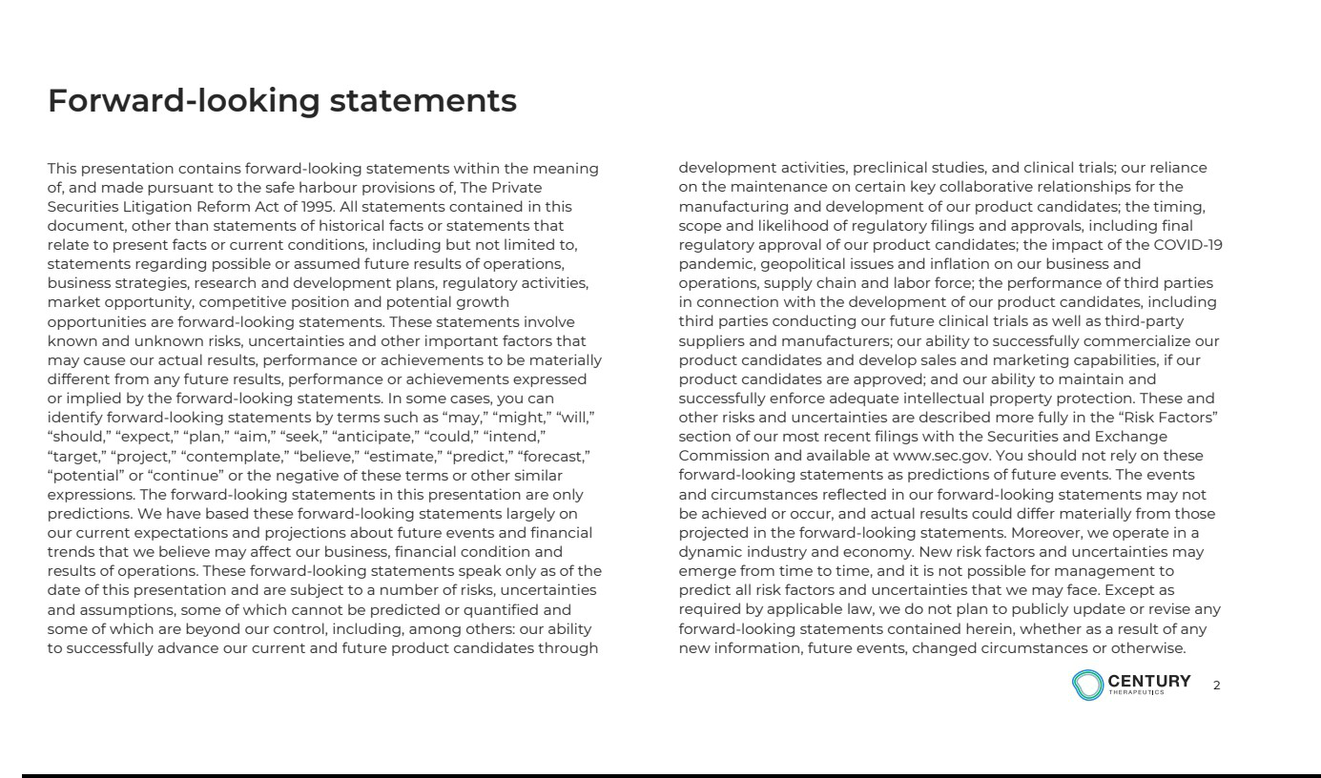

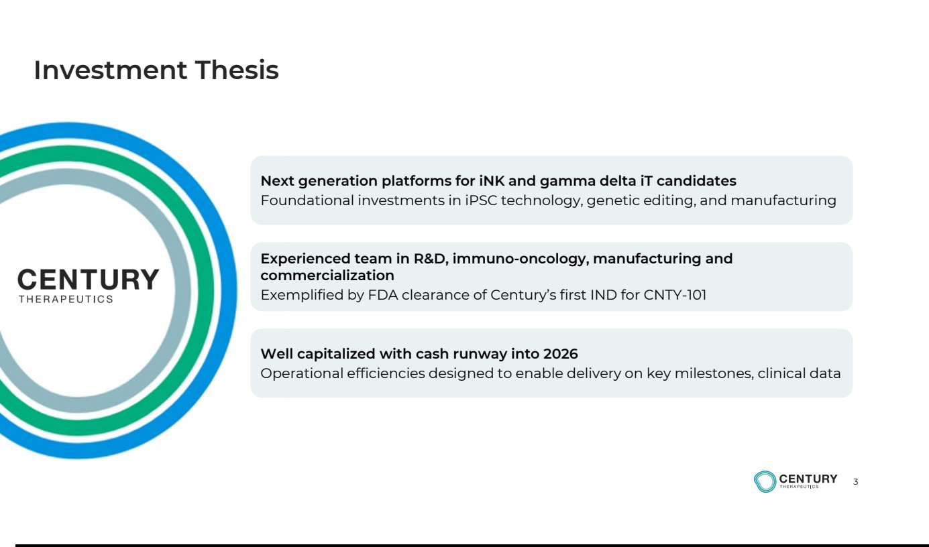

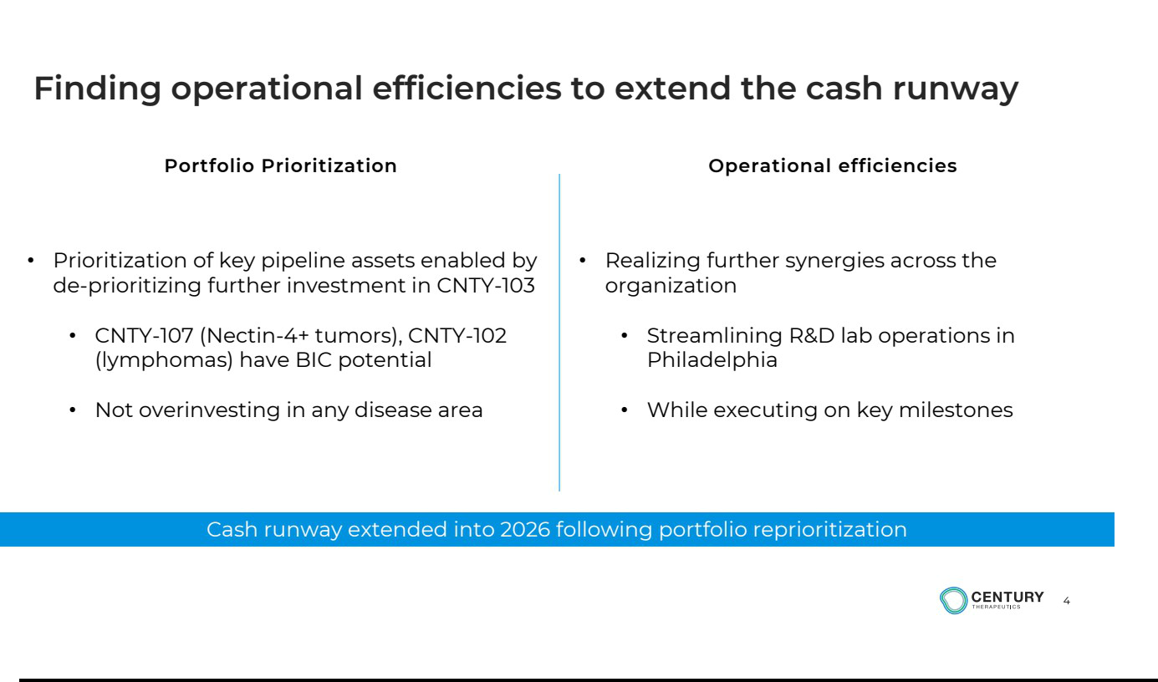

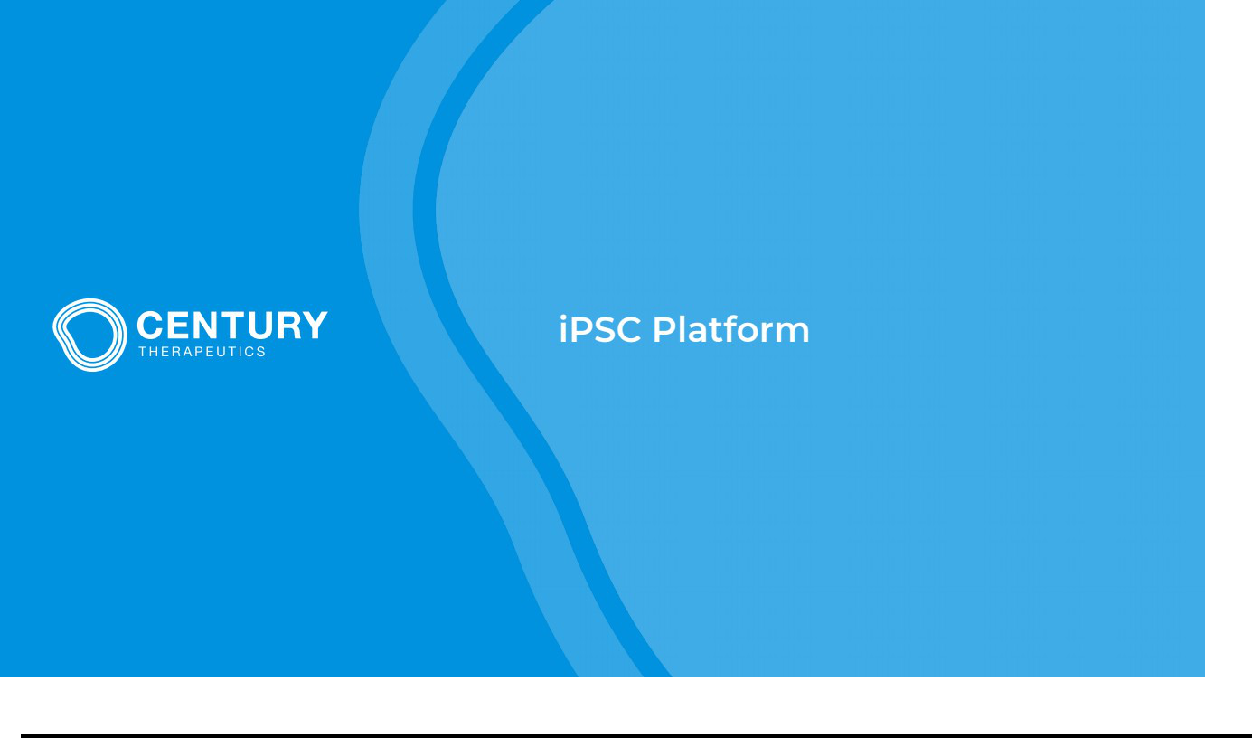

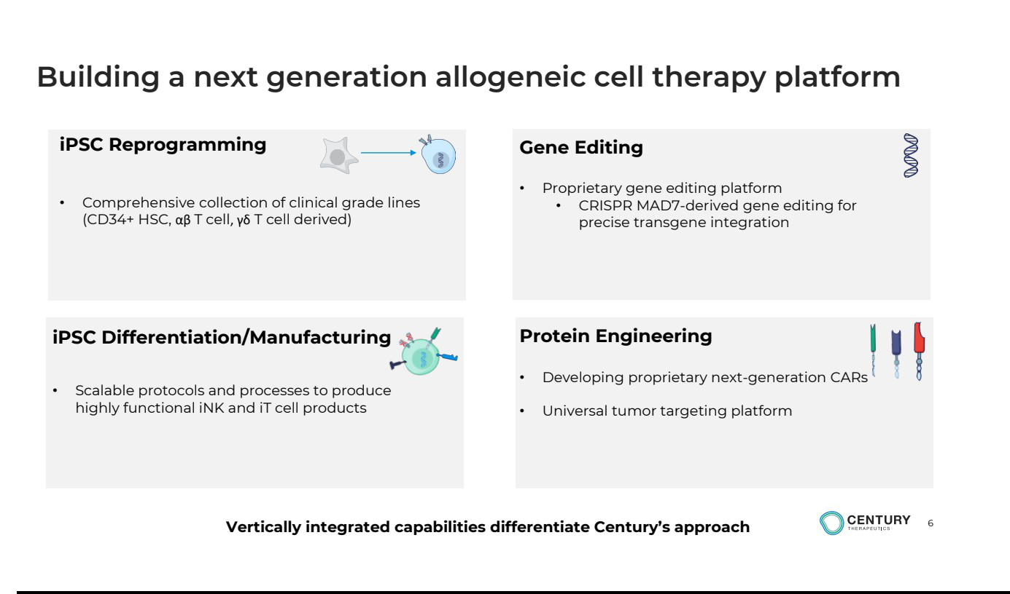

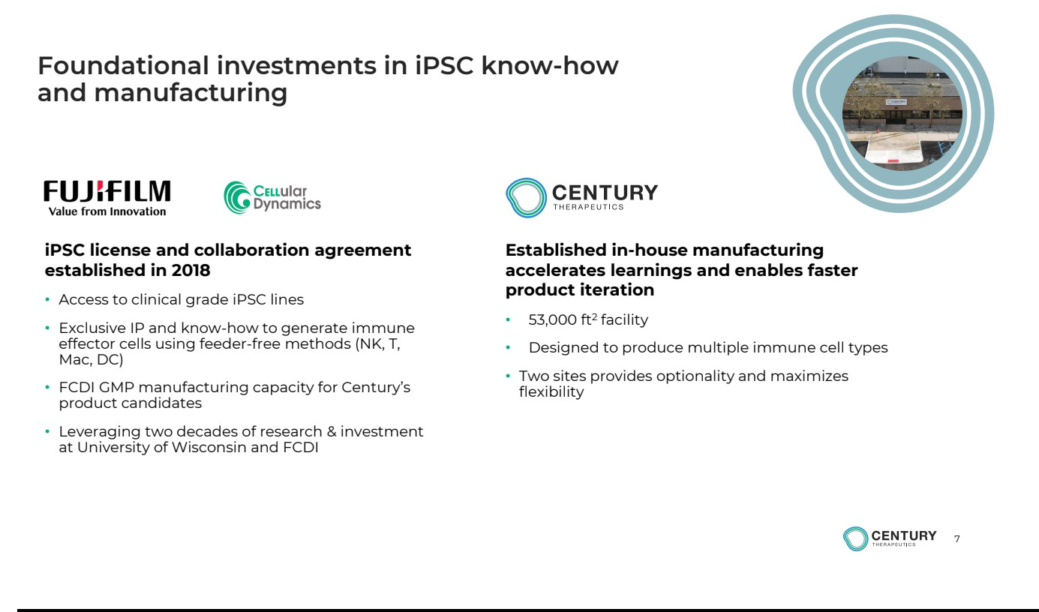

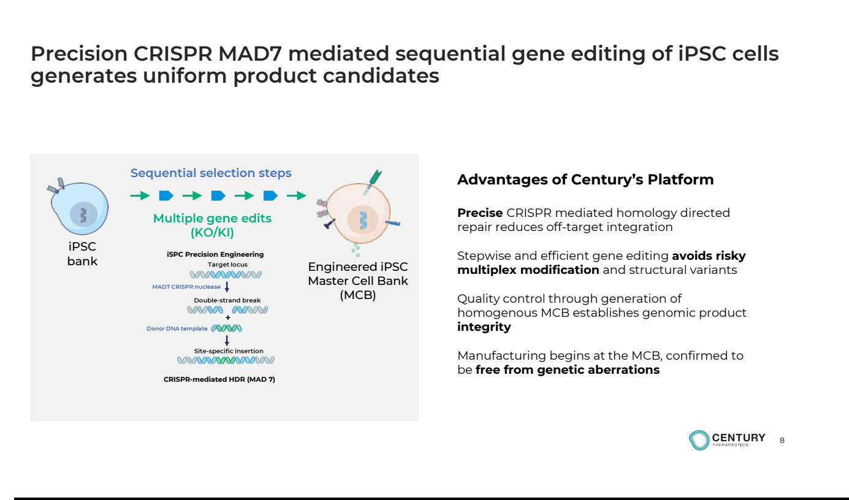

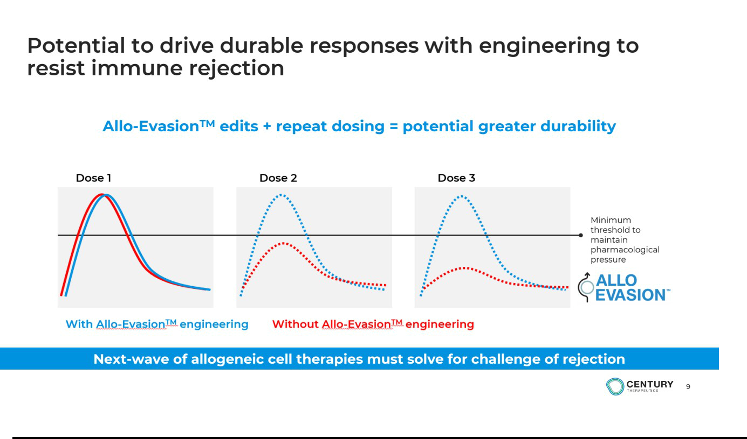

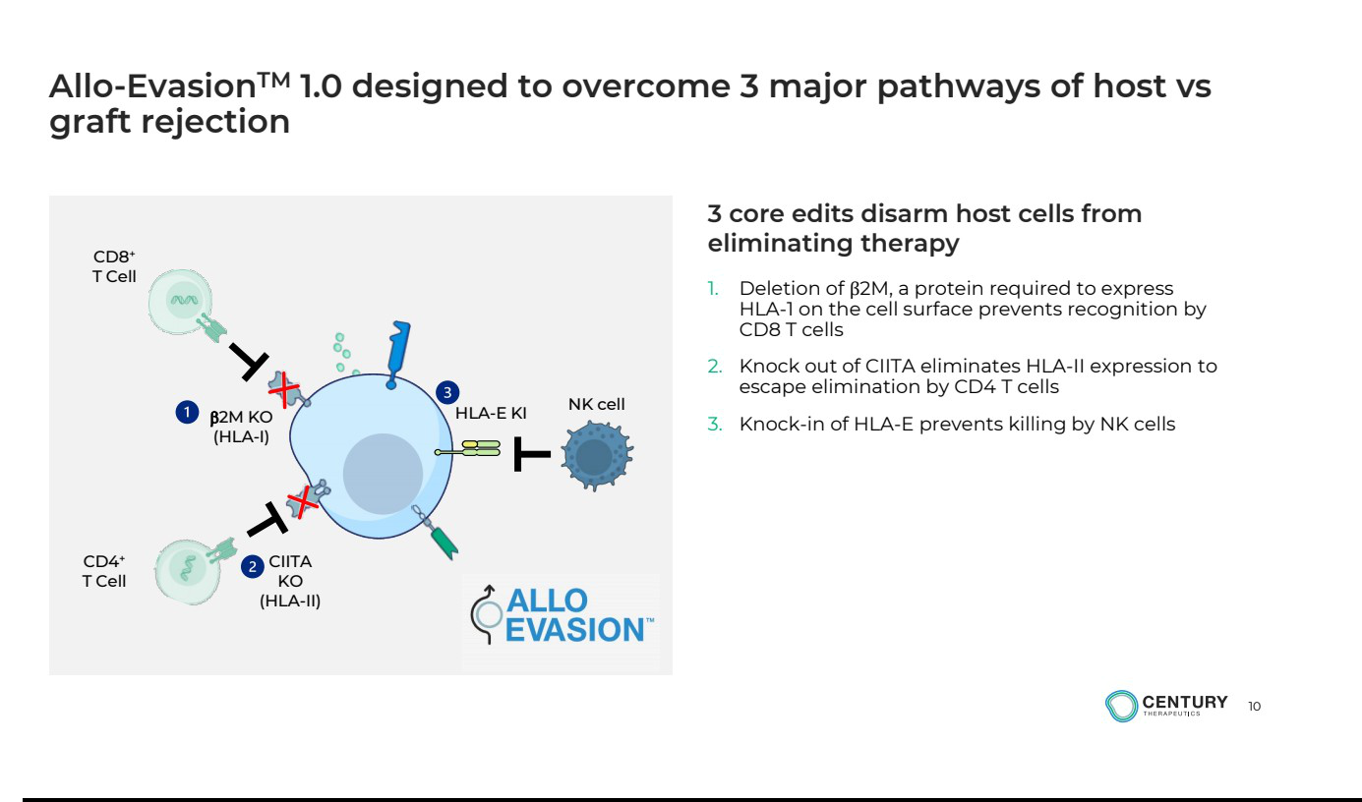

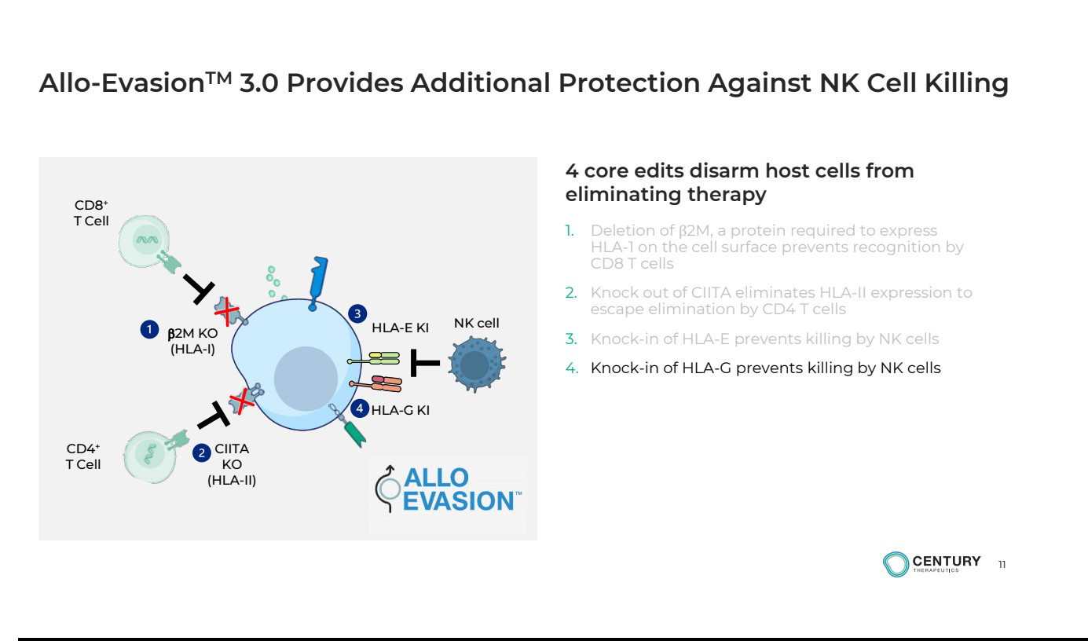

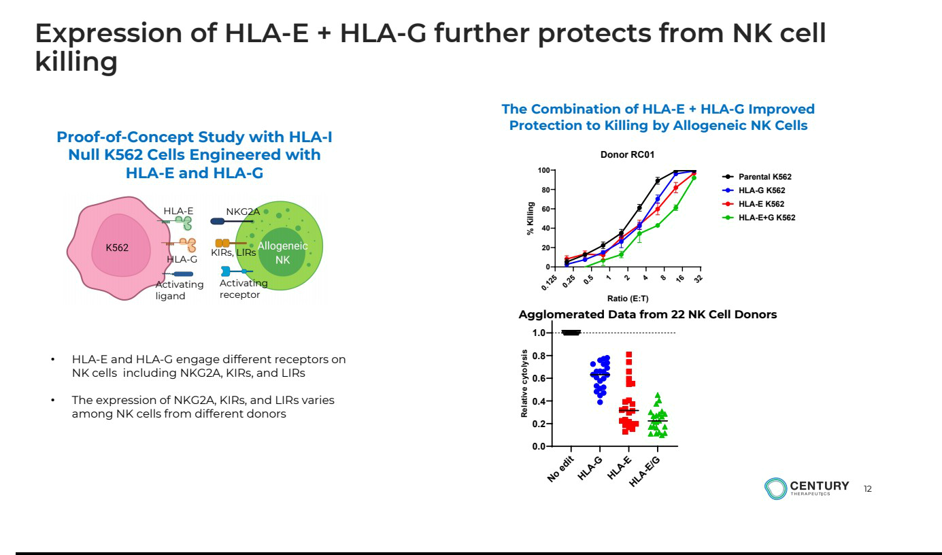



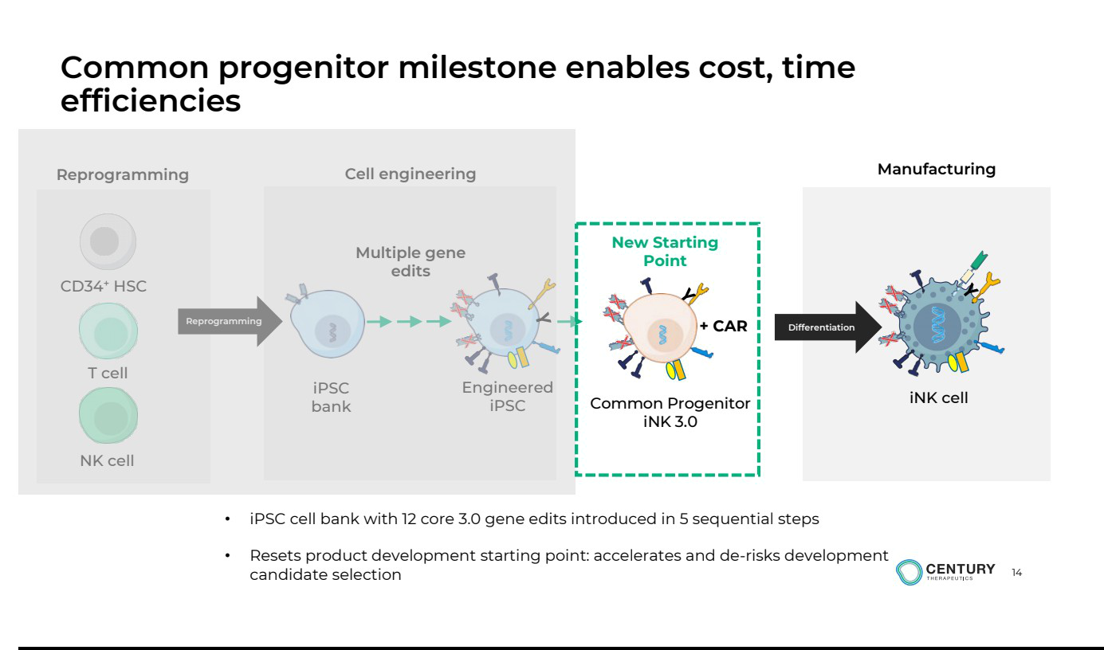

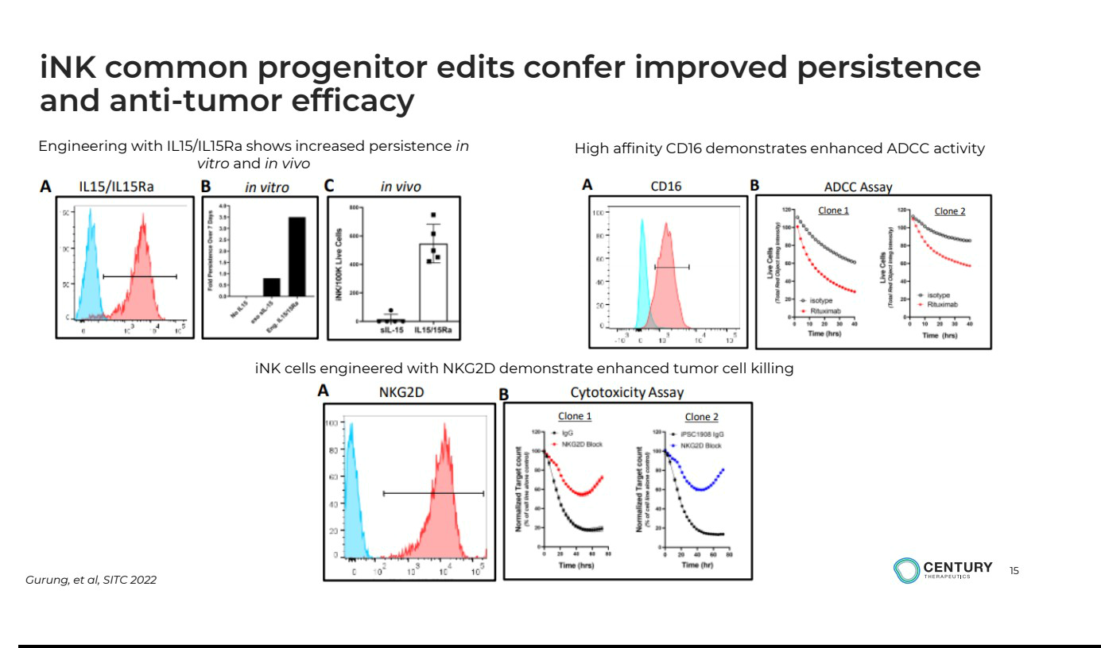



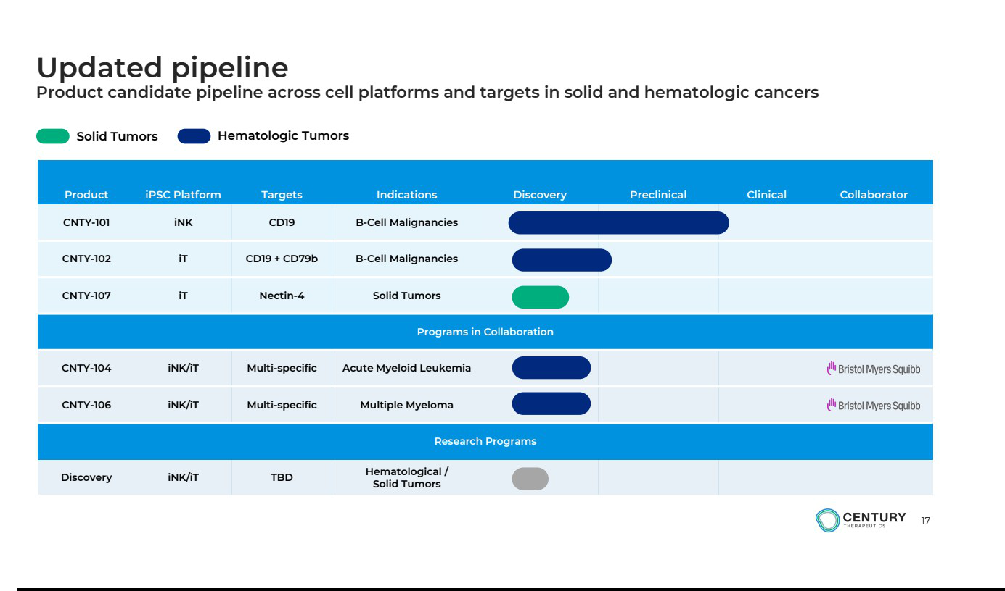

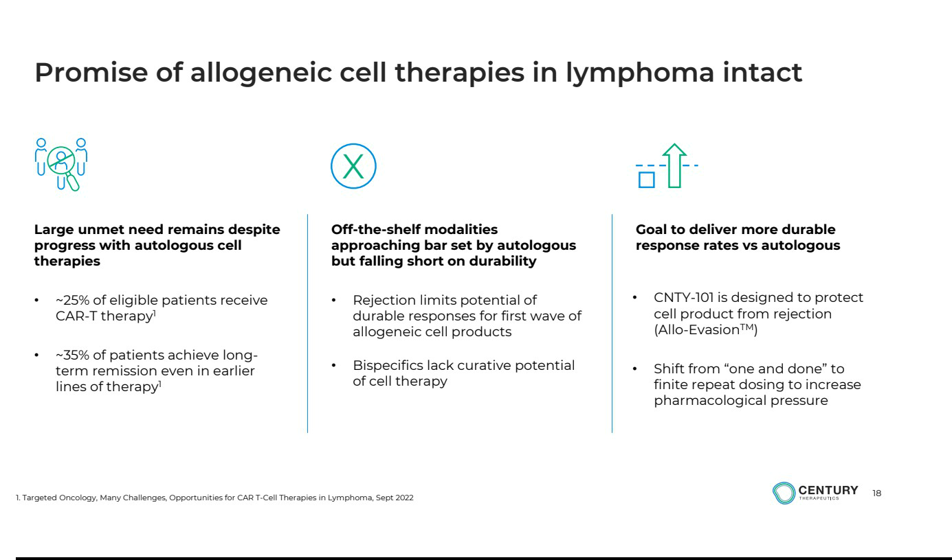

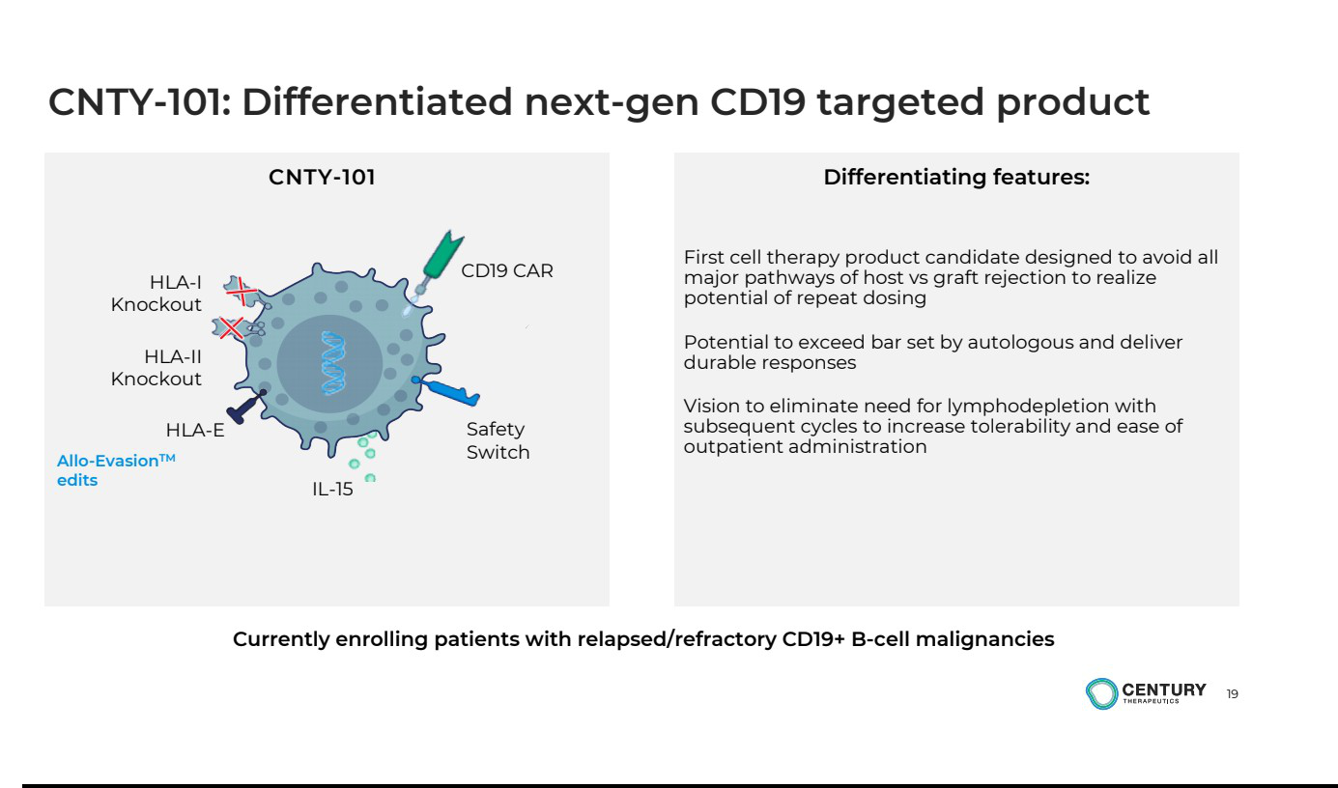

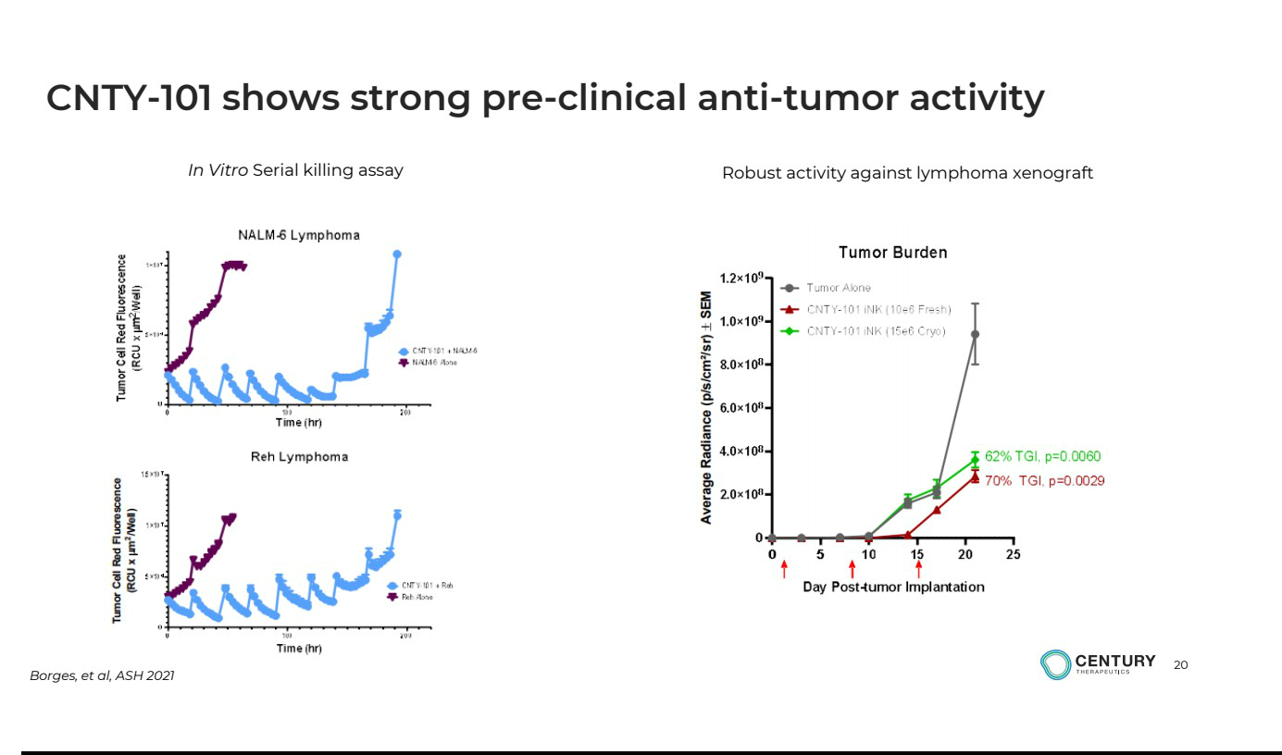

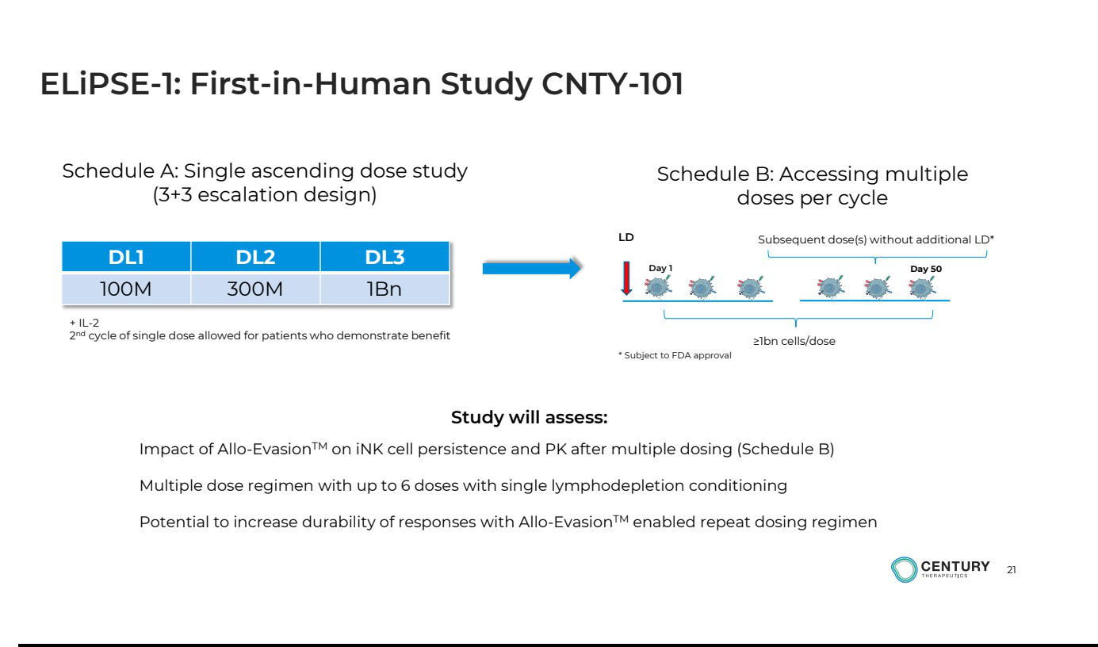

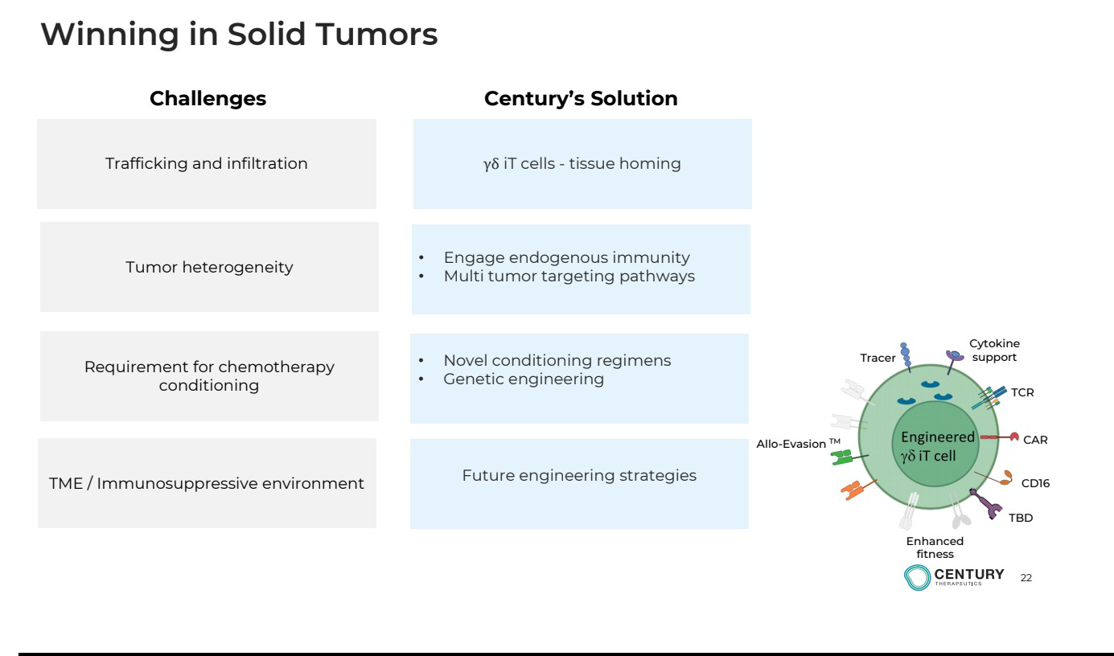

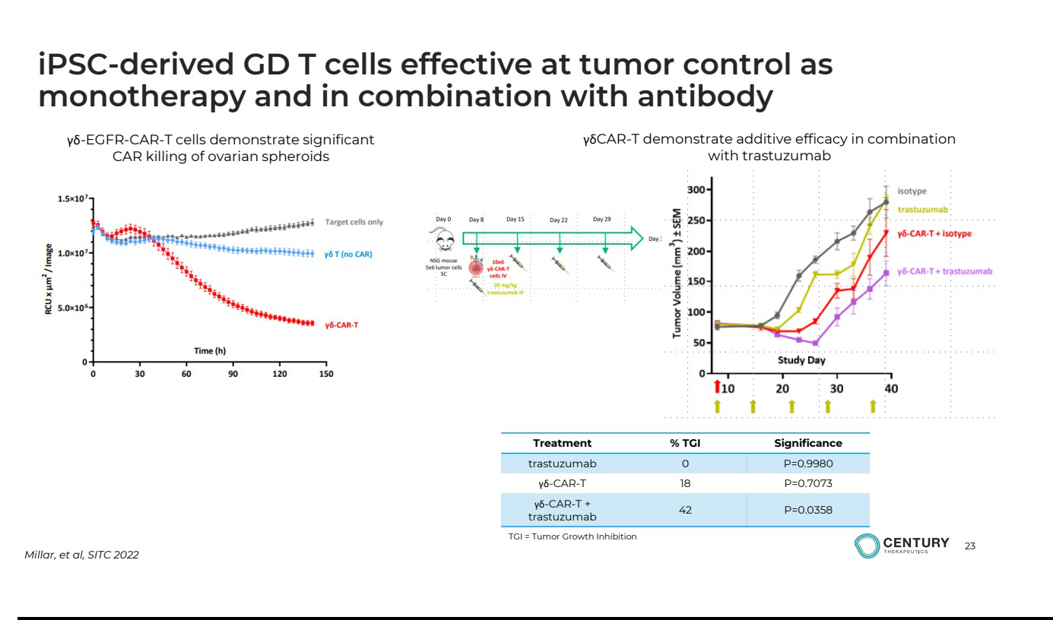

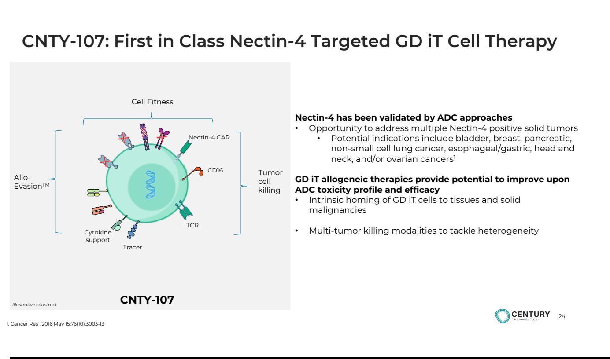

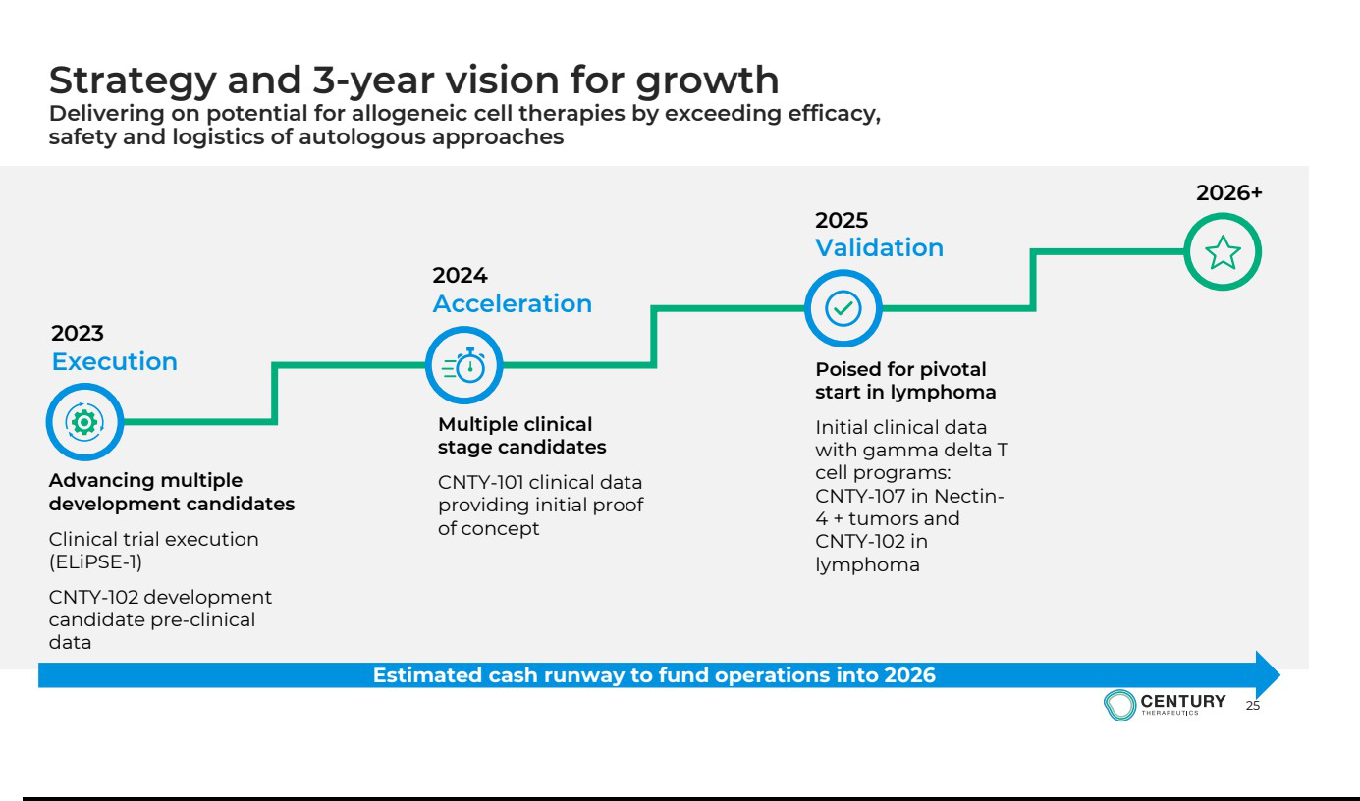

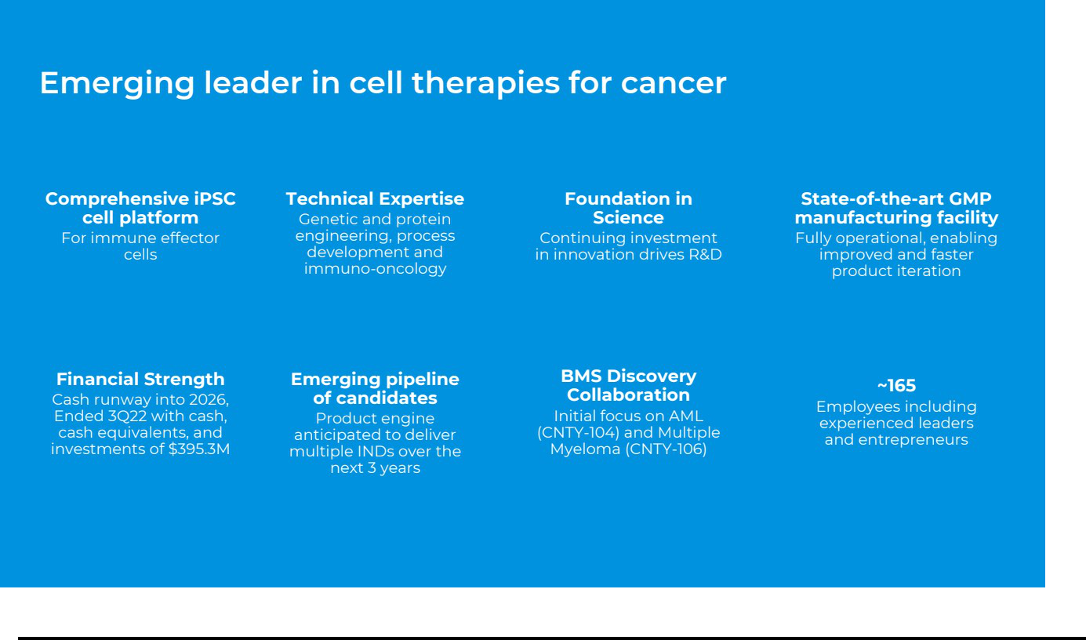

Exhibit 99.2


Century Therapeutics Announces Internal Portfolio Prioritization to Extend Cash Runway Into 2026

January 5, 2023

  - Prioritization allows for acceleration of key programs including CNTY-107 in Nectin-4+ tumors, while de-prioritizing further investment in CNTY-103 for glioblastoma -

    - Employee headcount reduced by approximately 25 percent, extending cash runway into 2026 -

- Phase 1 study of CNTY-101, Company's lead candidate targeting CD19, in relapsed/refractory B-cell lymphoma remains on track; No impact to partnered programs with

Bristol Myers Squibb -

PHILADELPHIA, Jan. 05, 2023 (GLOBE NEWSWIRE) -- Century Therapeutics (NASDAQ: IPSC), an innovative biotechnology company developing induced pluripotent stem cell (iPSC)-derived cell therapies in immuno-oncology, today announced a new internal portfolio prioritization and capital allocation strategy that is expected to extend cash runway into 2026. The resulting changes include de-prioritizing investment in CNTY-103 for glioblastoma as well as a discovery program in hematologic malignancies. The Company will focus on CNTY-101 and will prioritize key programs, including one follow-on product candidate for lymphoma, CNTY-102, and CNTY-107, a product candidate for Nectin-4+ tumors. In addition, Century will continue its partnered programs with Bristol Myers Squibb with no impact to previous guidance on timelines.

The strategic initiative allows the Company to reduce its headcount by approximately 25 percent, providing an estimated greater than 3-year cash runway to fund operations. These strategic changes will allow the Company to focus on delivering upon key milestones in the development of candidates that the Company believes have a higher probability of technical success and best-in-class potential. As a result of the operational restructuring, lab operations in Seattle and Hamilton will be closed and research activities will be consolidated in Philadelphia.

“As our confidence in the disruptive potential of our technology platform and prioritized pipeline programs continues to increase, we have implemented these cost saving measures to right size the organization and further extend our cash runway to enable achievement of key milestones,” said Lalo Flores, Ph.D., Chief Executive Officer, Century Therapeutics. “As a result, we are losing many valued colleagues, which is an incredibly difficult decision, and we would like to thank each of them for their contributions.”

Concurrent with today’s announcement, the Company also announced that Hy Levitsky, M.D., Ph.D., President of Research and Development, has tendered his resignation, effective January 31, 2023. Dr. Levitsky’s leadership responsibilities will be assumed by Luis Borges, Ph.D., Chief Scientific Officer and Adrienne Farid, Ph.D., Chief Operations Officer and Head of Early Development.

“I am pleased to have been part of the Century team during its formative years and I am tremendously proud of the progress the Company has made, leaving it well positioned for future success,” said Dr. Levitsky. “I leave Century with continued confidence in the vision for next-generation iPSC-derived cell therapies.”

“On behalf of the entire team, I would like to thank Hy Levitsky for his valuable contributions to the Company,” Dr. Flores said.

Strategy Update

Based on the outcomes of the strategic portfolio prioritization, the Company will focus on the following:

CNTY-101: lead product candidate targeting CD19 for relapsed/refractory B-cell lymphoma

- CNTY-101 is an iPSC-derived chimeric antigen receptor iPSC-derived NK (CAR-iNK) cell therapy candidate that has been engineered to include core Allo-Evasion™ edits, express a CD19 CAR, soluble IL-15, and an EGFR safety switch. The first sites for the ELiPSE-1 Phase 1 trial are activated and are currently recruiting patients. The first patient is expected to be enrolled imminently.

CNTY-102: multi-specific product candidate for relapsed/refractory B-cell lymphoma and other B-cell malignancies

- CNTY-102 is an iPSC-derived CAR gamma delta iT cell therapy candidate that will simultaneously target CD19 and a second antigen. This product candidate is designed to increase depth and durability of response by eliminating the effect of CD19 antigen loss that has been observed as a factor limiting treatment durability.

CNTY-107: gamma delta iT product candidate for the treatment of solid tumors expressing Nectin-4

- CNTY-107 is a first-in-class iPSC-derived Nectin-4 CAR gamma delta T-cell therapy product candidate that will be engineered with multiple features to provide several mechanisms for tumor killing. As presented at the Company’s virtual Research and Development Day on November 11, 2022, the product candidate will include core Allo-Evasion™ edits and other features to provide cytokine support, enhance tumor cell killing and cell fitness.

The Company continues its strategic research collaboration with Bristol Myers Squibb for CNTY-104 in acute myeloid leukemia and CNTY-106 in multiple myeloma. These programs are not impacted by the restructuring.

About Century Therapeutics

Century Therapeutics (NASDAQ: IPSC) is harnessing the power of adult stem cells to develop curative cell therapy products for cancer that we believe will allow us to overcome the limitations of first-generation cell therapies. Our genetically engineered, iPSC-derived iNK and iT cell product candidates are designed to specifically target hematologic and solid tumor cancers. We are leveraging our expertise in cellular reprogramming, genetic engineering, and manufacturing to develop therapies with the potential to overcome many of the challenges inherent to cell therapy and provide a significant advantage over existing cell therapy technologies. We believe our commitment to developing off-the-shelf cell therapies will expand patient access and provide an unparalleled opportunity to advance the course of cancer care. For more information on Century Therapeutics please visit www.centurytx.com.

Century Therapeutics Forward-Looking Statement

This press release contains forward-looking statements within the meaning of, and made pursuant to the safe harbor provisions of, The Private Securities Litigation Reform Act of 1995. All statements contained in this press release, other than statements of historical facts or statements that relate to present facts or current conditions, including but not limited to, statements regarding our clinical development plans and timelines are forward-looking statements. These statements involve known and unknown risks, uncertainties and other important factors that may cause our actual results, performance, or achievements to be materially different from any future results, performance or achievements expressed or implied by the forward-looking statements. In some cases, you can identify forward-looking statements by terms such as “may,” “might,” “will,” “should,” “expect,” “plan,” “aim,” “seek,” “anticipate,” “could,” “intend,” “target,” “project,” “contemplate,” “believe,” “estimate,” “predict,” “forecast,” “potential” or “continue” negative of these terms or other similar expressions. The forward-looking statements in this press release are only predictions. We have based these forward-looking statements largely on our current expectations and projections about future events and financial trends that we believe may affect our business, financial condition, and results of operations. These forward-looking statements speak only as of the date of this press release and are subject to a number of risks, uncertainties and assumptions, some of which cannot be predicted or quantified and some of which are beyond our control, including, among others: our ability to successfully advance our current and future product candidates through development activities, preclinical studies, and clinical trials; our ability to obtain FDA acceptance for our future IND submissions and commence clinical trials on expected timelines, or at all; our reliance on the maintenance of certain key collaborative relationships for the manufacturing and development of our product candidates; the timing, scope and likelihood of regulatory filings and approvals, including final regulatory approval of our product candidates; the impact of the COVID-19 pandemic, geopolitical issues and inflation on our business and operations, supply chain and labor force; the performance of third parties in connection with the development of our product candidates, including third parties conducting our future clinical trials as well as third-party suppliers and manufacturers; our ability to successfully commercialize our product candidates and develop sales and marketing capabilities, if our product candidates are approved; and our ability to maintain and successfully enforce adequate intellectual property protection. These and other risks and uncertainties are described more fully in the “Risk Factors” section of our most recent filings with the Securities and Exchange Commission and available at www.sec.gov. You should not rely on these forward-looking statements as predictions of future events. The events and circumstances reflected in our forward-looking statements may not be achieved or occur, and actual results could differ materially from those projected in the forward-looking statements. Moreover, we operate in a dynamic industry and economy. New risk factors and uncertainties may emerge from time to time, and it is not possible for management to predict all risk factors and uncertainties that we may face. Except as required by applicable law, we do not plan to publicly update or revise any forward-looking statements contained herein, whether as a result of any new information, future events, changed circumstances or otherwise.

For More Information:

Company: Elizabeth Krutoholow – investor.relations@centurytx.com

Investors: Melissa Forst/Maghan Meyers – century@argotpartners.com

Media: Joshua R. Mansbach – century@argotpartners.com

